

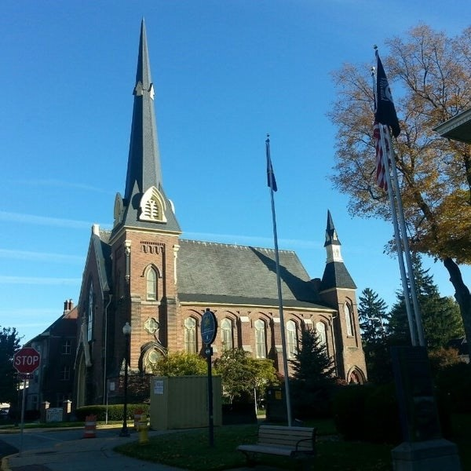
October 22, 2025
A Global Methodist Church
214 S. 5th Street
Goshen, IN 46528
Phone: 574-533-9518
Web Site: goshenfirstgmc.org

Office Hours: Monday-Friday,
8:00 a.m.-12:00 noon
Worship: 9:00 a.m.
Sunday School: 10:30 a.m.
Pastor Jeff & Lisa
Associate Pastor Rich Hull

OUR CHURCH VISION – “Growing in Faith, Gathering in Community, and Giving in Love”.
On November 2, we will be observing All Saints Day. This is a time to remember all those who have passed away since last November. If you have a loved one that you would like to remember, please contact the church office and provide a picture of them.

On November 9, we will honor our veterans on Veterans Day. If you are a veteran and have not given your information to the church office, please do so.

Our Charge Conference is on Wednesday, November 12, at 3:00 p.m. in the Parlor. All are welcome.

“Thank you for my birthday flower and to Lynette Burckhart for delivering it.
We had a wonderful conversation.” -Mary K. Yoder
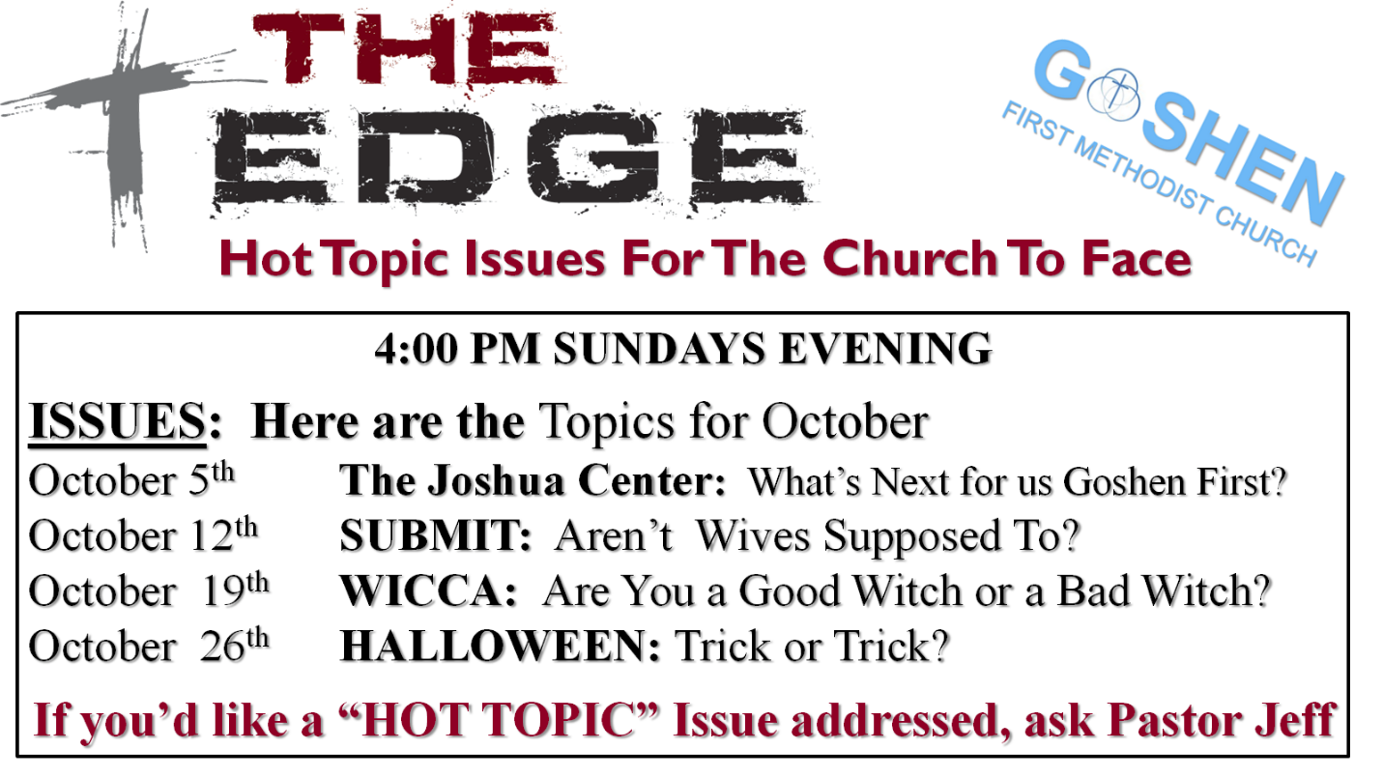

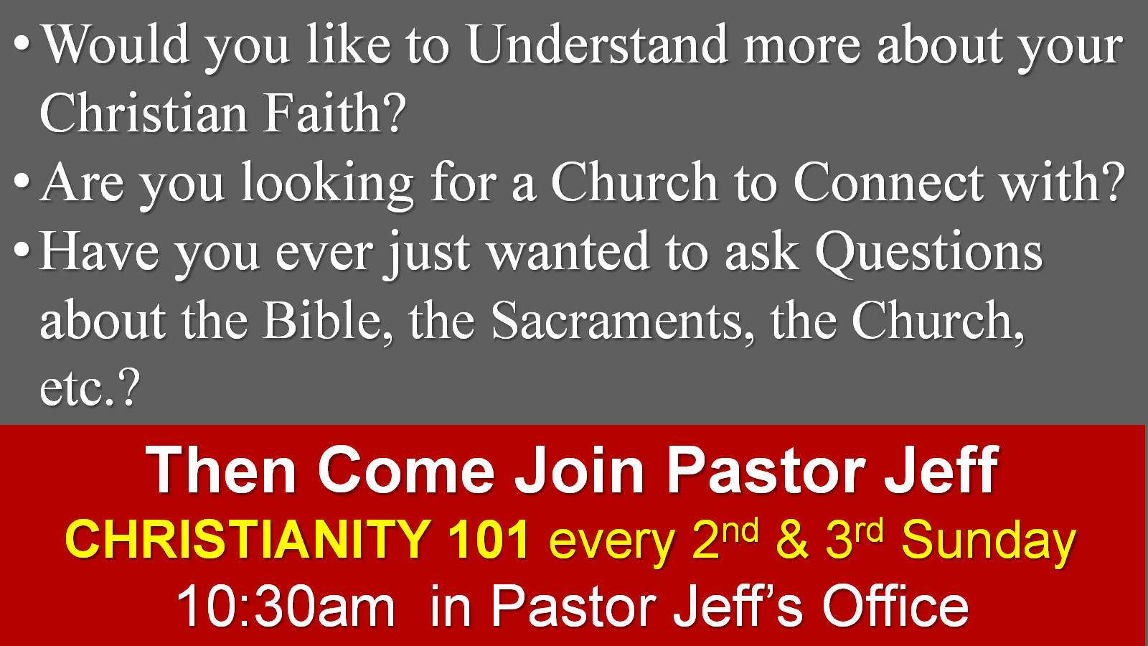

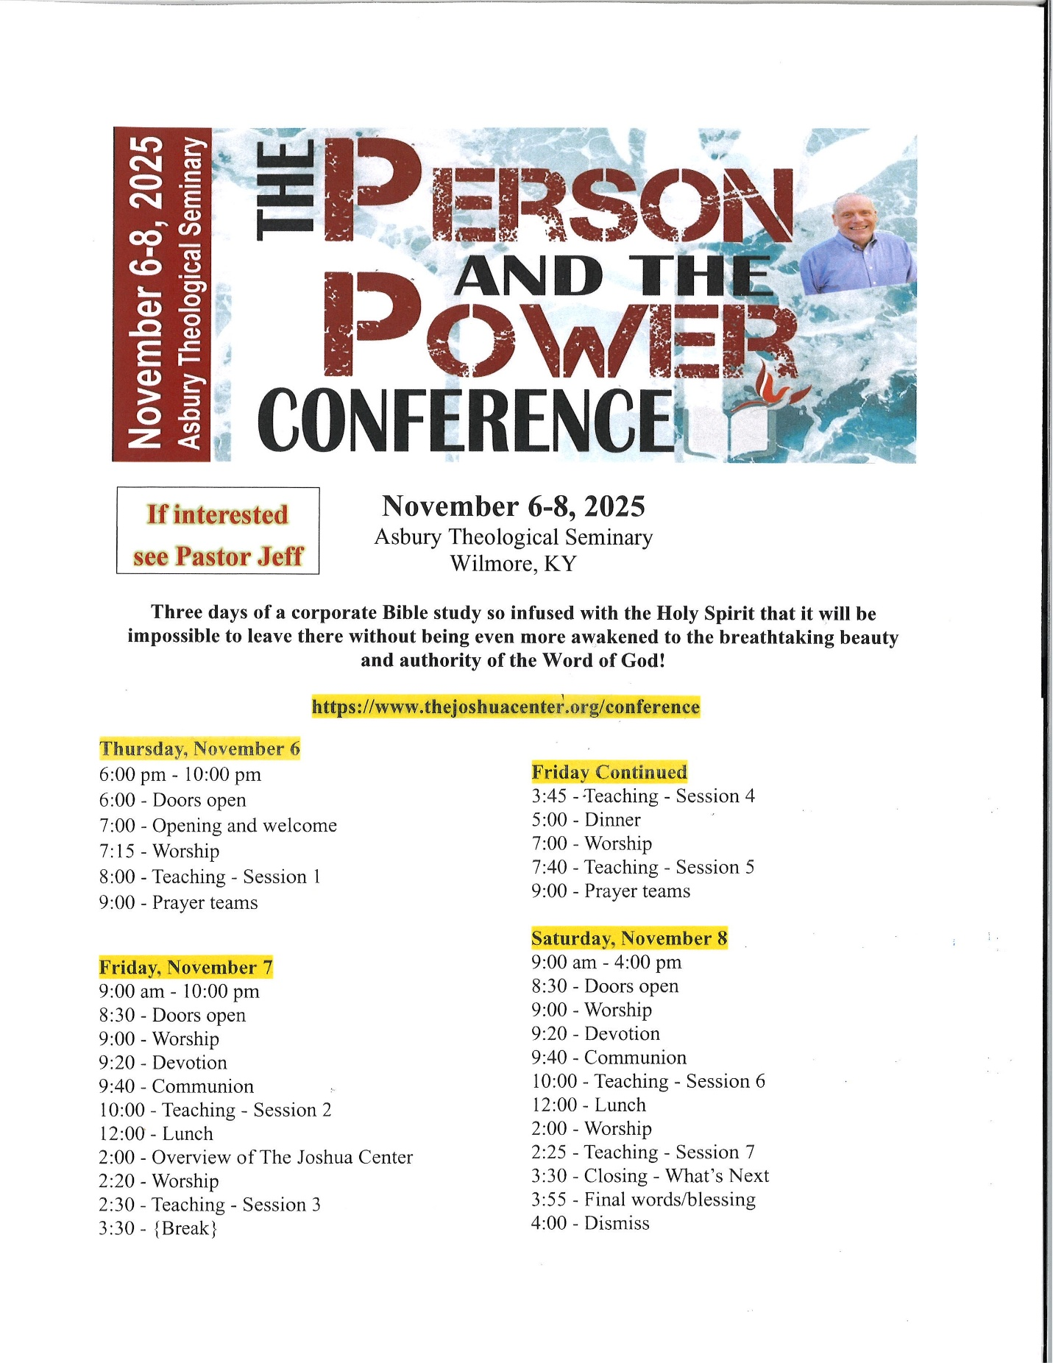

“Thank you so much to the flower ministry for my birthday arrangement. I enjoyed the visit with Lenette Burckhart who delivered the vase.”
-Janice Leek

OUR STAFF
Jeff Bealmear, Pastor – pastorjeff@goshenfirstgmc.org
Rich Hull, Associate Pastor – rich@goshenfirstgmc.org
Ben Whirledge – Pastor Emeritus – benwhirledge@goshenfirstgmc.org
Harriet Martin, Office Administrator – harrietmartin@goshenfirstgmc.org
Scott Carter, Director of Music Ministry – carters@westview.k12.in.us
Rachel Tenorio, Children/Youth Director – rachel@goshenfirstgmc.org
Linda Ponce, Treasurer – lcponce1@gmail.com
DeDe Russell, Caring Ministries Coordinator – russelldede@yahoo.com
Kimberly Lichty-Nyce, Social Media Editor – klichty-nyce@comcast.net
Joel Lane, Pianist – joell12068@gmail.com
John Jinright, Organist – jjinrig@troy.edu
Rodney Troyer, Custodian – troyerstc@gmail.com

VOLUNTEERS – Thank you for your service! Sunday morning, October 26
Greeters: George & Marty Buckingham VIP: Loraine Troyer
Elevator Hosts: Bob & Donna Shirk
Ushers: Gary Miller, Patty Krebs, Max Leatherman, Erv Herschberger, Ron Troyer
Scripture Reader: Ken Smith
Junior Church: Elementary – Pat Huber, Kelley Leeper
Junior Church: Jr. High –
Coffee Hour: Steve & Lori Warner, Max Leatherman, Betty Jo Morris
Bus Driver: Steve Warner

These are pictures from our children and youth hayride on October 12.

