

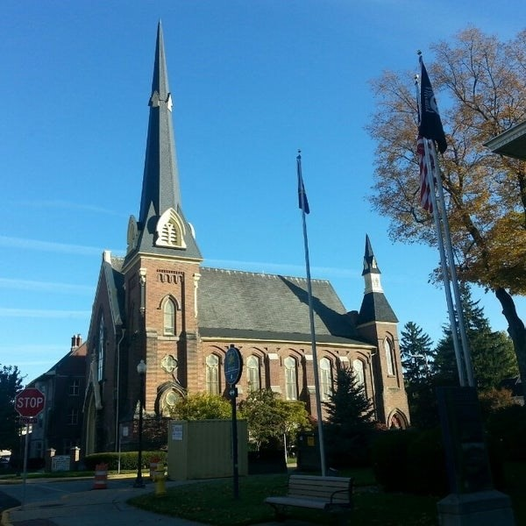
October 15, 2025

A Global Methodist Church
214 S. 5th Street
Goshen, IN 46528
Phone: 574-533-9518
Office Hours: Monday-Friday,
8:00 a.m.-12:00 noon
Worship: 9:00 a.m.
Sunday School: 10:30 a.m.
Pastor Jeff & Lisa
Associate Pastor Rich Hull

OUR CHURCH VISION – “Growing in Faith, Gathering in Community, and Giving in Love”.
Fall break is next week, but we will continue to have the Wednesday night meal and adult classes on October 22.

On November 2, we will be observing All Saints Day. This is a time to remember all those who have passed away since last November. If you have a loved one that you would like to remember, please contact the church office and provide a picture of them.

On November 9, we will honor our veterans on Veterans Day. If you are a veteran and have not given your information to the church office, please do so.

Our Charge Conference is on Wednesday, November 12, at 3:00 p.m. in the Parlor. All are welcome.




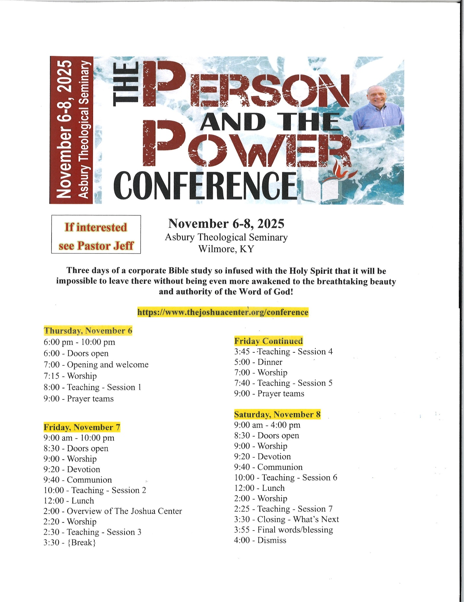

OUR STAFF
Jeff Bealmear, Pastor – pastorjeff@goshenfirstgmc.org
Rich Hull, Associate Pastor – rich@goshenfirstgmc.org
Ben Whirledge – Pastor Emeritus – benwhirledge@goshenfirstgmc.org
Harriet Martin, Office Administrator – harrietmartin@goshenfirstgmc.org
Scott Carter, Director of Music Ministry – carters@westview.k12.in.us
Rachel Tenorio, Children/Youth Director – rachel@goshenfirstgmc.org
Linda Ponce, Treasurer – lcponce1@gmail.com
DeDe Russell, Caring Ministries Coordinator – russelldede@yahoo.com
Kimberly Lichty-Nyce, Social Media Editor – klichty-nyce@comcast.net
Joel Lane, Pianist – joell12068@gmail.com
John Jinright, Organist – jjinrig@troy.edu
Rodney Troyer, Custodian – troyerstc@gmail.com

VOLUNTEERS – Thank you for your service! Sunday morning, October 19
Greeters: Mary Ann Eash, Arlene Randolph VIP: Loraine Troyer
Elevator Hosts: Chuck & Carol Rink
Ushers: Gary Miller, Patty Krebs, Max Leatherman, Erv Herschberger, Ron Troyer
Scripture Reader: Mike Bigler
Junior Church: Elementary – Patty Krebs, Karen Andrews, Dar Dechant
Junior Church: Jr. High – Beth Pettit
Coffee Hour: Dan & Kathy Seltenright, Arlene Randolph
Bus Driver: Al Eppert



