

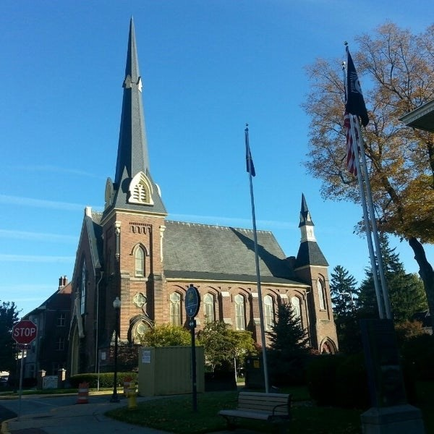
October 8, 2025

A Global Methodist Church
214 S. 5th Street
Goshen, IN 46528
Phone: 574-533-9518
Office Hours: Monday-Friday,
8:00 a.m.-12:00 noon
Worship: 9:00 a.m.
Sunday School: 10:30 a.m.
Pastor Jeff & Lisa
Associate Pastor Rich Hull

OUR CHURCH VISION – “Growing in Faith, Gathering in Community, and Giving in Love”.

SAVE THE DATE - On October 16, the Primetimers will go to Ben’s Pretzels at 2807 Marina Drive, in Elkhart. The bus will leave the Life Center at 9:15 a.m. The cost is $5. Lunch will be at Callahan’s Restaurant. Please contact Betty Jo Morris or Pat Huber if you want to go.

The Faith Weavers S.S. class will begin a new study on October 12, which is titled,
“Surviving in Babylon” by Larry Osborne. The study is based on the book of Daniel. Daniel, with the power of hope, humility, and wisdom, not only survived, but thrived. Though Daniel lived thousands of years ago, he has much to teach us today. All are welcome to the class!
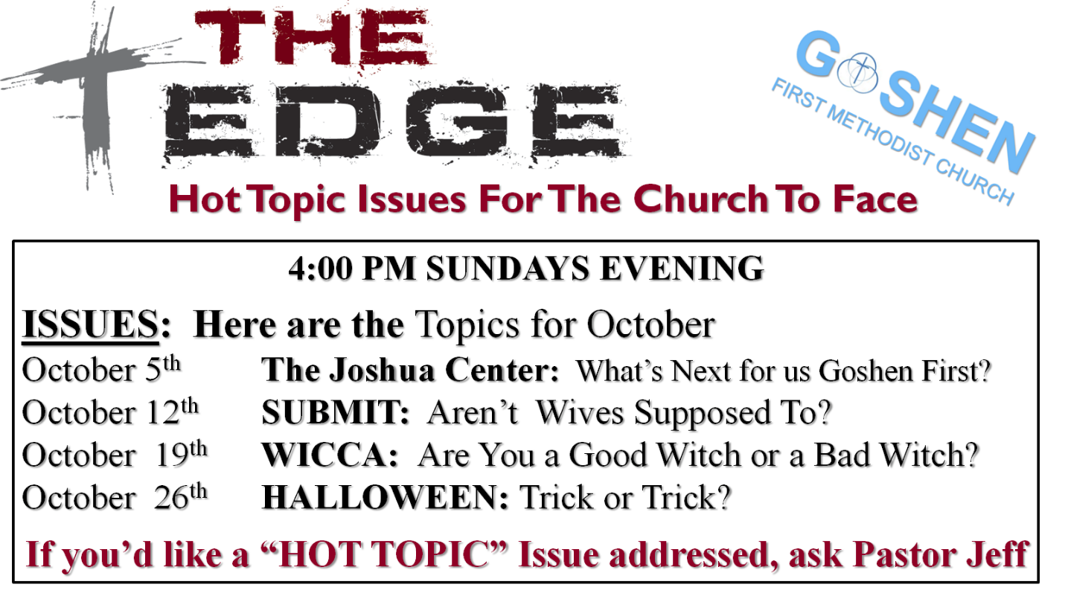

Hey, Kids! We are having a hayride at McCann’s house on Sunday at 3:00 p.m.
Everyone is welcome!

The last day for soup and food donations for The Window will be this coming Sunday, October 12.

OUR STAFF
Jeff Bealmear, Pastor – pastorjeff@goshenfirstgmc.org
Rich Hull, Associate Pastor – rich@goshenfirstgmc.org
Ben Whirledge – Pastor Emeritus – benwhirledge@goshenfirstgmc.org
Harriet Martin, Office Administrator – harrietmartin@goshenfirstgmc.org
Scott Carter, Director of Music Ministry – carters@westview.k12.in.us
Rachel Tenorio, Children/Youth Director – rachel@goshenfirstgmc.org
Linda Ponce, Treasurer – lcponce1@gmail.com
DeDe Russell, Caring Ministries Coordinator – russelldede@yahoo.com
Kimberly Lichty-Nyce, Social Media Editor – klichty-nyce@comcast.net
Joel Lane, Pianist – joell12068@gmail.com
John Jinright, Organist – jjinrig@troy.edu
Rodney Troyer, Custodian – troyerstc@gmail.com

VOLUNTEERS – Thank you for your service! Sunday morning, October 12
Greeters: Janet Taylor VIP: Loraine Troyer
Elevator Hosts: Ted & Shirley Fairfield
Ushers: Gary Miller, Patty Krebs, Max Leatherman, Erv Herschberger, Ron Troyer
Scripture Reader: Jeanne Bigler
Junior Church: Elementary – Rachel Parsons Tenorio, Kelley Leeper
Junior Church: Jr. High – Jeanne Bigler
Coffee Hour: Dave & Marcia Parsons, Sharon Hull
Bus Driver: Gary Miller

This article is from “The Post” newsletter.
