 | MINUTES  St. Francis de Sales Elementary School  Parish Education Committee  PEC Meeting 2025-3

Date: | 9/16/2025 | Chair: | Ms. Joselyn Navarro
Time: | 6:30pm | Recorder: | Ms. Jacqueline Lamasan
Location: | SFdS Rectory | Guests: | /
Attendees: | Father Mark McGuckin  Mrs. Irene Wihak  Mrs. Naomi Panganiban  Ms. Joselyn Navarro  Mr. Anthony Tillman / Mr. Jonathan Geronimo  Ms. Rossa Sung  Ms. Jacqueline Lamasan  Ms. Leah Canete  Ms. Paula Ramor | Regrets: | Mr. Jonathan Geronimo
Meeting opened at 6:34 pm by Ms. Joselyn Navarro.

1 | Opening Prayer & Reflections  Faith Development: Living, Celebrating and Proclaiming our Faith! | Fr. Mark | 10 min
An excerpt from Pope Leo’s homily on the occasion of the Canonization of Sts. Pier Giorgio Frasatti and Carlo Acutis (Sept. 7, 2025).

“[...] today we look to Saint Pier Giorgio Frassati and Saint Carlo Acutis: a young man from the early 20th century and a teenager from our own day, both in love with Jesus and ready to give everything for him.
Pier Giorgio encountered the Lord through school and church groups — Catholic Action, the Conferences of Saint Vincent, the FUCI (Italian Catholic University Federation), the Dominican Third Order — and he bore witness to God with his joy of living and of being a Christian in prayer, friendship and charity. This was so evident that seeing him walking the streets of Turin with carts full of supplies for the poor, his friends renamed him ‘Frassati Transport Company’! Even today, Pier Giorgio’s life is a beacon for lay spirituality. For him, faith was not a private devotion, but it was driven by the power of the Gospel and his membership in ecclesial associations. He was also generously committed to society, contributed to political life and devoted himself ardently to the service of the poor.
Carlo, for his part, encountered Jesus in his family, thanks to his parents, Andrea and Antonia — who are here today with his two siblings, Francesca and Michele — and then at school, and above all in the sacraments celebrated in the parish community. He grew up naturally integrating prayer, sport, study and charity into his days as a child and young man.
Both Pier Giorgio and Carlo cultivated their love for God and for their brothers and sisters through simple acts, available to everyone: daily Mass, prayer, and especially Eucharistic Adoration. Carlo used to say: “In front of the sun, you get a tan. In front of the Eucharist, you become a saint!” And again: “Sadness is looking at yourself; happiness is looking at God. Conversion is nothing more than shifting your gaze from below to above; a simple movement of the eyes is enough.”
[...] both had a great devotion to the saints and to the Virgin Mary, and they practiced charity generously. Pier Giorgio said: “Around the poor and the sick, I see a light that we do not have”. He called charity “the foundation of our religion” and, like Carlo, he practiced it above all through small, concrete gestures, often hidden, living what Pope Francis called “a holiness found in our next-door neighbors”
Even when illness struck them and cut short their young lives, not even this stopped them nor prevented them from loving, offering themselves to God, blessing him and praying to him for themselves and for everyone. One day Pier Giorgio said: “The day of my death will be the most beautiful day of my life” In his last photo, which shows him climbing a mountain in the Val di Lanzo, with his face turned towards his goal, he wrote: “Upwards”. Moreover, Carlo, who was even younger than Pier Giorgio, loved to say that heaven has always been waiting for us, and that to love tomorrow is to give the best of our fruit today.

2 | Approval of Agenda  MOTION to accept agenda (Ms. Paula Ramor, Ms. Rossa Sung) | Ms. Joselyn Navarro | 2 min

3 | Adoption / Review of Minutes  MOTION to adopt minutes (Ms. Leah Canete, Mr. Anthony Tillman) | Ms. Joselyn Navarro | 2 min

4 | Reports – 6:45 pm | All | 45 min
Pastor – Fr. Mark McGuckin
- As per report sent out in advance
- Catechetical Sunday following the AGM was a very positive energy
- AGM (Sept. 11): Successful event with strong energy, family connections, and good interactions.
- Upper Room Conference (Sept. 20 & 27): ~30 participants from SFDS attending; significant parish representation; aligns with renewal/evangelization work.
- Walkathon 2025: Promotion to launch once website and charitable pages are active; Fr. Lukose/team will lead while Fr. away (Sept. 23–Oct. 10).
- Alpha Marriage Course: Encouraging more school parents to join (mid-Oct. to late Nov.); noted positive impact on marriages.
- Alpha (January 2026): Preparing for relaunch; recruiting/training table leaders and refining kitchen plan.
- Outdoor Ed: Deacon Pat & Lynn Dwan joining team; Deacon Pat to lead daily Grade 7 liturgies at camp.
- Class Visits: Weekly Tuesday morning visits to three classes by clergy, complementing Wednesday Masses.
- Christmas Cards Project: Grades 3–5 and PREP students producing >100 handcrafted cards for Christmas hampers; initiative deeply meaningful.
- Special Tuition Subsidy: Refining 2026–27 questionnaire; current families to return by end of February; parish team assisting in discernment and support.
- Development & Peace Ministry: Growing; planning for Share Lent campaign; seeking student collaboration ideas.
- Seminarians: Esteban Garcia-Lopez beginning 2nd year; parish has 21 seminarians in total; letters of support encouraged.
- Parish Feast Day (Jan. 24, 2026): Early planning underway; P.E.C. input requested; focus on showcasing student talent/work.

Principal - Mrs. Irene Wihak
- As per report sent out in advance
- Gr. 5 Jr. Soccer Team will have try outs. May also have an exhibition team for Gr. 3/4.
- Spiritual & Faith Formation:
- First school Mass held Sept. 3 with Fr. Mark’s homily on courage, truth, and trust in God.
- Staff Commissioning Mass scheduled for Sept. 14 (parish-school unity).
- Staff Faith Development Day in August with Pete Burak: focus on intentional discipleship, Catholic identity, and practical strategies for faith in schools.
- Outreach & Clubs:
- Terry Fox Foundation: ~$1,200 raised last year; this year’s total pending.
- G.I.V.E.R.S. Club to launch in October after Grade 7 camp.
- School Safety:
- Planned drills: 6 fire, 3 lockdown, 3 playground safety, 2 earthquake release.
- Awaiting contact from new school liaison officer.
- No incidents logged from Rene Memorial Park.
- Air Quality Index monitored; adjustments made as needed.
- Parents signed up for morning playground sweeps beginning next week.
- Professional Development:
- Ongoing workshops using Dr. Jennifer Katz’s material (Equity, Diversity, Justice, Inclusion).
- Focus on student competence, access to curriculum, leadership, fairness as equity, self-regulation, and universal design.
- Policy Updates (Adopted July 8, 2025)
- Policy 321: Harassment & Bullying Prevention – scope limited to current employees; clarify procedures.
- Policy 405: Student Abuse & Neglect – update terminology to “AASO.”
- Policy 421: Inclusive Education – updated title/procedures to align with MOE standards.
- Revised Student Code of Conduct draft in PEC folder.
- Information Technology:
- Carlo coordinating 1:1 check-ins with staff.
- Classmate Training Centre supporting staff tech skills; training underway for new staff.
- Communicating Student Learning:
- 5 annual reports: Oct. conferences, Dec. written update, Mar. written update, May student-led conferences, June summative report.
- Fine Arts:
- Choir open for students (Ms. Walmsley).
- Guest performance Sept. (Shawn Bullshields, Blackfoot Nation).
- Sports
- Soccer: junior team formed; proposal for Grade 4 exhibition team.
- Cross-Country: Sept. 23 meet (St. Mary’s), Oct. 1 CISVA meet; Grades 2–7.
- Volleyball: 3 competitive girls’ teams + 1 developmental team; multiple coaches including parents; senior boys team pending commitment/coach.
- Staffing:
- In-camera update.
- Walkathon
- Goal: $45,000 net.
- All students walk Oct. 10; city permit requested.
- Theme: outdoor play and “Go Tell It On the Mountain.”
- Regular monitoring visit scheduled by the Office of the Inspector of Independent Schools (2-year cycle).

Teachers’ Representative - Mrs. Naomi Panganiban
- Dr. Jennifer Katz’ material will be used for Pro-D to staff on Inclusive Education
- Fall sports teams are up and running (Girls Volleyball, Boys Soccer, Cross Country)
- Two Cross Country meets upcoming in Sept. and Oct.
- EAs appreciated being invited to the AGM

Chair – Ms. Joselyn Navarro
- Thank you to PEC, Fr. Mark, Fr. Lukose for all of their help at the AGM

Treasurer - Mr. Anthony Tillman; Mr. Jonathan Geronimo
- No financials yet for the 2025-2026 school year

Vice Chair/Parish-School Community Building Initiative – Ms. Rossa Sung
- Nothing to report

Secretary - Ms. Jacqueline Lamasan
- Nothing to report

Facility and Maintenance/Tech - Ms. Leah Canete
- As per report sent out in advance
- Gym scoreboard installed and operational.
- Front door locks upgraded; additional upgrades scheduled.
- Exhaust hood/ductwork in gym kitchen cleaned (annual requirement).
- Backflow device inspections completed (main school & portable).
- EXIT sign batteries in portable replaced; spares ordered.
- Exterior door patching/painting scheduled.
- Annual fire alarm inspection completed (portable).

Community Engagement – Ms. Paula Ramor
- As per report sent out in advance
- Currently supporting parents with signing up for volunteer work, fundraising check marks, and families who have chosen to have their cheques cashed
- BWS and Walkathon are largely full
- Many families still need checkmarks
- The 3 families who have not signed up for any activities have been contacted through On Volunteers as well as via email

New Business
5 | Revised Code of Conduct | Mrs. Wihak | 10 min
- Action: add specific date, cyber safety, document control number
- Action for future registration: have both the parent and student Code of Conduct for people to sign off that it has been read and accepted
Motion to Approve Code of Conduct: Mr. Anthony Tillman and Ms. Leah Canete
-All in favour, none opposed

6 | Policy Updates | Mrs. Wihak | 5 min
- Policies discussed (previously discussed during the August meeting):
  - 321 Harassment and Bullying
  - 405 Responding to Student Abuse and Neglect
  - 421 Inclusive Education Policy

7 | Preschool | Mrs. Wihak | 5 min
- Inquiring about the option of increasing the Preschool hours of operation and associated fees
- In the process of hiring additional staff as needed

8 | Review of AGM Evening | Mrs. Wihak | 10 min
- Gym was full
- Having AGM with Meet the Teacher on the same night draws in more parents
- Having 25 minutes (additional time) during the Meet the Teacher was beneficial
- Hospitality before the AGM creates a positive and welcoming atmosphere

Closing Prayer – Fr. Mark (2 min)

Meeting closed at 7:50 pm by Ms. Joselyn Navarro.

NEXT MEETING: Wednesday, October 22, 2025 @ 6:30 PM

Next Actions
 | Details | Responsible | Due
1. | Add specific date, cyber safety, document control number to Code of Conduct | Mrs. Wihak | Before Code of Conduct is posted on website
2. | Have both the parent and student Code of Conduct for people to sign off that it has been read and accepted | Mrs. Wihak | Before registration
3. | Email On Volunteers Tip Sheet to families who have not signed up for On Volunteers | Parent Participation | As soon as feasibly possible
4. | Remove parents who are no longer activity leads from the specific activity on On Volunteers | Parent Participation | As soon as feasibly possible
Update:

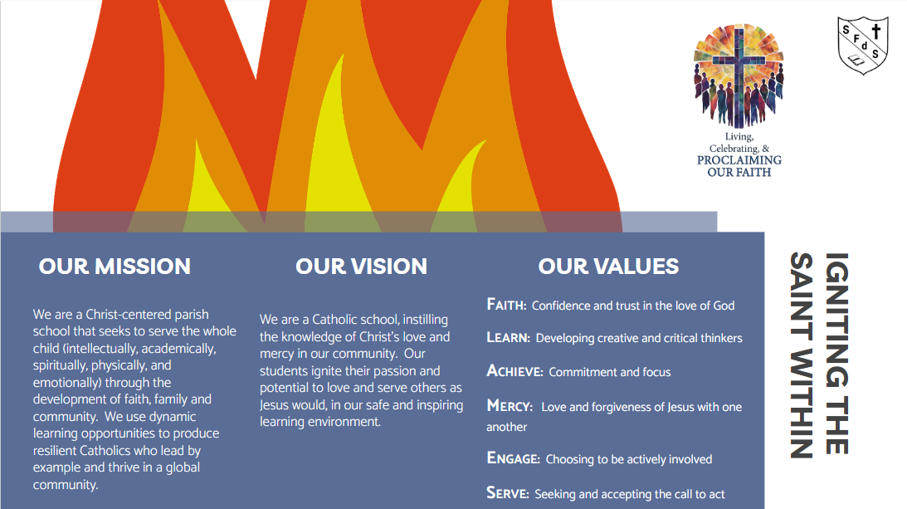
Our Core Values

F – Faith: Living actions that show confidence and trust in the love of God

L – Learn: Developing creative and critical thinkers whose actions contribute to a better world

A – Achieve: Committing and focusing on reaching your goals

M – Mercy: Demonstrating the love and forgiveness of Jesus with one another every day

E – Engage: Choosing to be actively involved in the life of our school

S – Serve: Seeking and accepting the call to act for the greater good

