

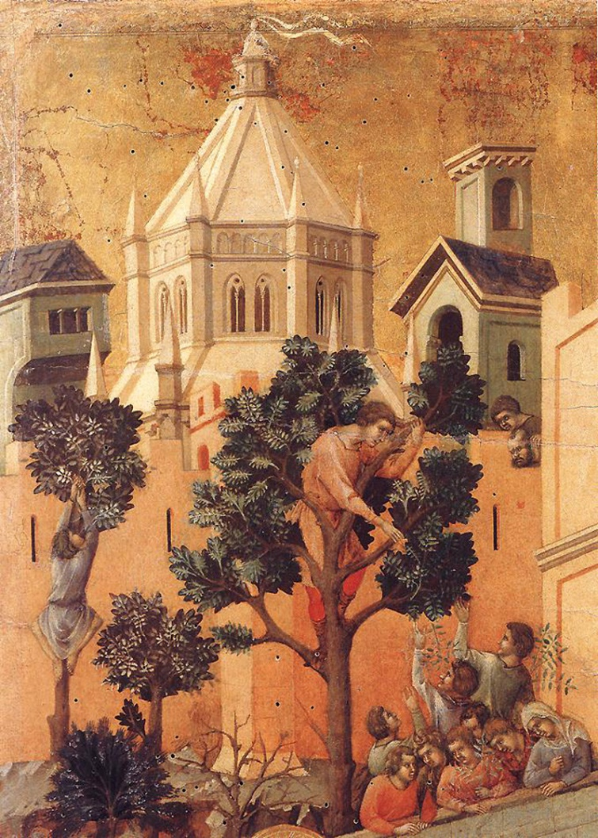

2 November 2025, Pentecost 21
Family Eucharist

Service outline, Parish News & Events
8 am HOLY COMMUNION__________________
Celebrant and preacher: Fr. Allen Doerksen
9.30 am FAMILY COMMUNION________________
Celebrant and preacher: Fr. Allen Doerksen
The Gathering of the Community
Worship Songs
Welcome
Territorial Acknowledgement
Greeting BAS 185
Song of Praise Gloria (Glory to God) tune: Pulkingham
The Story of Faith is Proclaimed
Children’s Time – Come and See the Light
First Reading:
Gospel Acclamation: Alleluia (sung)
Gospel: Luke
Gospel Acclamation: Alleluia (sung)
Sermon
A short period of silent reflection follows,
signalled by the sound of a bell
Affirmation of Faith
Collect
Confession and Absolution BAS 191
The Peace BAS 192
Offertory Hymn
Prayer over the Gifts ELW (2006) alt
The Celebration of the Eucharist
Eucharistic Prayer BAS 193 #1
Sanctus: Holy, holy, holy Lord
The Lord’s Prayer (sung) BAS 211
Breaking of the Bread BAS 212 #3
The Communion
Music during Communion
Prayer after Communion EVL (2006) alt
Doxology (Glory to God) BAS 214
Announcements & Birthday Box
Blessing BAS 683 i
Closing Song
Dismissal

Welcome to St Philip!
Please join us for coffee and fellowship after the 9.30 service.
The abbreviation BAS in the service order refers to page numbers in the Book of Alternative Services, the green volume in the pews. CP is Common Praise, the blue hymn book.
Welcome to Communion
We want you to feel welcome at St. Philip. All are encouraged to come forward to receive the bread (communion wafer) and wine. If you prefer to receive a blessing, please keep your head and hands down. If you are more comfortable not drinking from the cup, you may keep your head down and let it pass, or return to your pew after receiving the bread. Please tell the person distributing the bread if you require a gluten-free wafer. Prayer Ministers are available during Communion at the 9:30 am service, at the side of the altar.

Offering
It is Anglican custom to receive a financial offering in our worship, as an expression of gratitude to God. Please do not feel compelled to participate in this offering. Your presence is gift enough.

Services this week
26 October 2025 - 20th Sunday after Pentecost
8am Holy Communion - Celebrant and preacher: Rev. Matthew Humphrey
9am Community Prayers downstairs in the youth room
9.30am Holy Eucharist, in-person & streamed via Facebook Live
Celebrant and preacher: Rev. Matthew Humphrey
Altar Guild: Felicity Bradley, Karen Fenimore
Usher: Bruce Fyfe
Musicians: Alix and Chris Harvey, Ceal and Ged McLean, Gillian Rhodes, Sharon Richmond, Rev. Matt
Readers: Catherine Morris, Florie Varga
Prayers of the People: Lisa Alexander
Children's ministry: Melinda Weicker
Powerpoint slides: Clayton Savage
Facebook Live: Karishma Iyer
Coffee: Barb Evans-Ehricht
Offerings counters: Betty Davidson, Dorothy Dahli
28 October, Tuesday 10.30am Contemplative Prayer
30 October, Thursday 10am Holy Communion followed by coffee and book study (starts about 10.30).
Contemplative Prayer
Please join us on Tuesday mornings, 10:30 - 11:30, meeting in the choir area of the nave (at the front of the church), for a 20 minute contemplative sit with a time of prayer following.
Long-term Housing Rental Request
Our family of five (2 adults, 3 children) is looking for a long-term rental property (2-3 bedroom apartment or house) in the Greater Victoria or Saanich Peninsula area with the move-in date at the beginning of January 2026. If you have a suitable place available or anticipate availability around this date, please contact Lucie at 778-533-7877 or lucie.kotesovska@seznam.cz . Thank you very much for any tips and information.
- Alecs and Lucie Kotesovsky.
Thursday book study schedule
Saved From Sacrifice: a theology of the cross. Zoom link is in the e-newsletter, or request from the office.
- Nov 5/6 – Chapter 4, pp. 107-132
- Wed, Nov 5, 7 pm Zoom Study
- Thurs, Nov 6, 10 am Eucharist + Study (study starts at approx. 10:30 am)
- Nov 12/13 – Chapter 5, pp. 134-164
- Wed, Nov 12, 7 pm Zoom Study
- Thurs, Nov 13, 10 am Eucharist + Study (study starts at approx. 10:30 am)
- Nov 19/20 — No Zoom study and no Midweek Eucharist or in-person study
- Nov 26/27 — Chapter 7 pp. 192-215
- Wed, Nov 26, 7 pm Zoom Study
- Thurs, Nov 27, 10 am Eucharist + Study (study starts at approx. 10:30 am)
- Dec 3/4 — Chapter 8, Part 1 pp. 219-236
- Wed, Dec 3, 7 pm Zoom Study
- Thurs, Dec 4, 10 am Eucharist + Study (study starts at approx. 10:30 am)
- Dec 10/11 - Chapter 8, Part 2 pp. 236-259
- Wed, Dec 10, 7 pm Zoom Study
- Thurs, Dec 11, 10 am Eucharist + Study (study starts at approx. 10:30 am)
Drop-In Knitting Evening
Bring your knitting project (or your mending basket) Thursday, November 6, 7:00 - 8:30 pm at the Richmonds'. Enjoy a cup of tea and if it’s a blustery night, a fire in the fireplace. If you don’t know how to knit, someone will be there to get you started, or help you out if you get tangled! Email sharonlrichmond @gmail.com for the address.
Community Karaoke Night – 14 November
We have the microphones, the songs, the snacks and the (non-alcoholic) drinks, and all we need is you! Feel free to bring your friends, families, snacks and (non-alcoholic) drinks with you as well, because this is an all age karaoke event!
Whether you’re a first time singer or a veteran, this is a safe space for you to let it out and let loose! Feel free to belt out your inner baby shark, pop and country diva, rockstar and everything in between without a care in the world!
Date: 2nd Fridays - 14 November and 12 December 2025; 9 January, 13 February, 13 March, 10 April 2026
Location: downstairs hall at St Philip’s Anglican Church @ 2928 Eastdowne Road, Victoria, BC, V8R 5R8 - step-free ramp entrance from the parking lot. Follow the sign!
Feel free to drop in or leave at any time. You can access the church within walking distance through buses 4, 9, 7, 11, and 15.
See you then! If you have any questions, please reach out to Anderson at bvsdawnofnewyear@gmail.com!
Newcomers’ Lunch
If you are new to St. Philip in the last year and would like to get to know a bit more about other newcomers, meet Fr. Allen, and chat about the "ins-and-outs" of what makes our faith community tick, then this is for you: A Newcomers Lunch hosted by Rob and Brenda Hosie at their house (2911 Seaview Rd) starting at approximately 12 pm on Sunday, November 16th. Fr. Allen will attend as will a few of our Council members. It's fun, the food is provided, and you'll have opportunity to listen to others share their experiences, share your own, and dialogue over and questions that arise. See you there!
- Allen+

We Together 2025 – diocesan conference: Deadline tomorrow
Friday, November 14, 2025 @ St Paul's, Nanaimo
We Together is our biennial diocesan conference to remind us of the ways we are connected; we are stronger together. We are bound in countless ways, in our structures, in our prayers, and through the stories we tell. We are each other's concern, and we are each other's gift. This year is God is not Elsewhere. The God of our scriptures and stories, the God of our traditions and rites, the God who whispers through music and poetry, is the God moving here & now.
Friday evening program: banquet at St Paul's in Nanaimo and opening address. Saturday: full day of workshops at St. Paul's . Speakers: John Thatamanil, Jonathan Thomas, Jenny Replogle, Christine Conkin, Gordon Smith, Brendon Neilson and Denise Doerksen.
Registration deadline: 3 November – see the diocesan website bc.anglican.ca
St Luke’s Cedar Hill - Choral Evensong of Remembrance
You are invited to St. Luke's Church (3805 Cedar Hill Cross Road) this evening, Sunday, November 2 at 7 pm for a special musical service to honour All Saints'/All Souls' Days. As well as the beautiful liturgy and music of a sung Evensong service, special music will be presented by flutist Mary Byrne, bassoonist Matthew Robertson, and bell ringer Maria Ross. All are welcome. Please bring a friend.
Prayers & readings for Sun 26 October & the following week:
We pray for Anna, our bishop, and Allen, our rector. In our parish cycle of prayer, we pray for the coffee crew.
Diocese: the Diocesan Council and Parish Councils.
Anglican Church in Canada: The Rt. Rev. Lesley Wheeler-Dame as she begins her retirement, and for the clergy and people of the Diocese of Yukon.
Anglican Communion: The Church of the Province of West Africa.
Collect: Almighty God, whose people are knit together in one holy Church, the mystical Body of your Son, grant us grace to follow your blessed saints in lives of faith and commitment, and to know the inexpressible joys you have prepared for those who love you; through your Son Jesus Christ our Lord, who lives and reigns with you and the Holy Spirit, one God, now and for ever. (BAS 428)
Anglican Communion Cycle of Prayer for the week:
- Mon 3 Nov The Diocese of Portsmouth – Church of England
- Tues 4 Nov The Diocese of Pretoria – The Anglican Church of Southern Africa
- Wed 5 Nov The Diocese of Puerto Rico –Episcopal Church
- Thurs 6 Nov The Diocese of Pune – The Church of North India (United)
- Fri 7 Nov The Diocese of Pungue River – Igreja Anglicana de Mocambique e Angola
- Sat 8 Nov The Diocese of Pyay – The Church of the Province of Myanmar (Burma)
Lectionary for Sunday 2 November (Pentecost 21): Habakkuk 1:1-4; 2:1-4 and Psalm 119:137-144; Isaiah 1:10-18 and Psalm 32:1-7; 2 Thessalonians 1:1-4, 11-12; Luke 19:1-10.
Daily readings below are related to the weekly Sunday Gospel lection and sermon.
- Mon 3 Nov Psalm 50; Nehemiah 13:1-3, 23-31; 1 Cor 5:9-13
- Tues 4 Nov Psalm 50; Zechariah 7:1-14 ; Jude 1:5-21
- Wed 5 Nov Psalm 50; Amos 5:12-24; Luke 19:11-27
- Thurs 6 Nov Psalm 17:1-9; Deut 25:5-10; Acts 22:22-23:11
- Fri 7 Nov Psalm 17:1-9; Genesis 38:1-26; Acts 24:10-23
- Sat 8 Nov Psalm 17:1-9; Exodus 3:13-20; Luke 20:1-8

This week's retro recipe from the parish cookbook 1976
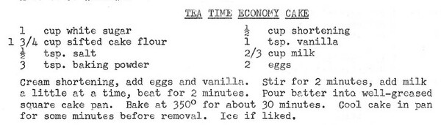
This concludes the series of highlights from the 1976 cookbook. If you're interested in compiling or contributing to a collection of current parish recipes for the 50th anniversary, please contact Anna in the office.
Cover image: Duccio di Buoninsegna, -1319?: Zacchaeus, detail from Entry into Jerusalem, from Art in the Christian Tradition, a project of the Vanderbilt Divinity Library, Nashville, TN. https://diglib.library.vanderbilt.edu/act-imagelink.pl?RC=57182 [retrieved October 27, 2025]. Original source: https://commons.wikimedia.org/wiki/File:Duccio_di_Buoninsegna_-_Entry_into_Jerusalem_(detail)_-_WGA06784.jpg..
Rector: Rev. Allen Doerksen (incumbent@stphilipvictoria.ca,
work cell 236-508-2928; day off: Friday)
Warden: Judith Armstrong (jarmstrong@stphilipvictoria.ca)
Warden: Larry Anthony (lanthony@stphilipvictoria.ca)
Parish Office Hours: Mon 1-4.30, Wed & Thurs 9-4.30
250-592-6823 | admin@stphilipvictoria.ca
Facebook including live streams: https://www.facebook.com/stphilipoakbay
Instagram: https://www.instagram.com/stphilipoakbay/
Thank you for avoiding scented products at church.

