Parkside Lutheran Church
Rediscovering the Radical Love of Jesus
Gathering All
Serving All
Caring For All

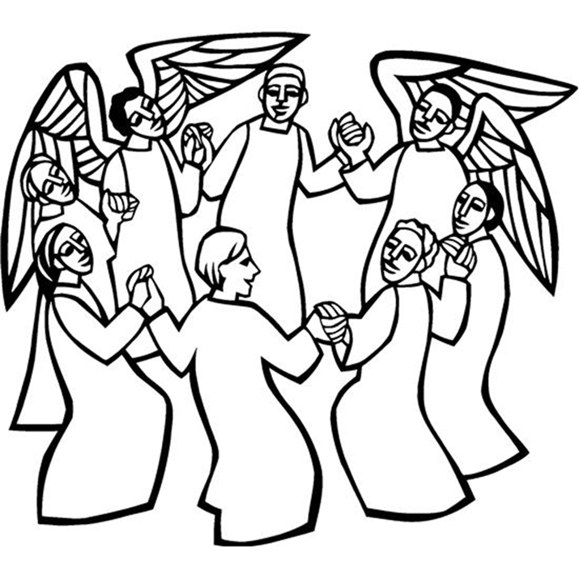

November 2nd, 2025
All Saints Sunday
Holy Communion 10:00am
Rev. Jeremiah Smith
Parkside Lutheran Values

Proclaiming Grace - Jesus shared and lived out a message of grace, love, and new life. We believe these promises come from God freely, as a gift for all. We are loved and the Spirit inspires us to share this good news in accessible, relevant, and new ways. Luke 4:17-19, John 1:16-17, John 3:16-17, Ephesians 2:8-9

Practicing Hospitality – Jesus welcomed the little children, broke bread with outcasts, and proclaimed the Good News to all. Whether you are strong in faith, wrestling with doubt, or somewhere in between, we affirm that you are welcome here. Jesus is for everyone. Leviticus 19:34, Matthew 9:10, Matthew 19:14, Hebrews 13:2

Loving Boldly - Jesus challenged traditions to demonstrate God’s justice and love of neighbor. His compassionate and sacrificial love inspires us to take risks. Striving to follow his command to love neighbor, our ministries serve, transform, and advocate for folks near and far. Micah 6:8, Mark 11:15-17, Luke 10:25-28, John 15:12-13

Cultivating Community - Jesus built communities that transformed lives. We are the body of Christ and we are called to continue this ministry of transformation. Guided by the Holy Spirit, we build connections within and outside of these walls, and with all of God’s creation. Ecclesiastes 4:9-12, Matthew 28:16-20, 1 Corinthians 12:12-14, Galatians 3:26-29

Welcome Visitors!
Please use QR code
to let us know you were here today or to sign up for our weekly enewsletter
or, sign up for weekly enewsletter via website parksidelutheran.org.
Find us on Facebook & Instagram WIFI: Balcony password: FreeGrace

For your safety in the event of an emergency: In addition to the three exits in the back of the sanctuary, there are exits on either side of the altar (on left side: floor level near piano and up steps past altar. On right side: up steps to the altar, past band area)

Contact us: (716) 836-1361
2 Wallace Ave. Buffalo, NY 14214
parksidelutheran.org | parksidelutheran@gmail.com

GATHER
The Holy Spirit calls us together as the people of God.

Introduction to the Day: In holy baptism God makes saints out of sinners. In holy communion God forgives the sins of all the saints. In worship today we give thanks for all the saints “who from their labors rest.” In the same breath we petition our God for the strength to hear and to heed the admonitions of Jesus in today’s gospel. Sealed by the Spirit and sustained by the Savior’s body and blood, we live with joy as God gives us breath, to the praise of God’s glory.

Prelude Michael Hooker, Music Director

Call to Worship
WA: In all our weakness and strength, with our youth-filled spirits and aging bodies,
C: we come to be your people, O God.
WA: Strong in faith and eager with questions, singing our praise and whispering our prayers,
C: we come to be your people, O God.
WA: Filled with saintly determination yet mindful of our human limitations,
C: we come to be your people, O God.
WA: Made strong in your endless love for us, we know ourselves to be yours and
C: we come to be your people, O God.
WA: May we truly become your people today. C: Amen.

Gathering Hymn: For All the Saints ELW #422
(printed next page)

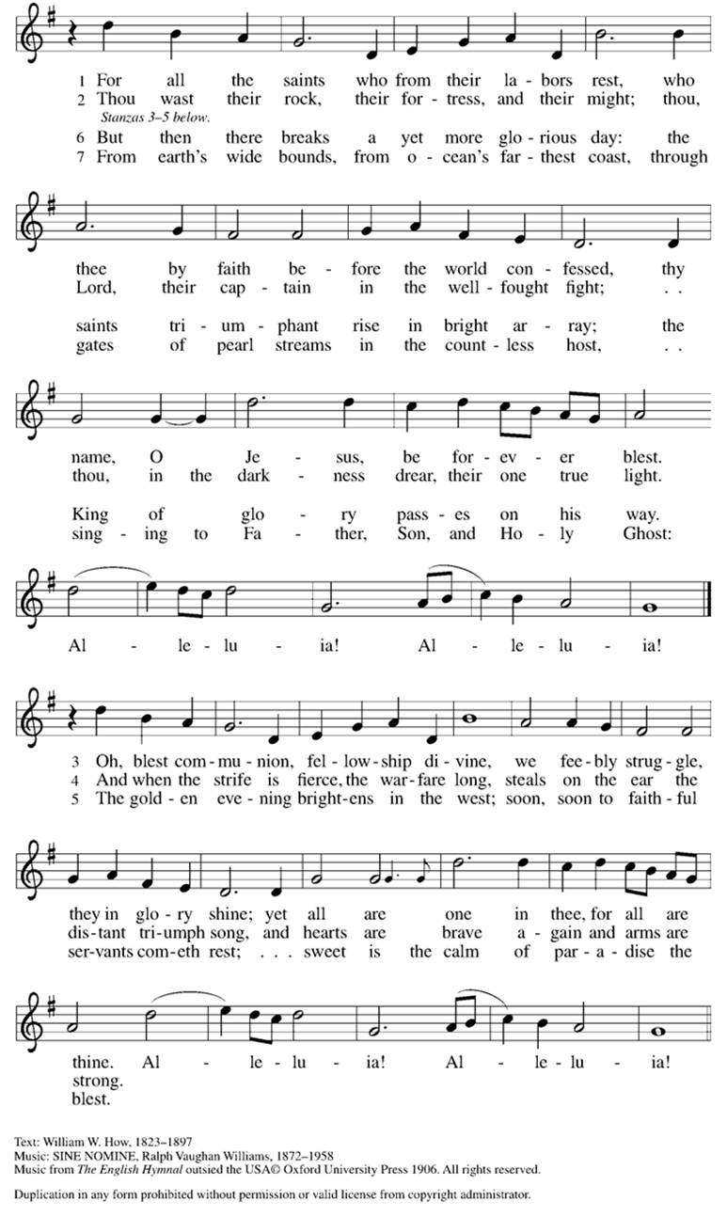
Welcome and Announcements

Holy Baptism: Callen Gene Pascucci ELW p. 227

P: God, who is rich in mercy and love, gives us a new birth into a living hope through the sacrament of baptism. By water and the Word God delivers us from sin and death and raises us to new life in Jesus Christ. We are united with all the baptized in the one body of Christ, anointed with the gift of the Holy Spirit, and joined in God's mission for the life of the world.
P: Who do you present to be baptized? Sponsors: We present Callen for baptism.

P: Called by the Holy Spirit, trusting in the grace and love of God, as his parents, do you desire to have Callen baptized into Christ? Parents: We do.

P: As you bring him to receive the gift of baptism, you are entrusted with responsibilities: to live with him among God's faithful people, bring him to the word of God and the holy supper, teach him the Lord's Prayer, the Creed, and the Ten Commandments, place in his hands the holy scriptures, and nurture him in faith and prayer, so that he may learn to trust God, proclaim Christ through word and deed, care for others and the world God made, and work for justice and peace.

P: Do you promise to help Callen grow in the Christian faith and life?
Parents: We do.

P: Sponsors, do you promise to nurture Callen in the Christian faith as you are empowered by God's Spirit, and to help him live in the covenant of baptism and in communion with the church? Sponsors: We do.

P: People of God, do you promise to support Callen and pray for him in his new life in Christ? C: We do.

+ Profession of Faith
P: All together as the people of God, I ask you to profess your faith in Christ Jesus, reject sin, and confess the faith of the church.

P: Do you renounce the devil and all the forces that defy God?
C: We renounce them.

P: Do you renounce the powers of this world that rebel against God?
C: We renounce them.

P: Do you renounce the ways of sin that draw you from God?
C: We renounce them.

P: Do you believe in God the Father?
C: I believe in God, the Father almighty, creator of heaven and earth.
P: Do you believe in Jesus Christ, the Son of God?
C: I believe in Jesus Christ, God's only Son, our Lord, who was conceived by the Holy Spirit, born of the virgin Mary, suffered under Pontius Pilate, was crucified, died, and was buried; he descended to the dead.* On the third day he rose again; he ascended into heaven, he is seated at the right hand of the Father, and he will come to judge the living and the dead.
P: Do you believe in God the Holy Spirit?
C: I believe in the Holy Spirit, the holy catholic church, the communion of saints, the forgiveness of sins, the resurrection of the body, and the life everlasting.

Thanksgiving at the Font
P: The Lord be with you. C: And also with you.
P: Let us give thanks to the Lord our God.
C: It is right to give our thanks and praise.

P: We give you thanks, O God, for in the beginning your Spirit moved over the waters and by your Word you created the world, calling forth life in which you took delight. Through the waters of the flood you delivered Noah and his family, and through the sea you led your people Israel from slavery into freedom.
At the river your Son was baptized by John and anointed with the Holy Spirit. By the baptism of Jesus' death and resurrection you set us free from the power of sin and death and raise us up to live in you.
Pour out your Holy Spirit, the power of your living Word, that those who are washed in the waters of baptism may be given new life. To you be given honor and praise through Jesus Christ our Lord, in the unity of the Holy Spirit, now and forever. C: Amen.

The assembly may be seated.

Baptism
P: Callen Gene, I baptize you in the name of the Father, and of the Son, and of the Holy Spirit. Amen.

P: Let us pray. We give you thanks, O God, that through water and the Holy Spirit you give your daughters and sons new birth, cleanse them from sin, and raise them to eternal life.

Laying hands on the head of Callen, the minister prays:

P: Sustain Callen with the gift of your Holy Spirit: the spirit of wisdom and understanding, the spirit of counsel and might, the spirit of knowledge and the fear of the Lord, the spirit of joy in your presence, both now and forever. Amen.

P: Callen, child of God, you have been sealed by the Holy Spirit and marked with the cross of Christ forever. Amen.

Welcome
WA: Jesus said, I am the light of the world.
Whoever follows me will have the light of life.

P: Let us welcome Callen.
C: We welcome you into the body of Christ and into the mission we share: join us in giving thanks and praise to God and bearing God's creative and redeeming word to all the world.

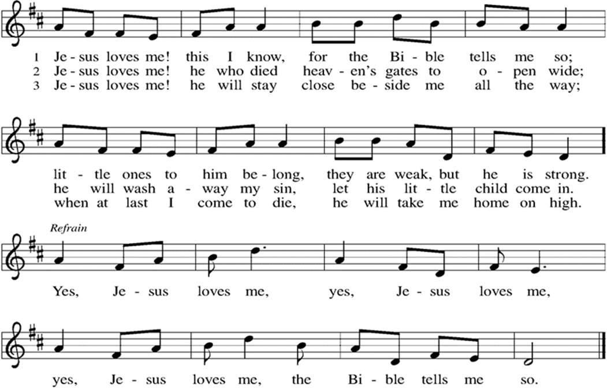

Greeting
WA: The grace of our Lord, Jesus Christ, the love of God, and the communion of the Holy Spirit be with you all. C: And also with you.

Everyone is invited to come forward during the solo and light a candle in honor of the saints you remember this day. In the Baptismal font we have two floating votives. They represent those in our worship community who died this past year. This year we remember Joan Bauer and William (Bill) Elrod, Jr.

Solo “Come Jesus Come” Heather Casseri

Prayer of the Day
WA: Let us pray together.
C: Almighty God, you have knit your people together in one communion in the mystical body of your Son, Jesus Christ our Lord. Grant us grace to follow your blessed saints in lives of faith and commitment, and to know the inexpressible joys you have prepared for those who love you, through Jesus, Christ, our Savior and Lord, who lives and reigns with you and the Holy Spirit, one God, now and forever. Amen.

WORD
God speaks to us in scripture readings, preaching and song.

First Reading: Daniel 7:1-3, 15-18
The book of Daniel was written in the second century BCE, when the Syrian king Antiochus Epiphanes was severely persecuting the Jews. Daniel’s vision of the four beasts proclaims that human kings will come and go, but the kingdom will ultimately belong to God and to God’s people.
L: ¹ In the first year of King Belshazzar of Babylon, Daniel had a dream and visions of his head as he lay in bed. Then he wrote down the dream: ² I, Daniel, saw in my vision by night the four winds of heaven stirring up the great sea, ³ and four great beasts came up out of the sea, different from one another.
¹⁵ As for me, Daniel, my spirit was troubled within me, and the visions of my head terrified me. ¹⁶ I approached one of the attendants to ask him the truth concerning all this. So he said that he would disclose to me the interpretation of the matter: ¹⁷ “As for these four great beasts, four kings shall arise out of the earth. ¹⁸ But the holy ones of the Most High shall receive the kingdom and possess the kingdom forever—forever and ever.”
L: Word of God, word of life. C: Thanks be to God.
Psalm: Psalm 149 Sing the Lord’s praise in the assembly of the faithful. (Ps. 149:1)
L: ¹Hallelujah! Sing to the Lord a new song,
God’s praise in the assembly of the faithful.
C: ²Let Israel rejoice in their maker;
let the children of Zion be joyful in their ruler.
L: ³Let them praise their maker’s name with dancing;
let them sing praise with tambourine and harp.
C: ⁴For the Lord takes pleasure in the people
and adorns the poor with victory.
L: ⁵Let the faithful rejoice in triumph; let them sing for joy on their beds.
C: ⁶Let the praises of God be in their throat
and a two-edged sword in their hand,
L: ⁷to wreak vengeance on the nations and punishment on the peoples,
C: ⁸to bind their kings in chains and their nobles with links of iron,
L: ⁹to inflict on them the judgment decreed;
this is glory for all God’s faithful ones. Hallelujah! L: Word of God, word of life. C: Thanks be to God.

Second Reading: Ephesians 1:11-23
After giving thanks for the faith of the Ephesians, the writer of this letter prays that they might understand the wisdom, hope, and power of God that is embodied in Jesus Christ.
L: ¹¹ In Christ we have also obtained an inheritance, having been destined according to the purpose of him who accomplishes all things according to his counsel and will, ¹² so that we, who were the first to set our hope on Christ, might live for the praise of his glory. ¹³ In him you also, when you had heard the word of truth, the gospel of your salvation, and had believed in him, were marked with the seal of the promised Holy Spirit; ¹⁴ this is the pledge of our inheritance toward redemption as God’s own people, to the praise of his glory.
¹⁵ I have heard of your faith in the Lord Jesus and your love toward all the saints, and for this reason ¹⁶ I do not cease to give thanks for you as I remember you in my prayers, ¹⁷ that the God of our Lord Jesus Christ, the Father of glory, may give you a spirit of wisdom and revelation as you come to know him, ¹⁸ so that, with the eyes of your heart enlightened, you may perceive what is the hope to which he has called you, what are the riches of his glorious inheritance among the saints, ¹⁹ and what is the immeasurable greatness of his power for us who believe, according to the working of his great power. ²⁰ God put this power to work in Christ when he raised him from the dead and seated him at his right hand in the heavenly places, ²¹ far above all rule and authority and power and dominion and above every name that is named, not only in this age but also in the age to come. ²² And he has put all things under his feet and has made him the head over all things for the church, ²³ which is his body, the fullness of him who fills all in all.
L: Word of God, word of life. C: Thanks be to God.

Please stand as you are able

+Gospel Acclamation ELW setting 8 (p. 188)
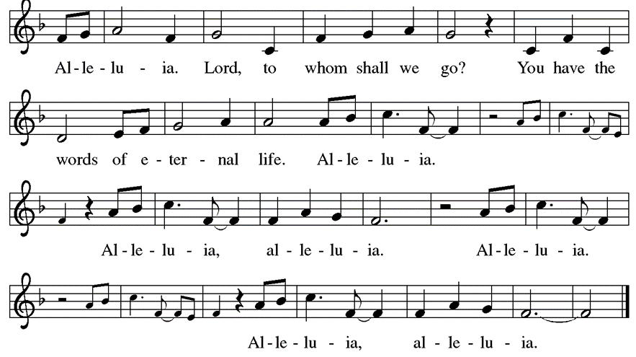

Gospel Reading: Luke 6:20-31
In echoes of the prophet Isaiah and Mary’s song of praise, Jesus reveals surprising things about who enjoys blessing and who endures woe. He invites his disciples to shower radical love, blessing, forgiveness, generosity, and trust even on enemies and outsiders. P: The Holy Gospel according to Luke. C: Glory to you, O Lord.
P: ²⁰ Then [Jesus] looked up at his disciples and said:
“Blessed are you who are poor,
for yours is the kingdom of God.
²¹ “Blessed are you who are hungry now,
for you will be filled.
“Blessed are you who weep now,
for you will laugh.
²² “Blessed are you when people hate you and when they exclude you, revile you, and defame you on account of the Son of Man. ²³ Rejoice on that day and leap for joy, for surely your reward is great in heaven, for that is how their ancestors treated the prophets.
²⁴ “But woe to you who are rich,
for you have received your consolation.
²⁵ “Woe to you who are full now,
for you will be hungry.
“Woe to you who are laughing now,
for you will mourn and weep.
²⁶ “Woe to you when all speak well of you, for that is how their ancestors treated the false prophets.
²⁷“But I say to you who are listening: Love your enemies; do good to those who hate you; ²⁸ bless those who curse you; pray for those who mistreat you. ²⁹ If anyone strikes you on the cheek, offer the other also, and from anyone who takes away your coat do not withhold even your shirt. ³⁰ Give to everyone who asks of you, and if anyone takes away what is yours, do not ask for it back again. ³¹ Do to others as you would have them do to you.” P: The Gospel of the Lord. C: Praise to you, O Christ.

Sermon Rev. Jeremiah Smith

Please stand as you are able.

Hymn of the Day: Borning Cry – ELW # 732
(printed next page)

Prayers of the People
WA: Gathered with one voice, we offer our prayers for the church, the world, and all who are in need. (a brief silence)

WA: God of all that is, delight in the praises of your people and revive the spirit of your church. Move through us with boldness so that we proclaim the gospel of Christ throughout the world. Renew and revive pastors, deacons, and lay leaders. Hear us, O God. C: Your mercy is great.

WA: God of all our days, guide the leaders of governments, nations, municipalities, and all those seeking office. Accompany election officials and volunteers. Dismantle injustice and oppression wherever it is found. Hear us, O God. C: Your mercy is great.

WA: God of comfort in troubled times, we pray for those in need of protection and care, especially those we name aloud or in the silence of our hearts…. Trusting that you are constant in mercy, protect those who seek safety and solace. Hear us, O God. C: Your mercy is great.

WA: God of what is yet to come, encourage and inspire those who give their time, talent, and treasure in service to your church. By their commitment, further the work of ministry in this place and uplift your gospel. Hear us, O God. C: Your mercy is great.

WA: God of time and space, we give thanks for the faithful departed. With thanksgiving we remember all your saints, Joan Bauer and William Elrod, Jr. Today we also honor the newly baptized, especially Emmet Dafchik, Oliver Paradowski, Max Paradowski, Cooper Tuzzo, Mac Bruns, Corrado Calandra, Westin Pizza, William Hoekstra, Isaac Hamm, Cole Stroczkowski, Finley Luss, Eliot Doyle, Samuel Ende, Hazel Nelson, Henry Nelson and Callen Pascucci. Sustain us in hope of our eternal unity in Christ. Hear us, O God. C: Your mercy is great.

WA: We offer these and all our prayers to you, O God, trusting in your grace and unyielding love, through Jesus Christ, our Lord. C: Amen.

Peace
P: The peace of Christ be with you always. C: And also with you.

Meal
God feeds us with the presence of Jesus Christ

Offering Congregation may be seated
We are grateful to those who help sustain our mission. To donate online, please use QR code:


Offering Prayer
WA: Let us pray together:
C: God of healing and hope, you bless those who are hungry, promising to fill them with good things. Fulfill that promise through us and these your gifts. Nourish us with the abundance of your feast and unite us into the blessed body of Jesus Christ our Savior, now and forever. Amen.

Please stand as you are able
+ Offertory Song “We are an Offering” ELW 692
We lift our voices, we lift our hands, we lift our lives up to you;
We are an offering. Lord, use our voices, Lord, use our hands,
Lord, use our lives, they are yours; We are an offering.
All that we have, all that we are, all that we hope to be-
we give to you, we give to you.
We lift our voices, we lift our hands, we lift our lives up to you;
We are an offering. We are an offering.

GREAT THANKSGIVING
P: The Lord be with you. C: And also with you.
P: Lift up your hearts. C: We lift them to the Lord.
P: Let us give thanks to the Lord our God.
C: It is right to give our thanks and praise.

Preface:
P: It is indeed right, our duty and our joy, that we should at all times and in all places give thanks and praise to you, almighty and merciful God, through our Savior Jesus Christ. By the witness of the saints you show us the hope of our calling, and strengthen us to run the race set before us, that we may delight in your mercy, and rejoice with them in glory. And so, with all the choirs of angels, with the church on earth and the host of heaven, we praise your name and join their unending hymn:

Holy Holy Holy ELw setting 8 (p. 190)
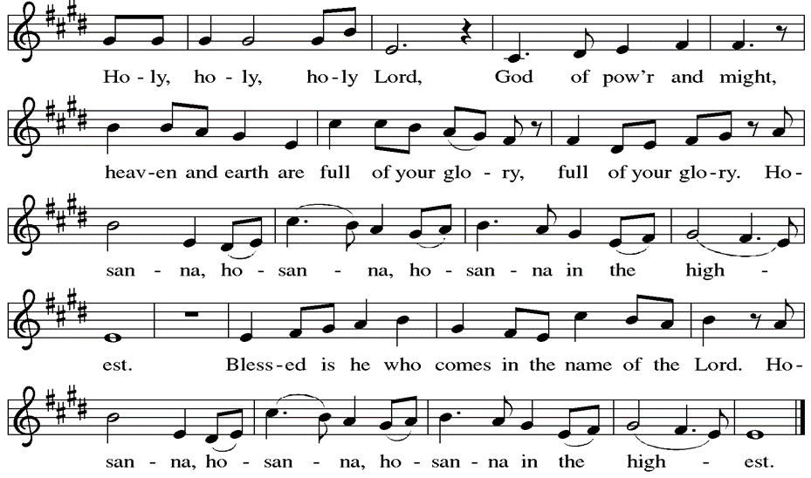

Thanksgiving at the Table

P: Holy God, you alone are holy, you alone are God. The universe declares your praise: beyond the stars; beneath the sea; within each cell; with every breath.
C: We praise you, O God.
P: Generations bless your faithfulness: through the water; by night and day; across the wilderness; out of exile; into the future.
C: We bless you, O God.
P: We give you thanks for your dear Son: at the heart of human life; near to those who suffer; beside the sinner; among the poor; with us now.
C: We thank you, O God.
P: In the night in which he was betrayed, our Lord Jesus took bread, and gave thanks; broke it, and gave it to his disciples, saying: Take and eat; this is my body, given for you. Do this for the remembrance of me. Again, after supper, he took the cup, gave thanks, and gave it for all to drink, saying: This cup is the new covenant in my blood, shed for you and for all people for the forgiveness of sin. Do this for the remembrance of me.
Remembering his love for us on the way, at the table, and to the end, we proclaim the mystery of faith.
C: Christ has died. Christ is risen. Christ will come again.

P: We pray for the gift of your Spirit: in our gathering; within this meal; among your people; throughout the world.
Blessing, praise, and thanks to you, holy God, through Christ Jesus, by your Spirit, in your church, without end.
C: Amen

Lord’s Prayer
P: Lord, remember us in your kingdom and teach us to pray.
C: Our Father, who art in heaven, hallowed be thy name, thy kingdom come, thy will be done, on earth as it is in heaven. Give us this day our daily bread; and forgive us our trespasses, as we forgive those who trespass against us; and lead us not into temptation, but deliver us from evil. For thine is the kingdom, and the power, and the glory, forever and ever. Amen.

Invitation to the Table
At Parkside Lutheran Church we have an open table. We believe the invitation to receive comes from Jesus himself and all are welcome at Christ’s table. More than just Bread and Wine these are tangible signs of God’s love for you! If you do not wish to receive communion but would like a blessing, come forward and cross your arms over your chest. The Pastor will give you a blessing before you return to your seat via the side aisle. You’ll receive communion bread* in your hands and a small cup containing white wine or grape juice. When giving the bread and cup, the communion ministers say:
“The body of Christ, given for you. The blood of Christ, shed for you.” and each person may respond: Amen. *Please let Pastor know if you need gluten-free bread

P: There is a place for you at the table of God. Come, receive the food that does not perish, a taste of life eternal.

The Communion Distribution

Communion Song ELW setting 8 (p. 191)
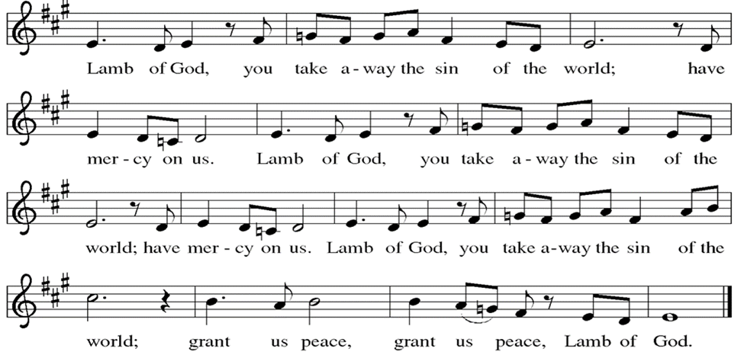

Communion Song: Sanctuary
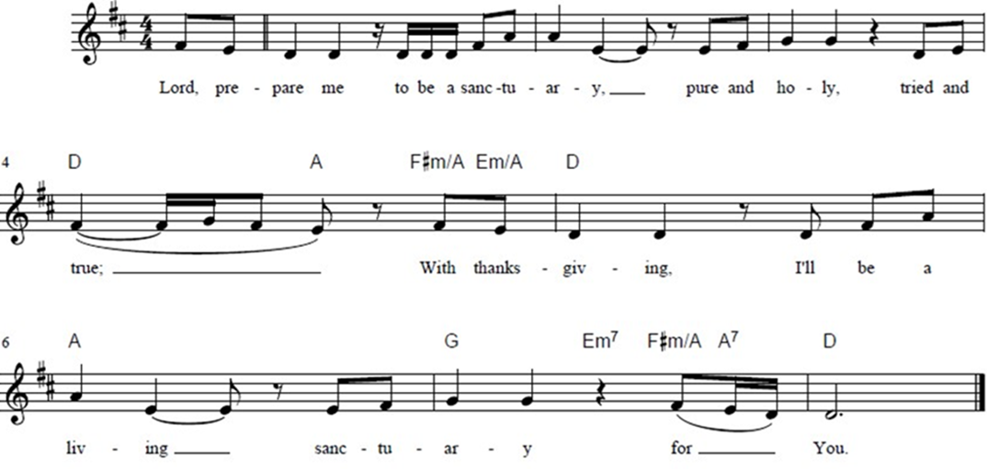

Post Communion Blessing
P: The Body and Blood of our Lord and Savior, Jesus Christ, strengthen you and keep you in God's grace. C: Amen.

Prayer After Communion
WA: Let us pray together.
C: God of field and flower, wheat and grape, you have nourished us with the bread of heaven that gives life to the world. Strengthened by the body and blood of your Son, send us out to gather your good gifts for all who hunger and thirst, and embolden us to love and serve in Christ’s name. Amen.

Sending - God blesses us and sends us in mission to the world.

Blessing
P: The love of God the Sovereign strengthen you, God the Son save, you and God the Holy Spirit anoint you for the work ahead. The holy Trinity bless you ☩ and grant you a faithful and courageous heart now and forever. C: Amen.

Sending Hymn: O When the Saints Go Marching In

Oh, when the saints go marching in, oh, when the saints go marching in,
O Lord, I want to be in that number when the saints go marching in.

Oh, when the Lord in glory comes, oh, when the Lord in glory comes,….

Oh, when the new world is revealed, oh, when the new world is revealed,….

Oh, when they gather round the throne, oh, when they gather round the
throne….

And on that hallelujah day, and on that hallelujah day,….

Dismissal and Postlude
WA: Parkside Lutheran Church is rediscovering the radical love of Jesus.
C: Gathering All. Serving All. Caring for All.
WA: Go in peace. Share the harvest.
C: Thanks be to God.

ELW Music licensed from Sundays & Seasons, Augsburg Fortress CCLI MUSIC License # 11440069 , CCLI
Streaming License#21835523 Do not duplicate any music or Liturgy herein without license and permission
To sponsor Altar flowers or a Soloist in honor of a loved one
or to mark a special occasion. Contact the office for more info.

PARKSIDE STAFF:
• The Rev. Jeremiah Smith: prjeremiahpsmith@gmail.com
• Kris Pope & Suzanne Gracie, Admin. Assistants (Church Office): parksidelutheran@gmail.com
• Mike Hooker, Music Director: mrhooker@me.com

CHURCH OFFICE HOURS: M/T/R 10:00am-3:00pm (716)836-1361

SCHEDULES and Events:
Acolytes: |  | Worship Assistants
11/2 – Lucy & Emmet |  | 11/2 - Susan
11/9 – Franklin & Hudson |  | 11/9 - Onda
Readers: |  | Ushers:
11/2 – Dave P. |  | 11/2 – Dave C. & Tom S.
11/9 – Sarah |  | 11/9 – John V. & Bryants

Coming up: contact office for more info – parksidelutheran@gmail.com, (716)836-1361
- November 12th – 7pm Brewing Theology at Steel Leaf Brewing

- November 16th – Breakfast Church
- November 19th – International Thanksgiving Dinner. Sign up to bring a dish to share, on our website, or via the QR Code ~~>

Visit our website for more information about these and other Events at Parkside – www.parksidelutheran.org/events


Detailed announcements and more are found in the e-newsletter. Sign up for e-newsletter on our website parksidelutheran.org or via constant contact with the QR code. You can find the full bulletin in the Worship section of our website www.parksidelutheran.org.

Parkside Lutheran Church - All Saints Sunday – November 2, 2025

In Loving Memory of: | Joan Bauer (recently passed)
Rick & Gail Hammond | Joseph & Julia Stoklosa
William (Bill) Elrod (recently passed) | John & Agnita Garrity
Don Frueh & Wilma Frueh | Caroline & Elmer Dye
Lucian Mascellino | Doris & Dick Carpenter
Stephen “Corky” Dafchik | Pat & Bob Putman
Kevin J. Sullivan | Sue Testa
Betty Gombert | Barbara Borkowski
Bill Rickerson | Sophia Eddy
George & Rita Witmer | Robert Hopkins
Henry & Rita Occhi | Debbie Doster Miller
Irene Scranton | Grace Flach
Thomas Kachelmeyer | Frank Martinez
David & Eleanor Scott | Jeff Donato
Barbara Holmes | John & Jean McNamara
Our Parents & Brother Rick
Catherine & George Mueller | In Honor of those Newly Baptized:
Marion Eldrige | Emmet Dafchik
Jim Russ | Oliver Paradowski
Clarence Russ, Sr | Max Paradowski
Sam Loiacano | Cooper Tuzzo
Gerry Loiacano | Mac Bruns
Robert Durkin | Corrado Calandra
Mabel Owens | Westin Pizza
Carl Seifert | William Hoekstra
Ramona Semilla | Isaac Hamm
Alice Ratajczak | Cole Stroczkowski
Therese McGreevy | Finley Luss
Sally Weidler | Eliot Doyle
Walter and Elizabeth Fantini | Samuel Ende
Sandra G. Lennert | Henry Nelson
Florence E. Lennert | Hazel Nelson
Maria Long | Callen Pascucci

