ALASKA SYNOD
2025 ADVENT DEVOTIONAL
A Visual Journey

I am very excited to announce that this years Alaska Advent Devotional will be new and different, and contributions are needed and wanted. This year it will be a VISUAL devotional. Each page will have a verse from the previous Sunday’s scriptures with a word highlighted for consideration.
Have you painted a picture, taken a photograph, beaded a hair barrette, sculpted a piece of clay lately? Does this piece of art express to you something like comfort or flood or rejoice or defend or ready?

Here is a sample –
READY COMFORT
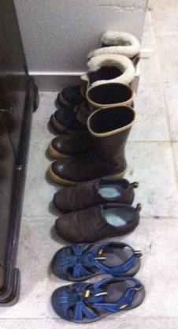
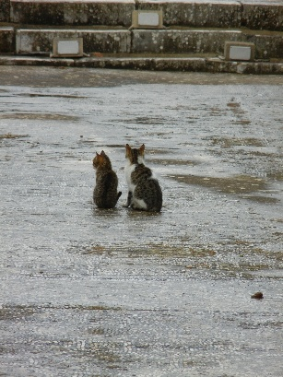
Please look over the following verses, pray about it, see what speaks to you.
- Tell a friend – maybe they have the perfect visual for this devotional.
- It would be better to pick visuals where people’s faces are not identifiable as this devotional will be widely distributed in both print and electronic form.
- Please send your pictures to me at pr.sandraak@yahoo.com
- Send questions to me as well.
- HARD DEADLINE for submissions – NOVEMBER 9th, 2025
- Happy looking, seeing, creating……
Advent 2025
Quotes taken from the previous Sunday’s scripture readings for Advent.

SUNDAY - Nov 30 – PATHS
Isaiah 2:3, "Come, let us go up to the mountain of the LORD, to the house of the God of Jacob, that he may teach us his ways and that we may walk in his paths.”

Dec 1 – READY
Matthew 24:44 “ Therefore you also must be ready, for the Son of Man is coming at an hour you do not expect.”

Dec 2 - LIGHT
Isaiah 2:5, “O house of Jacob, come, let us walk in the light of the LORD!”

Dec 3 - PEACE
Psalm 122: “For the sake of my relatives and friends I will say, ‘Peace be within you.’”

Dec 4 - GOOD
Psalm 122: “For the sake of the house of the LORD our God, I will seek your good.”

Dec 5 - SALVATION
Romans 13:11 Besides this, you know what time it is, how it is already the moment for you to wake from sleep. For salvation is nearer to us now than when we became believers.”

Dec 6 - AWAKE
Matthew 24:42 “Keep awake, therefore, for you do not know on what day your Lord is coming.”

SUNDAY - Dec 7 - BRANCH
Isaiah 11:1 “A shoot shall come out from the stump of Jesse, and a branch shall grow out of his roots.”

Dec 8 – SPIRIT
Isaiah 11:2 “ The spirit of the LORD shall rest on him, the spirit of wisdom and understanding, the spirit of counsel and might, the spirit of knowledge and the fear of the LORD.”

Dec 9 - DELIGHT
Isaiah 11:3-4” His delight shall be in the fear of the LORD. He shall not judge by what his eyes see or decide by what his ears hear…”

Dec 10 - DEFEND
Psalm 72:4 “May he defend the cause of the poor of the people, give deliverance to the needy, and crush the oppressor.”

Dec 11- WONDROUS
Psalm 72:18 “Blessed be the LORD, the God of Israel, who alone does wondrous things.”

Dec 12 - HOPE
Romans 15: “May the God of hope fill you with all joy and peace in believing, so that you may abound in hope by the power of the Holy Spirit.”

Dec 13 - VOICE
Matthew 3:3 “This is the one of whom the prophet Isaiah spoke when he said, "The voice of one crying out in the wilderness: ‘Prepare the way of the Lord; make his paths straight.’”

SUNDAY Dec 14 - BLOSSOM
Isaiah 35:1-2 “The wilderness and the dry land shall be glad; the desert shall rejoice and blossom; like the crocus it shall blossom abundantly and rejoice with joy and shouting.”

Dec 15 - STRENGTHEN
Isaiah 35:3 36 “Strengthen the weak hands and make firm the feeble knees.”

Dec 16 - FAITH
Psalm 146:5-6 “Happy are those whose help is the God of Jacob, whose hope is in the LORD their God, who made heaven and earth, the sea, and all that is in them; who keeps faith forever;”

Dec 17 - STRANGERS
Psalm 146:9 “The LORD watches over the strangers; he upholds the orphan and the widow, but the way of the wicked he brings to ruin.”

Dec 18 - MAGNIFIES
Luke 1:46b-47 "My soul magnifies the Lord, and my spirit rejoices in God my Savior.”

Dec 19 – GENERATION
Luke 1:50 “…. his mercy is for those who fear him from generation to generation.”

Dec 20 BLESSED
Matthew 11:6 “And blessed is anyone who takes no offense at me.”

SUNDAY Dec 21 - SIGN
Isaiah 7:14 “Therefore the Lord himself will give you a sign. Look, the young woman is with child and shall bear a son and shall name him Immanuel.”

Dec 22 - WEARY
Isaiah: 7:13 “Then Isaiah said, "Hear then, O house of David! Is it too little for you to weary mortals that you weary my God also?”

Dec 23 - RESTORE
Psalm 80:19 “Restore us, O LORD God of hosts; let your face shine, that we may be saved.”

Dec 24 - GRACE
Romans 1:7 “To all God's beloved in Rome, who are called to be saints: Grace to you and peace from God our Father and the Lord Jesus Christ.”

Dec 25 - JESUS
Matthew 1:21 “She will bear a son, and you are to name him Jesus, for he will save his people from their sins.”

