A Picture is worth A Thousand Words

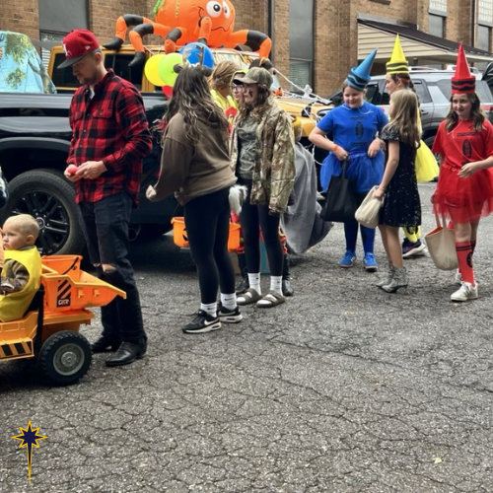
“They” say a picture is worth a thousand words. Pictures hold memories, place markers of events and people that are near and dear to our hearts. Pictures are visual stories of life events and treasured experiences. Pictures are a way in which we connect to the people and places of our lives that give us a deeper sense of meaning.
On my office desk sits a picture of a pastor with shiny, sweat covered forehead moments after his ordination service. And standing beside him is an attractive woman with long, wavy, brown hair (who that pastor was just months away from marrying at that time). The picture is from the night of my ordination. Mandy and I are standing in Grace Chapel, decked out in all of our “red” (because red is the color often used for the celebration of an ordination, resemblant of the Spirit that moved at Pentecost and had moved in the church yet again). I hope that as long as I have breath, I’ll always be able to remember that picture and that night.
Maybe you have a picture with similar importance in your life: a family portrait, a parent or grandparent, a picture of you and classmates from school who you are still connected closely with, your child’s first portrait, that cousin who lives on the other side of the country… This week we celebrate “All Saints Sunday.” One of our understandings in the Lutheran faith is that we are “simil justus et peccator,” which in English translates to “simultaneously saint and sinner.” While we are all captive to our sinfulness, we are all still saints of God!
On All Saints Sunday, it’s common practice to light candles in memory of our loved ones (some of those saints in our lives) who have died and gone before us into the promise of our resurrection hope. BUT, All Saints isn’t only for remembering the dead. It’s also for celebrating the living. Sunday, you are invited to bring pictures (that might be worth a thousand or ten thousand words) of your loved ones. I invite you not only to bring pictures of loved ones who have died, but also pictures of those who are living, though they might be separated from us by location. This Sunday we will celebrate those not only who have gone before us, but also for those who have been baptized in this past year. We will light candles in their honor and memory, and we will also tape their pictures up around us in the worship space.
With all of the pictures, each that hold their own wonderful story, we will see and sense the wonder of God’s story and the relationships that through God we have been blessed with in our lives.
Speaking of pictures and blessings… this past Sunday evening, we held our annual “Trunk or Treat” event. That event was a blessing! We gathered with fellow members of Bethlehem, friends from Clinton Tabernacle AME Zion, and some 600-700 folks from our surrounding communities. Sunday evening was nothing short of amazing! If you weren’t able to be present for our “Trunk or Treat” event, I especially want to invite you to click on the following link, which will take you to an album of pictures that tell a great story of what took place this past Sunday. One of those pictures you can see at the top of this reflection.
See Trunk or Treat Pictures Here: https://photos.app.goo.gl/1V24F2Wz3rCCGLAv9
We look forward to seeing you, and your pictures as we gather to worship among the saints this Sunday!

The Peace of Christ be with y’all,

Pastor Vern

