

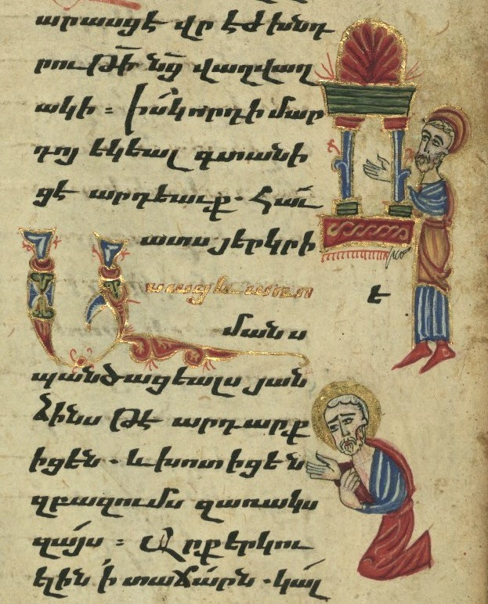

26 October 2025, Pentecost 20
Family Eucharist

Service outline, Parish News & Events

Today we welcome Rev. Matthew Humphrey as our Preacher and Celebrant at both services; Fr. Allen has been on a study week and will be back tomorrow, Monday the 27th.
8 am HOLY COMMUNION__________________
Celebrant and preacher: Rev. Matthew Humphrey
9.30 am FAMILY COMMUNION________________
Celebrant and preacher: Rev. Matthew Humphrey
The Gathering of the Community
Worship Songs
Welcome
Territorial Acknowledgement
Greeting BAS 185
Song of Praise Gloria (Glory to God) tune: Pulkingham
The Story of Faith is Proclaimed
Children’s Time – Come and See the Light
First Reading: Joel 2:23-32
Gospel Acclamation: Alleluia (sung)
Gospel: Luke 18:9-14
Gospel Acclamation: Alleluia (sung)
Sermon
A short period of silent reflection follows,
signalled by the sound of a bell
Collect
Confession and Absolution BAS 191
The Peace BAS 192
Offertory Hymn
Prayer over the Gifts ELW (2006) alt
The Celebration of the Eucharist
Eucharistic Prayer BAS 193 #1
Sanctus: Holy, holy, holy Lord
The Lord’s Prayer (sung) BAS 211
Breaking of the Bread BAS 212 #3
The Communion
Music during Communion
Prayer after Communion EVL (2006) alt
Doxology (Glory to God) BAS 214
Announcements & Birthday Box
Blessing BAS 683 i
Closing Song
Dismissal

Welcome to St Philip!
Please join us for coffee and fellowship after the 9.30 service.
The abbreviation BAS in the service order refers to page numbers in the Book of Alternative Services, the green volume in the pews. CP is Common Praise, the blue hymn book.
Welcome to Communion
We want you to feel welcome at St. Philip. All are encouraged to come forward to receive the bread (communion wafer) and wine. If you prefer to receive a blessing, please keep your head and hands down. If you are more comfortable not drinking from the cup, you may keep your head down and let it pass, or return to your pew after receiving the bread. Please tell the person distributing the bread if you require a gluten-free wafer. Prayer Ministers are available during Communion at the 9:30 am service, at the side of the altar.

Offering
It is Anglican custom to receive a financial offering in our worship, as an expression of gratitude to God. Please do not feel compelled to participate in this offering. Your presence is gift enough.

Services this week
26 October 2025 - 20th Sunday after Pentecost
8am Holy Communion - Celebrant and preacher: Rev. Matthew Humphrey
9am Community Prayers downstairs in the youth room
9.30am Holy Eucharist, in-person & streamed via Facebook Live
Celebrant and preacher: Rev. Matthew Humphrey
Altar Guild: Felicity Bradley, Karen Fenimore
Usher: Bruce Fyfe
Musicians: Alix and Chris Harvey, Ceal and Ged McLean, Gillian Rhodes, Sharon Richmond, Rev. Matt
Readers: Catherine Morris, Florie Varga
Prayers of the People: Lisa Alexander
Children's ministry: Melinda Weicker
Powerpoint slides: Clayton Savage
Facebook Live: Karishma Iyer
Coffee: Barb Evans-Ehricht
Offerings counters: Betty Davidson, Dorothy Dahli
28 October, Tuesday 10.30am Contemplative Prayer
30 October, Thursday 10am Holy Communion followed by coffee and book study (starts about 10.30).
Parish News & Notices
Parish Council meeting
There will be a regular meeting of Parish Council tomorrow, Monday, October 27, 2025 at St Philip. All are welcome to attend.
Contemplative Prayer
Please join us on Tuesday mornings, 10:30 - 11:30, meeting in the choir area of the nave (at the front of the church), for a 20 minute contemplative sit with a time of prayer following.

Calendars have arrived
For those who ordered 2026 church calendars, it's time to collect them in the church office. The final price (at cost) was $6.60 per calendar. This includes taxes - shipping was free thanks to the bulk order. To pay:
- cash or cheque in an envelope (separate from offerings/donations) labelled "RECOVERY - CALENDARS" and your name, in the collection or left in the office, or
- e-transfer to treasurer@stphilipvictoria.ca , message "CALENDARS"
If you would like a church calendar and did not order one through the church office, they are available to order online for $8-10 each plus taxes & shipping.
Pump Up the Pantry at Shelbourne Community Kitchen
The Kitchen's fall food drive continues through October. A box for donations is at the back of the Church. To donate directly via their website: https://www.shelbournecommunitykitchen.ca/support-our-work/ . The most needed items right now are:
- Canned proteins (tuna, ham, chicken, fish)
- Canned plain beans (kidney, black, white, lentils)
- Canned tomatoes
- Pasta Sauce
- Toilet Paper
- St Philip Missions committee
Long-term Housing Rental Request
Our family of five (2 adults, 3 children) is looking for a long-term rental property (2-3 bedroom apartment or house) in the Greater Victoria or Saanich Peninsula area with the move-in date at the beginning of January 2026. If you have a suitable place available or anticipate availability around this date, please contact Lucie at 778-533-7877 or lucie.kotesovska@seznam.cz . Thank you very much for any tips and information.
- Alecs and Lucie Kotesovsky.
Thursday book study schedule
Saved From Sacrifice: a theology of the cross. Zoom link is in the e-newsletter, or request from the office.
- Oct 29/30 – Chapter 3, Part 2, pp. 84-104
- Wed, Oct 29, 7 pm Zoom Study
- Thurs, Oct 30, 10 am Eucharist + Study (study starts at approx. 10:30 am)
- Nov 5/6 – Chapter 4, pp. 107-132
- Wed, Nov 5, 7 pm Zoom Study
- Thurs, Nov 6, 10 am Eucharist + Study (study starts at approx. 10:30 am)
- Nov 12/13 – Chapter 5, pp. 134-164
- Wed, Nov 12, 7 pm Zoom Study
- Thurs, Nov 13, 10 am Eucharist + Study (study starts at approx. 10:30 am)
- Nov 19/20 — No Zoom study and no Midweek Eucharist or in-person study
- Nov 26/27 — Chapter 7 pp. 192-215
- Wed, Nov 26, 7 pm Zoom Study
- Thurs, Nov 27, 10 am Eucharist + Study (study starts at approx. 10:30 am)
- Dec 3/4 — Chapter 8, Part 1 pp. 219-236
- Wed, Dec 3, 7 pm Zoom Study
- Thurs, Dec 4, 10 am Eucharist + Study (study starts at approx. 10:30 am)
- Dec 10/11 - Chapter 8, Part 2 pp. 236-259
- Wed, Dec 10, 7 pm Zoom Study
- Thurs, Dec 11, 10 am Eucharist + Study (study starts at approx. 10:30 am)
Drop-In Knitting Evening
Bring your knitting project (or your mending basket) Thursday, November 6, 7:00 - 8:30 pm at the Richmonds'. Enjoy a cup of tea and if it’s a blustery night, a fire in the fireplace. If you don’t know how to knit, someone will be there to get you started, or help you out if you get tangled! Email sharonlrichmond @gmail.com for the address.
Teens & Twenties Games Night – Halloween edition, Friday, Oct 31
WE HAVE BEEN DOING BOARD GAME NIGHT FOR A WHOLE YEAR! This month's board game night falls on Halloween! A lot of the attendees are excited about this coincidence and have taken it upon themselves to make the night special!
Tell all the teens and 20-somethings you know - BOARD GAME NIGHT IS AFOOT!
Date: Friday 6:30-9:30pm, 31 Oct - Halloween costumes strongly encouraged!
Where: St. Philip Anglican Church, 2928 Eastdowne - entrance to the lower level through the pathway by the garden at the side of the building - follow the signage!
Feel free to drop in or leave at any time. There are bus stops for buses 4, 9, 7, 11, and 15 within walking distance from the church.
Questions?: Contact Karishma at ms.shrutikarishma[at] gmail.com
Community Karaoke Night – 14 November
We have the microphones, the songs, the snacks and the (non-alcoholic) drinks, and all we need is you! Feel free to bring your friends, families, snacks and (non-alcoholic) drinks with you as well, because this is an all age karaoke event!
Whether you’re a first time singer or a veteran, this is a safe space for you to let it out and let loose! Feel free to belt out your inner baby shark, pop and country diva, rockstar and everything in between without a care in the world!
Date: 2nd Fridays - 14 November and 12 December 2025; 9 January, 13 February, 13 March, 10 April 2026
Location: downstairs hall at St Philip’s Anglican Church @ 2928 Eastdowne Road, Victoria, BC, V8R 5R8 - step-free ramp entrance from the parking lot. Follow the sign!
Feel free to drop in or leave at any time. You can access the church within walking distance through buses 4, 9, 7, 11, and 15.
See you then! If you have any questions, please reach out to Anderson at bvsdawnofnewyear@gmail.com!
Newcomers’ Lunch
If you are new to St. Philip in the last year and would like to get to know a bit more about other newcomers, meet Fr. Allen, and chat about the "ins-and-outs" of what makes our faith community tick, then this is for you: A Newcomers Lunch hosted by Rob and Brenda Hosie at their house (2911 Seaview Rd) starting at approximately 12 pm on Sunday, November 16th. Fr. Allen will attend as will a few of our Council members. It's fun, the food is provided, and you'll have opportunity to listen to others share their experiences, share your own, and dialogue over and questions that arise. See you there!
- Allen+
Missing offerings envelope
An envelope (just the envelope) went missing during counting of the offerings 2 weeks ago. The money has been safely deposited as usual, but we need to know who it came from so the donation can be accredited to the right donor, to ensure that their 2025 tax receipt is correct. If someone remembers giving $125 in cash, in a numbered St Philip envelope, on Sunday 5 October, please contact Betty Davidson, Leslee Scott, or Anna Sander in the office to confirm.
- Offerings Secretaries
Paddling Together: The Village Workshop at St Mary's Oak Bay, Tuesday 28 October
During this experiential workshop we will explore our personal role in supporting the revival of the values that worked so beautifully in Indigenous villages for thousands of years. We will also explore in-depth the affects of Residential Schools and Canada's Policy of Assimilation. This workshop is geared to solutions rather than recrimination and is a great forum in which to ask questions. Please see St Mary’s website or ask at the office for details.

SHORT NOTICE: Gonzales Preschool wreaths & poinsettias
Adorn your home this holiday season with a festive and fragrant Evergreen Wreath, Evergreen Door Swag, Poinsettia or Christmas Cactus. We have also added one of a kind, preschool community greeting cards this year! Locally grown and crafted on Vancouver Island, these holiday decorations will last all season long!
- Evergreen swag $25
- Evergreen wreath $35
- Preschool holiday cards, pack of 10 $20
- Poinsettia 6.5" - red, white or pink $14
- Christmas cactus, 4" $7
Orders are due this Wednesday October 29, 2025
Pick up in the parking lot at St. Philip on Saturday, November 29, 2025, from 10am to 12pm, with Bake Sale & Craft Sale by donation!
The children and families of Gonzales Cooperative Preschool thank you for your support!
Order online: gonzalespreschool.paperform.co
We Together 2025 – diocesan conference:
Friday, November 14, 2025 @ St Paul's, Nanaimo
We Together is our biennial diocesan conference to remind us of the ways we are connected; we are stronger together. We are bound in countless ways, in our structures, in our prayers, and through the stories we tell. We are each other's concern, and we are each other's gift. This year is God is not Elsewhere. The God of our scriptures and stories, the God of our traditions and rites, the God who whispers through music and poetry, is the God moving here & now.
Friday evening program: banquet at St Paul's in Nanaimo and opening address. Saturday: full day of workshops at St. Paul's . Speakers: John Thatamanil, Jonathan Thomas, Jenny Replogle, Christine Conkin, Gordon Smith, Brendon Neilson and Denise Doerksen.
Registration deadline: 3 November – see the diocesan website bc.anglican.ca
St Luke’s Cedar Hill - Choral Evensong of Remembrance
You are invited to St. Luke's Church (3805 Cedar Hill Cross Road) next Sunday, November 2 at 7 pm for a special musical service to honour All Saints'/All Souls' Days. As well as the beautiful liturgy and music of a sung Evensong service, special music will be presented by flutist Mary Byrne, bassoonist Matthew Robertson, and bell ringer Maria Ross. All are welcome. Please bring a friend.
Shelbourne Community Kitchen Jazz Bar: Monday, October 27 | Broad View United (3703 St. Aidan’s Street). Show at 7pm | Doors open at 6:30pm
Our 2025 headliners are two powerhouse vocalists, Stephanie Greaves and Maureen Washington, performing with an absolutely stellar band: Attila Fias on piano, Kelby McNayr on drums, and Ryan Tandy on stand-up bass. It will be an unforgettable night of world-class jazz, shared laughter, and community connection.
Your $75 ticket includes your choice of delicious dessert or savoury appetizer, and one drink of your choice. See the Kitchen website for details & online ticket purchase link.
Prayers & readings for Sun 26 October & the following week:
We pray for Anna, our bishop, and Allen, our rector. In our parish cycle of prayer, we pray for children's ministry, for our children's ministry worker, and for the children of the parish.
Diocese: the people of St Philip by the Sea, Lantzville, and their visiting clergy and lay leaders.
Anglican Church in Canada: The Most Rev. John Stephens, Archbishop, and the clergy and people of the Diocese of New Westminster; for an end to gender-based violence and human trafficking.
Anglican Communion: The Church in Wales

Collect: God beyond our knowing, we make you into an idol to serve our own needs. Humble our arrogance by the strangeness of your coming and the wonder of your mercy; through Jesus Christ, the friend of Pharisees and tax collectors. Amen. (Prayers for an Inclusive Church (2009))
Anglican Communion Cycle of Prayer for the week:
- Mon 27 Oct Diocese of N. Philippines – The Episcopal Church in the Philippines
- Tues 28 Oct Diocese of S. Philippines – The Episcopal Church in the Philippines
- Wed 29 Oct The Diocese of Phulbani – The Church of North India (United)
- Thurs 30 Oct The Diocese of Pittsburgh – The Episcopal Church
- Fri 31 Oct The Diocese of Polynesia – The Anglican Church in Aotearoa, New Zealand and Polynesia
- Sat 1 Nov The Diocese of Popondota –Anglican Church of Papua New Guinea
Lectionary for Sunday 26 October (Pentecost 20): Joel 2:23-32 and Psalm 65 OR Sirach 35:12-17 or Jeremiah 14:7-10, 19-22 and Psalm 84:1-7; 2 Timothy 4:6-8, 16-18; Luke 18:9-14.
Daily readings below are related to the weekly Sunday Gospel lection and sermon.
- Mon 27 Oct Ps 84:8-12; 1 Samuel 2:1-10; 1 Peter 4:12-19
- Tues 28 Oct Psalm 84:8-12; Daniel 5:1-12; 1 Peter 5:1-11
- Wed 29 Oct Psalm 84:8-12; Daniel 5:13-31; Matt 21:28-32
- Thurs 30 Oct Ps 32:1-7; Prov 15:8-11, 24-33; 2 Cor 1:1-11
- Fri 31 Oct Psalm 32:1-7; Job 22:21-23:17; 2 Peter 1:1-11
- Sat 1 Nov Psalm 32:1-7; Isaiah 1:1-9; John 8:39-47

This week's retro recipe from the parish cookbook 1976
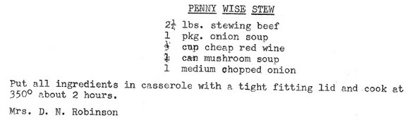
Cover image: Armenian Gospel Book, Publican and the Pharisee, Walters Manuscript W.540, fol. 179r (detail). Public domain. Source for photo and description: Walters Art Museum, Baltimore MD. https://www.flickr.com/photos/39699193@N03/8510942038/
This manuscript was executed in 1475 by a scribe identified as Aristakes, for a priest named Hakob. It contains a series of 16 images on the life of Christ preceding the text of the gospels [in Armenian], as well as the traditional evangelist portraits, and there are marginal illustrations throughout. The style of the miniatures, which employ brilliant colors and emphasize decorative patterns, is characteristic of manuscript production in the region around Lake Van during the 15th century. The style of Lake Van has often been described in relation to schools of Islamic arts of the book.
Rector: Rev. Allen Doerksen (incumbent@stphilipvictoria.ca,
work cell 236-508-2928; day off: Friday)
Warden: Judith Armstrong (jarmstrong@stphilipvictoria.ca)
Warden: Larry Anthony (lanthony@stphilipvictoria.ca)
Parish Office Hours: Mon 1-4.30, Wed & Thurs 9-4.30
250-592-6823 | admin@stphilipvictoria.ca
Facebook including live streams: https://www.facebook.com/stphilipoakbay
Instagram: https://www.instagram.com/stphilipoakbay/
Thank you for avoiding scented products at church.

