This Week at PPBC

Tuesday, October 28, 2025


Wednesdays @ 6:30pm



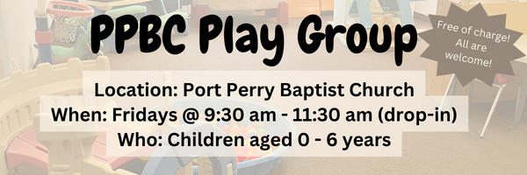Friday, October 31, 2025

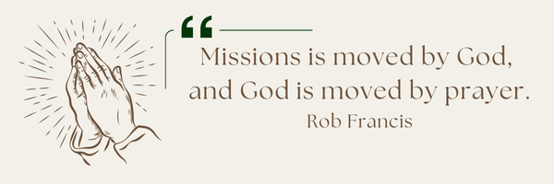
A Prayer Request from Anjou: Pray for Rene as he works with Wisme who is taking on more leadership responsibilities. The Anjou church is now being recognized for their work but still have work to do to be fully part of the fellowship. The biggest part is having a pastor before he turns 80 in a few years. Praise God for increased attendance at Sunday services.

Notes

Sunday Ministry Schedules
Below are ministry schedules for Nursery, Jr. Church, Greeters, Ushers, and Sound & Video:
Nursery
Oct 26: Jen Werner, Audrianna Angrove
Nov 2: Brenda Clemens, Brantley Colwell
Infant Nursery
Oct 26: Laura Saunders, Amber Saunders
Nov 2: Stephanie Anderson, Rosalie McLaren
Jr. Church; ages 3 to grade 1
Oct 26: Ellianne McLaren, Hailey Ferguson
Nov 2: Deb Brown, Kelsey Schoenrock
Jr. Church; Grades 2 to 6
Oct 26: Mary Deli, Kim St-Onge
Nov 2: Kate Anderson, Tiffany Green
Greeters
Oct 26: Leno & Donna Araujo
Nov 2: Fern & Kim St-Onge
Ushers
Oct 26: Mark McLaren, Paul Sammut
Nov 2: Leno Araujo, Gregg Anderson
Sound & Video
Oct 26: Sound: Wyatt Werner | Video: Josh Myers
Nov 2: Sound: Jordan Anderson | Video: Josh Bolsonello

Morning Service
Song – When We All Get to Heaven
Welcome
Song – And Can it Be
Philippians 1:3-6
Song – All My Ways
John 15:16 – 16:15
Prayer
Song – Holy Spirit
Message – Pastor Jim Clemens
Song – All Praise to Him


All are welcome to attend our time of Worship and discussion.

Praise & Prayer Highlights
PRAY for our nursery ministry. PRAY for wisdom and discernment as we look to accommodate for our growing numbers in the nursery. PRAY that God would sustain our volunteers and grow us in our faithfulness to Christ.
PRAY for Joan Mabley's ongoing health & recovery as she is now home. PRAY for her and the family as they look for care to meet Joan's needs.
PRAY for Rob & Shelley VanUden's 6yo great-niece Bryte and her family. PRAY for her health and for the family as they try to make decisions on her care.
PRAY for Bert & Ada Faber and their ongoing health concerns.
PRAY for Dave and Mari Deli. Dave was in an ATV accident and is in saint Mikes Hospital for observation. Please PRAY that God would provide wisdom and clarity for the doctors in their diagnosis and treatments. PRAY for Dave's physical and spiritual health and healing and for Mary as she looks to love and care for her husband.
PRAY for Dennis Tomcheski and his ongoing health concerns.
PRAY for Barbara Fry and the Werner family as they mourn the loss of Ron. PRAY for Barbara, Roy, Elizabeth and the family as they make preparations for a service. PRAY that God will give them great comfort in Christ and that the truth of the Gospel will shine through this loss.
Giving
Just as a reminder, there are several ways you can give:
In Person using the offering box located on the back wall of the sanctuary. Donation envelopes are available at the Welcome Centre. Please contact the church office if you would like a box of donation envelopes (office@portperrybaptist.ca)
Through your online banking, you may send electronic transfers to ppbcdonations@gmail.com.
You can also give through Canada Helps. Donation receipts will be provided by Canada Helps, and transaction fees apply.
***********************************************************************
Weekly Newsletter
The PPBC Newsletter is emailed to the church family every Friday. If you would like to be added to the weekly email list, please contact the office by phone: 905-985-8681 or by email: office@portperrybaptist.ca.
*****************************************************************
Church Information:
Location:
2210 Hwy 7A
Port Perry, ON
L9L 1B4
Office Hours:
Monday: 8:30am – 4:00pm
Tuesday: 8:30am – 4:00pm
Wednesday: Closed
Thursday: 8:30am – 4:00pm
Friday: 8:30 am - 3:00 pm
Contact:
Phone: 905.985.8681
Email: office@portperrybaptist.ca
Website: www.portperrybaptist.ca
Staff:
Sr. Pastor – Rev. Jim Clemens
Administrative Assistant – Madeline Werner
Family Ministries Director – Josh Anderson

PPBC Newsletter
Sunday, October 26th, 2025


Sunday Starting Point
Sunday, October 26, 2025 - 9:30 am
“Beginning the day with the Word and prayer”
Adults:
Adults will meet in the sanctuary for a time of study and prayer. Psalm 140.
Youth:
Jr High (Grades 7-8) will meet in room 18 with Kate Anderson to study the book of Ephesians.
Children:
Children ages 3 - grade 6 will meet in room 26
(Please note nursery is unavailable during Starting Point)
Sunday Morning Worship
Sunday, October 26, 2025 - 10:30 am
We are meeting in the sanctuary and will continue to live-stream for those who are unable to attend.
Message: The Church’s Mission Begins
Scripture: Acts 1-4
Pastor Jim Clemens

