Name of Assembly: United Apostolic Church
Type of service: Bible Study
Date: October 21st, 2025
Series Topic: “Questions from Corinth”
Lesson 3: “Is it okay to tolerate sin in the church?”
Scripture Text: 1 Corinthians 5; 2 Corinthians 2:6-8

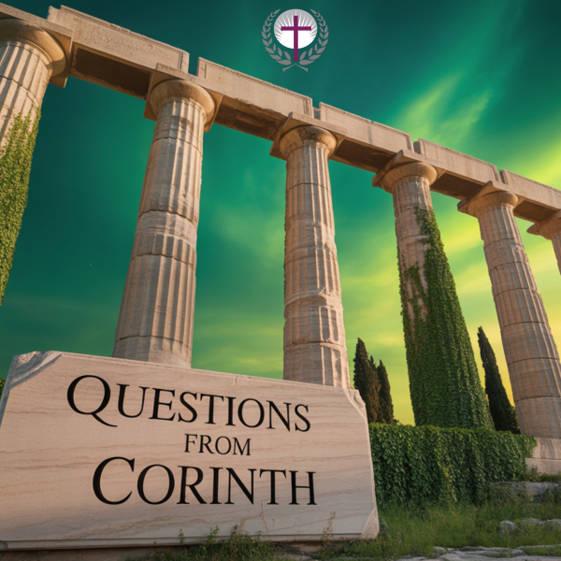
INTRODUCTION

In this third lesson, we’ll explore one of the most challenging issues Paul confronted in his first letter to the Corinthians: how the church should respond when serious, unrepentant sin is present and seemingly tolerated within its community.

Paul’s forceful directives on addressing sin were crucial for preserving the church’s witness, purity, and spiritual health. He understood that unchecked sin could contaminate the entire body, hindering its growth and its mission to represent Christ to the world.

The apostle’s words remain relevant for believers today, as many churches often grapple with similar questions of holiness, grace, accountability, and compassion. How do we balance love for an individual with the integrity of the community? What is the church’s role in confronting sin, and what are the ultimate goals of such confrontation?

This lesson aims to provide deeper insight into Paul’s inspired guidance, helping us understand the gravity of sin, the importance of church discipline, and the aim of restoration for both the individual and the community.

Corinth: The Immorality Capital of the Ancient World

Corinth’s widespread sexual immorality was deeply connected to the prominent cult of Aphrodite. The temple was known for its ‘sacred’ temple prostitutes, making promiscuity an accepted, even revered, part of daily life and public culture.

The Corinthians Church existed in a society where idol worship and sexual immorality were often religiously accepted; as a result, they faced significant pressure to conform to the widespread cultural acceptance of sexual immorality and pagan practices.

The Sin That Shocked Even the Pagans

“It is reported commonly that there is fornication among you, and such fornication as is not so much as named among the Gentiles, that one should have his father’s wife.”

Within the Corinthian church, a shocking scandal took place: a man was openly involved in an incestuous relationship with his father’s wife—an act clearly forbidden by biblical law.

- “The nakedness of thy father’s wife shalt thou not uncover: it is thy father’s nakedness” ( Leviticus 18:8 - KJV).

The woman is identified as the man’s “father’s wife” rather than his biological mother, suggesting that she was his stepmother.

The Greek verb for “have” implies a current, ongoing relationship, not a past sinful act. Some commentaries suggest the man may have married his stepmother after his father’s death, but it was still considered incestuous. Other commentaries opined that the man’s father was still alive and that she may have been divorced.

What made this situation even more alarming was that such behavior was condemned not only by Jewish law but also by Roman law and pagan moral standards. Even unbelievers recognized this as unacceptable. Yet, the Corinthian church tolerated this sin. Living in blatant defiance of divine and natural law, this man was permitted to remain in full fellowship—unconfronted, unrebuked, and without consequence. Their silence could be interpreted as an endorsement.

“And ye are puffed up, and have not rather mourned, that he that hath done this deed might be taken away from among you” - 1 Corinthians 5:2.

Instead of mourning this sin, the church became arrogant and self-satisfied. Paul states they were “puffed up” about their tolerance. This puffing up indicates spiritual arrogance—a false sense of enlightenment that led them to boast about their “open-mindedness” or “inclusivity” while blatantly disregarding God’s clear moral standards.

The complacency toward this sin jeopardized the church’s purity, weakened its witness to nonbelievers, and endangered its spiritual health.

THE BIBLICAL RESPONSE

“ ³ For I verily, as absent in body, but present in spirit, have judged already, as though I were present, concerning him that hath so done this deed, ⁴ In the name of our Lord Jesus Christ, when ye are gathered together, and my spirit, with the power of our Lord Jesus Christ, ⁵ To deliver such an one unto Satan for the destruction of the flesh, that the spirit may be saved in the day of the Lord Jesus”- 1 Corinthians 5:3-5.

STEP # 1 - Confront the Sin!

- Paul’s command to “purge out the old leaven” (1 Corinthians 5:7) emphasizes the importance of confronting unrepentant sin directly, with clarity and firm conviction. This is not about condemnation but about a caring appeal to conscience and a call for repentance.

- Paul aimed to awaken the sinner to the seriousness of their actions, which dishonor Christ and damage the community. This approach aligns with the principles of restorative justice found in scripture, emphasizing personal responsibility and the need for a change of heart, as seen in Matthew 18:15-17, where confrontation is outlined as a necessary first step toward reconciliation.

- “¹⁵ Moreover, if thy brother shall trespass against thee, go and tell him his fault between thee and him alone: if he shall hear thee, thou hast gained thy brother. ¹⁶ But if he will not hear thee, then take with thee one or two more, that in the mouth of two or three witnesses every word may be established. ¹⁷ And if he shall neglect to hear them, tell it unto the church: but if he neglect to hear the church, let him be unto thee as an heathen man and a publican” – Matthew 18:15-17.

- This process involves several key principles:

  - Initiative: “Go!” is an imperative, meaning you should take the first step to address the issue rather than letting it fester or turning to gossip.
  - Privacy: The conversation should be kept “between thee and him alone” to protect both parties’ dignity and avoid public shaming.
  - Goal: The ultimate aim is reconciliation and restoring the relationship (“if he shall hear thee”) rather than seeking victory or revenge.
  - Love and humility: The confrontation should be done with love, humility, and respect, recognizing our own imperfections and the importance of grace.
  - Gaining the brother: If the person listens and the issue is resolved, the goal of reconciliation is achieved.

STEP # 2 - Reclaim the Sinner!

- The ultimate goal of church discipline is always the spiritual healing and restoration of the wandering believer. Paul explicitly states this in 2 Corinthians 2:6-8, urging the Corinthians to forgive and comfort the repentant man, lest he be overwhelmed by excessive sorrow.

- “⁶ Sufficient to such a man is this punishment, which was inflicted of many. ⁷ So that contrariwise ye ought rather to forgive him, and comfort him, lest perhaps such a one should be swallowed up with overmuch sorrow. ⁸ Wherefore I beseech you that ye would confirm your love toward him” - 2 Cor. 2:6-8

- Like the shepherd seeking the lost sheep (Luke 15:3-7), the church’s primary concern is to bring the individual back into fellowship with God and the community. This requires immense patience, compassion, and humility, ensuring that confrontation is not punitive but redemptive, motivated by the desire to see a brother or sister genuinely turn from sin and return to Christ.

- “³ And he spake this parable unto them, saying, ⁴ What man of you, having an hundred sheep, if he lose one of them, doth not leave the ninety and nine in the wilderness, and go after that which is lost, until he find it? ⁵ And when he hath found it, he layeth it on his shoulders, rejoicing. ⁶ And when he cometh home, he calleth together his friends and neighbours, saying unto them, Rejoice with me; for I have found my sheep which was lost. ⁷ I say unto you, that likewise joy shall be in heaven over one sinner that repenteth, more than over ninety and nine just persons, which need no repentance” – St. Luke 15:3-7.

STEP # 3 - Protect the Community!

- “⁶ Your glorying is not good. Know ye not that a little leaven leaveneth the whole lump?” – 1 Corinthians 5:6.

- Paul uses the vivid analogy of leaven corrupting the entire batch of dough (1 Corinthians 5:6) to illustrate how tolerated sin can spread and contaminate the whole church.

- Just as a small amount of yeast permeates and transforms an entire batch of dough, a little tolerated sin can corrupt a congregation as a whole.

- Sin begins Small - What starts as one person’s private compromise seems manageable at first.

- Sin Spreads - Others observe the tolerance and begin to excuse their own sins or adopt similar behavior.

- Church Corrupted - Eventually, the entire community's standards erode, and holiness becomes optional.

- Unaddressed sin compromises the church’s witness to the world, undermines its purity, and can lead other believers astray. By addressing sin, the church maintains its distinction as a holy people set apart for God’s purposes (1 Peter 1:15-16). This protective measure safeguards the spiritual health of the congregation, preserves the integrity of the gospel message, and ensures a healthy environment where believers can grow in Christlikeness without the corrosive influence of ungodly behavior.


In essence, Paul’s burden reflects a deep pastoral care for both the individual caught in sin and the church’s collective purity. His directives are not harsh rules but loving guidance, rooted in the understanding that true freedom and spiritual vitality are found in living lives that reflect Christ’s transformative power.

