*For more information about this*

*Our mailing address is Oasis Youth Ministries PO Box 445, Holbrook, AZ 86025*

*ministry or to join our prayer*

*and support team,*

*you can go online to*

*www.oasisyouthministries.com*

Dear Friends and Family, July 2025

Howdy from hot Holbrook, AZ; we pray you are well! We are in the time of the year known as monsoon season (July and August), although we have not yet had much precipitation in Holbrook. Praying for rain is an ongoing activity in Arizona, and parts of the state are currently plagued by fires—rain would certainly be welcomed and prayers for it much appreciated!

While the Well has been on a summer hiatus, Oasis has stayed reasonably busy. During the first week of June we had several teens and adults who took part in helping lead Hopi Camp (a Christian summer camp for Hopi young people) held at American Indian Christian Mission near Show Low, AZ. We were also blessed to once again have the Gospel Lights team from Kentucky who came out and were a huge help. It is always great to see them! The camp went very well; eleven young people prayed to receive Christ! Also, Shivanna, one of our former students, taught the teen Bible study out of Romans 12 for the week and she did a fantastic job! It is such a blessing to see someone God has allowed us to pour into over a 3-year period step up to lead and teach!

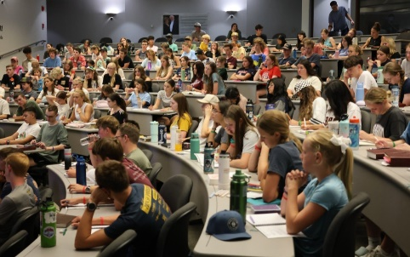

From June 22-26 we sent 10 students to Worldview Academy at Arizona Christian University in Glendale, AZ (near Phoenix). All ten of them had a great time of learning, fun, and growth in spiritual undertanding. They studied their own faith and how it applies to every aspect of life; they also studied other relgious worldviews (and particularly secularism) and how they differ from Christianity. On that Wednesday, they spent a few hours at Arizona State University doing street outreach. They, as always, came back with fascinating stories of their encounters! We had several teens who attended for the second and third time and it is encouraging to see how much more they get out of this camp as they grow from year to year.

On the subject of teens growing in their faith, one of our young volunteer team members, and former teen students, Taven, has recently gone to Montana for a DTS (Discipleship Training School) with Youth With a Mission. It’s an intensive ministry school that trains for around 3 months and then goes to an international destination to do mission work for the remaining 2-3 months. While we will miss having him here, we are proud of him for taking this big step, and thrilled that he is following the direction God is leading him in. I’m sure he would appreciate your prayers!

On July 23 we are planning to join with Winslow First Baptist Church to take a group of teens to Phoenix to Jake’s Unlimited, a large (thankfully, well-air conditioned!) arcade with games, rides, bowling, and pizza buffet to spend the day. This will be our fourth visit and should be fun.

THANK YOU for your part in this ministry; we truly could not do it without your prayers and giving!

*Prayer Requests:*

* *Pray for students and leaders as we get prepared for the upcoming school year.*
* *Pray for Taven and his new assignment with Youth With A Mission.*
* *Pray that Arizona would get some much needed rain to calm the wild fires*
* *Pray for Abigail and our family as she prepares to head to college.*

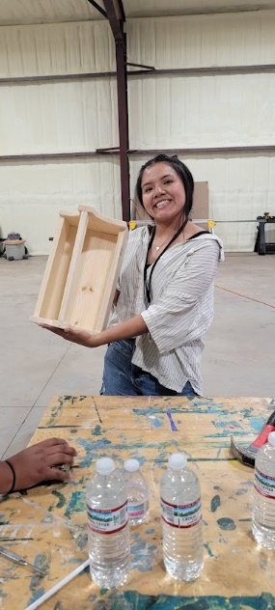Grace and Peace,

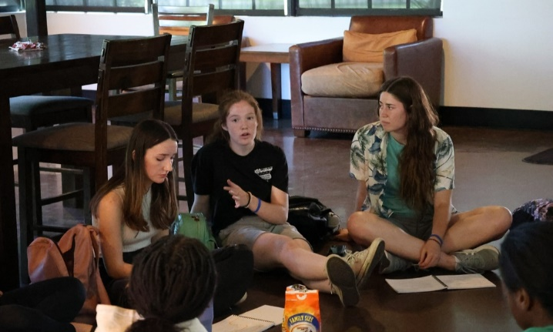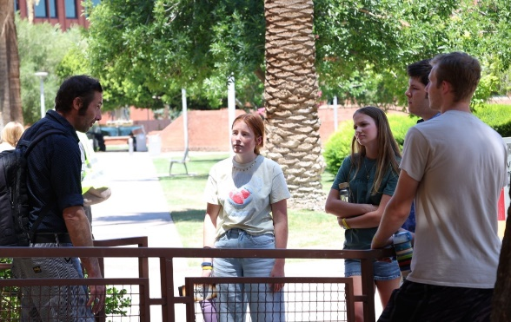Jerad and Carrie Burgess

Abi, Naomi, & Sarah