
For more information about this
Our mailing address is Oasis Youth Ministries PO Box 445, Holbrook, AZ 86025
ministry or to join our prayer
and support team,
you can go online to
www.oasisyouthministries.com

Dear Friends and Family, August 2025

Hello! We hope you are well! With things starting to cool down, we are excited about autumn approaching here.

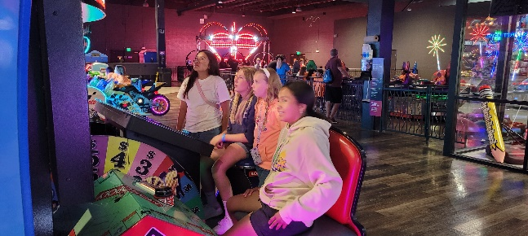
On July 23rd we joined with Winslow First Baptist Church’s youth group and took a bunch of teens to Jake’s Unlimited in Phoenix for several hours of pizza, video games, laser tag, rides, bowling, air hockey, etc. It went well. It was our fourth time joining them for this outing and on the way back we came home a different way than they did, since they were headed back to Winslow; coming back they saw 62 elk along the sides of the curvy road! The roads going up an area called the Mogollon Rim can be quite dangerous in the dark. Thankfully everyone got home fine.

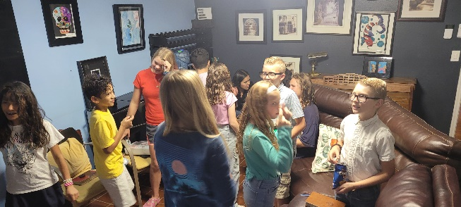
The Well finally began again for the fall school semester on August 25. We had 22 young people show up. We will be studying the subject of worldview for the next 9 weeks, and particularly what it is to have a biblical worldview. We want them to understand that our faith in Jesus should not be merely a part of our lives, but that it should inform our entire view of reality and guide us in how we live our lives.

As you know, God often has us in places for seasons. We recently had one of our cherished and incredibly helpful team members step down. She has been involved in ministry with us for over 6 years and has been amazing. Between leading youth at camps, serving with us in Costa Rica, faithfully teaching the Well, helping with fundraising, and being involved with monthly events, Bernice has been an invaluable team member that we will miss greatly. However God is leading her, we know that she will be a blessing.

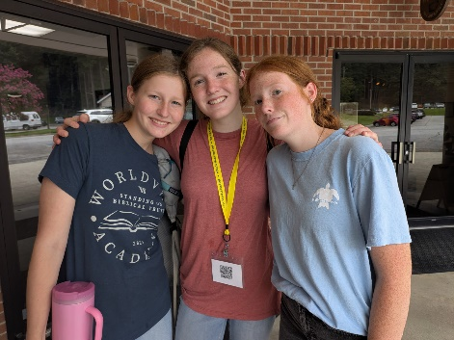
For September we will be having our kickoff event—a hayride out to a group of large sand dunes where we will build a bonfire, roast hot dogs, make s’mores, and the teens will hurl themselves down the dunes in delight. It’s kind of like going to the beach, but with no water. A local rancher graciously takes us on a ride across his land to his dunes and gets a fire going. It’s always a favorite. We will also be having someone give a short talk about Jesus.

On a personal note, we recently dropped off our oldest daughter, Abigail, at Toccoa Falls College in Georgia, where she is planning to study nursing. It is a difficult transition for both of us, particularly being separated by a 3-day drive.

THANK YOU for your part in this ministry; we truly could not do it without your prayers and giving!

Prayer Requests:
- Pray for students and leaders as we begin the upcoming school year.
- Pray for Taven as he is on his outreach with Youth With A Mission.
- Pray for Abigail as she attends her first year of college.
- Pray for the protection of the ministry.

Grace and Peace,
Jerad and Carrie Burgess
Abi, Naomi, & Sarah

