*For more information about this*

*Our mailing address is Oasis Youth Ministries PO Box 445, Holbrook, AZ 86025*

*ministry or to join our prayer*

*and support team,*

*you can go online to*

*www.oasisyouthministries.com*

Dear Friends and Family, October 2025

Greetings from the high desert! We pray you are doing well and that you are enjoying the early fall.

We have had a surprisingly wet and rainy time of it lately, due to large storms in the Pacific Ocean that have sent enormous amounts of moisture into Arizona from Baja California in Mexico. The abnormal precipitation has twice now affected our plans for monthly events. We had planned to kickoff the semester with a hayride and bonfire out at the dunes on the property of a local rancher, but were forced to cancel due to mud (not usually a problem here!). Instead we had a game night at the home of two of our leaders. We were able to have a fire, roast hot dogs and make s’mores while playing various games from football to Trivial Pursuit to Scattergories and others. One of our former students who’s now a leader, Abbey, gave an excellent testimony of her walk with God and His carrying her through tragedy. She passionately encouraged the 23 kids (and several adults) to trust in Christ and to seek to learn all they can about Him. Despite having to cancel the hayride, the kickoff went extermely well. We are going to try the hayride again in November.

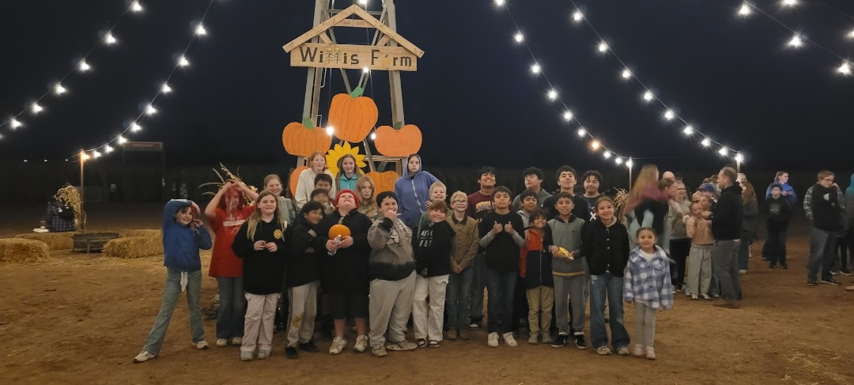

The event for October was our annual trip to Willis Farm in Snowflake, AZ to pick pumpkins, play laser tag, and conquer the corn maze. Jerad spoke about God’s nearness to us as humans and used the story of Lazarus’ death and resurrection as a point to show how Jesus empathizes with his people and show that only God is able to redeem death through a relationship with Jesus.

The Well is meeting this month at Peace Lutheran (we met for the month of September at First Assembly of God). We sincerely appreciate the local evangelical churches opening their buildings for our young people to meet! Over 20 kids gather each week to learn about and discuss what it means to have a biblical worldview.

In November we are planning our monthly event, hosting a dessert to show our gratitude to all the churches and people locally who have helped with, prayed for, and given to Oasis since it began three years ago, and YFC for six years before that.

THANK YOU for your part in this ministry; we truly could not do it without your prayers and giving!

*Prayer Requests:*

* *Pray for leaders to be committed to serving the youth and their families.*
* *Pray for Taven as he is on his outreach with Youth With A Mission.*
* *Pray for Shivanna as she is at Basic Combat Training in South Carolina.*
* *Pray for the protection of the ministry and for continued growth.*

Grace and Peace,

Jerad and Carrie Burgess

Abi, Naomi, & Sarah