**St. Paul**

**UNITED CHURCH OF CHRIST**

**October 5, 2025 10:30am**

***Welcome!*** Whether you are a guest, friend or member, we are delighted that you are here. Large print bulletins are available at either door. Ask a greeter for any directions you may need.

*“Please note that this service will be live-streamed on Facebook. If you do not wish to be visible on camera, please let an usher know so we can take appropriate measures to ensure*

*your privacy."*

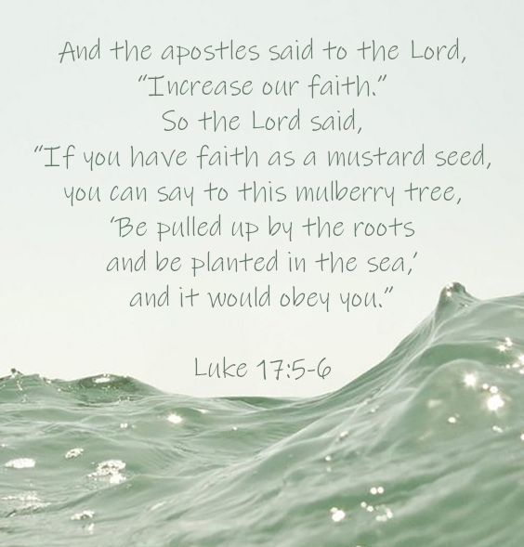

Rev. Jim Oleson, Pastor

Christopher Dickmeyer, Musician

Carolyn Meier, Musician

***Seventeenth Sunday after Pentecost – World Communion Sunday***

*\*Please rise in body or spirit*

**Ringing of the Bell**

**Welcome & Announcements**

*In the last days, says God, I will pour out my Spirit upon all people. Your sons and daughters shall prophesy. Your young people shall see visions, and your old people shall dream dreams. People of God, we have been baptized into one Spirit and one body through Jesus Christ. Let us worship today.*

**Prelude and Lighting of the Candles**

**\*** **Call to Worship**

**One:** Around the world, in all nations, the faithful have gathered for worship

**Many: We gather in this space to worship You, O God.**

**One:** Around the world, speaking in all languages, the faithful come to pray together

**Many: We lift up our prayers to You, O God.**

**One:** Around the world, using tortillas and pita, crackers and bread, the faithful remember your body that was given to us.

**Many: We share in the meal of remembrance, O Christ our Savior**

**One:** Around the world, we remember our brothers and sisters this World Communion Sunday

**Many: We worship, we pray, we remember and we celebrate our diversity and our unity in Christ.**

**\*Invocation**

**Jesus, Savior of the World, on this World Communion Sunday we come to You to celebrate, and to pause, remember, and give Thanks for Your Body and Blood given for us. We participate with our brothers and sisters all around the world, each with our own language and way of remembering that You gave Yourself for us. Until that day when You come in a new way into our world and into our lives, we celebrate Your presence now with us, together as Your body around the world, proclaiming Your death and resurrection together. In your Living name we pray, remember, and celebrate. Amen.**

**\*Hymn of Praise** #245 New Century The Day of Resurrection

**\*Prayer for Transformation** **and New Life**   
**Merciful God, we admit to each other and confess to you, our shallowness and willfulness, our folly and our selfishness.**

**We confess the careless, cruel word, the negative, cynical thought, the irresponsible deed, and the dithering inaction.**

**We regret the kindness withheld, the opportunity not taken, the high ideal betrayed, and the faith fudged or denied.**

**Please forgive us, cleanse us, amend us, and restore to us that zest for abundant life which we have witnessed in Jesus. Amen.**

<pause for silent reflection >

**Words of Grace**   
**Leader:** There is nothing that can separate you from God’s love. Know that hope will see you through, and God’s steadfast love endures forever. Go and live into God’s love, peace and justice.

**People:** **Amen.**

**\*Response of Praise**

**Glory be to the Father, and to the Son, and to the Holy Ghost; As it was in the beginning, is now, and ever shall be, World without end. Amen. Amen.**

**Mission Moment** Janet Drown

**Written Word** Lamentations 3:19-26

2 Timothy 1:1-14

Luke 17:5-10

**Hymn** #606 New Century Nearer, My God, to You

**Message** Knowing Rev. Jim Oleson

Lamentations 3:22-23

**Church in Prayer**

**Pastoral Prayer**

**Lord’s Prayer** (Debts, Debtors)

**Offertory**

**Invitation to Generosity**

**\*Doxology** (Tune: Old Hundredth)

**Praise God, from Whom all blessings flow; Praise Him, all creatures here below;**

**Praise Him above, ye heavenly host; Praise Father, Son, and Holy Ghost. Amen.**

**\*Prayer of Dedication**

**Gracious God, we give these gifts because you ask us to share. We dedicate this offering and our lives to your service, that the hungry may be fed, the oppressed may receive justice, and the stranger may be welcomed in our midst. We offer this prayer in the name of the bearer of your good news, Jesus the Christ. Amen.**

**The Lord’s Supper**

**INVITATION TO CHRIST’S TABLE**

**COMMUNION PRAYER**

**WORDS OF INSTITUTION**

**SHARING OF THE BREAD AND CUP**

(Please hold each of the elements as it is distributed so that we may partake each together. The inner ring of cups in each tray holds juice rather than wine.)

**\* THANKSGIVING PRAYER (unison)**

**Bountiful God, we give you thanks that you have refreshed us at your table by granting us the presence of Christ. Strengthen our faith, increase our love for one another and send us forth into the world in courage and peace, rejoicing in the power of your Holy Spirit. Amen.**

**\*Closing Hymn #**336 New Century Here, O My Lord, I See You Face to Face

\***Commission and Benediction**

**\*Christ’s Light Leads Us into the World**

**\*Congregational Response** #76 New Century Sent Forth by God’s Blessing

(Verse 1)

**\*Ringing of the Bell and Postlude**

903 Meier Road, Old Monroe, Missouri 63369

[stpauluccom@gmail.com](mailto:stpauluccom@gmail.com)

Website: stpauluccom.com

636-665-5329

**OFFICE HOURS**

Wednesday: 9:00am – 3:00pm

Friday: 9:00am - Noon

It Happens

Here St. Paul UCC

Weekly Calendar

October 5th - October 12

**October 5th *Seventeenth Sunday after***

***Pentecost***

***World Communion Sunday***

9:15am Bible/Book Study

10:30am Worship

11:30am Fellowship Hour

**October 12th *Eighteenth Sunday after***

***Pentecost***

9:15am Bible/Book Study

10:30am Worship

11:30am Carry in Dinner

***Looking Ahead***

October 10th

9:30am Finance Committee Meeting

October 11th

5-7pm Trunk or Treat & Spook

House

October 12th

11:30am Planning Meeting

________________________________________________________________________________________

**OUR GIVING IN 2025**

**Needed weekly to meet our commitments** $**2317.02 $ 2317.02**

General Fund Offering September 28th $ 210.00 September Average $ 1010.00 Stewardship Offering September 28th $ 0.00 August Average $ 1285.00

______ ____________________________________________________ ____________________ ________

**HAPPENING IN OUR COMMUNITY**

**Thursday, October 16:** Outsmart the Scammers at St. John’s UCC in Weldon Springs. 12:30pm Light Refreshments. 1:00pm Presentation. Keynote Speaker: Doug Anstedt from Edward Jones.

**Saturday, November 1**: Holiday Bazaar & Silent Auction at St. John’s UCC in Weldon Springs. Fun for the whole family from 9:00am to 3:00pm.

**Thank you to all our volunteers!**

**Greeters/Ushers**

Bob Bothe & Jennifer Schulte

**Acolyte**

Jennifer Schulte

**Liturgist**

**Fellowship Hour**

Christian Nurture

In our prayers …

This week we added the Burke family to our prayers.

We continue to keep in our prayers: Lauretta, Lynn and Ron D., Laurie S., Mike S., Brittney, Debbie & Tony, Bernadette, James C., Mike S., Carrie B., Ruth and Stephanie, the family of Bonnie, and the family of Zachary K.

We lift up in our prayers those who need prayers for their *long-term circumstances*: Carol Jean P.

Emergency Planning is checking into a CPR/AED refresher course.  There are 2 options: refresher course without certification at no cost or a certification course at the cost of $40. Let Joyce Noble know if you are interested.

We have one new programmable thermostat on the south side of the sanctuary. We are testing temperature settings. Please do not adjust the temperature.