**St. Paul**

**UNITED CHURCH OF CHRIST**

**October 19, 2025 10:30am**

***Welcome!*** Whether you are a guest, friend or member, we are delighted that you are here. Large print bulletins are available at either door. Ask a greeter for any directions you may need.

*“Please note that this service will be live-streamed on Facebook. If you do not wish to be visible on camera, please let an usher know so we can take appropriate measures to ensure*

*your privacy."*

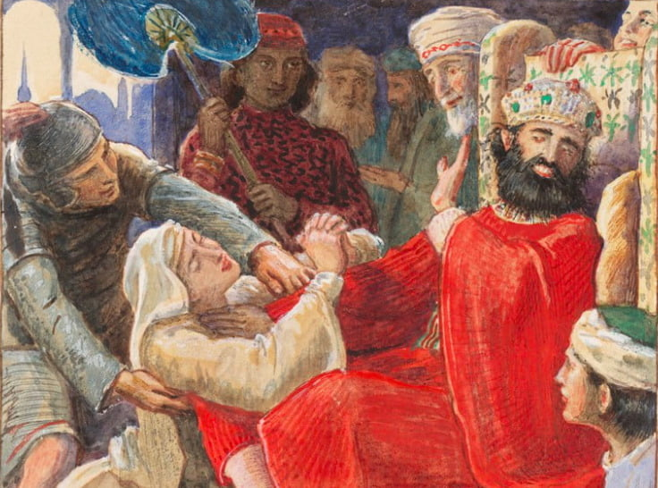

Rev. Jim Oleson, Pastor

Carolyn Meier, Musician

***Nineteenth Sunday after Pentecost***

*\*Please rise in body or spirit*

**Ringing of the Bell**

**Welcome & Announcements**

*In the last days, says God, I will pour out my Spirit upon all people. Your sons and daughters shall prophesy. Your young people shall see visions, and your old people shall dream dreams. People of God, we have been baptized into one Spirit and one body through Jesus Christ. Let us worship today.*

**Prelude and Lighting of the Candles**

**\*** **Call to Worship**

**One:** The time is coming, says the Eternal God, when I will write my law on your hearts.

**Many: How sweet are your words to me, loving God, much sweeter than honey in my mouth.**

**One:** I will be your God and you will be my people.

**Many: How sweet are your words to me, loving God, much sweeter than honey in my mouth.**

**One:** You shall know me from the least to the greatest, I will forgive your evil and remember your sin no more.

**Many: How sweet are your words to me, loving God, much sweeter than honey in my mouth.**

**One:** Let us worship this wonderful God.

**Many: Let us worship this wonderful God.**

**\*Invocation**

**Loving God, you are the truth far beyond all knowledge, the word excelling all human ideas and wisdom, the joy higher than all delight and happiness, the glory brighter than the light of a billion stars. Yet you are nearer than our thoughts, and dearer than our deepest love. We trust you, we worship you, we adore you! In wonder and love we lift up our hearts in praise. Amen.**

**\*Hymn of Praise** #104 New CenturyWe Hail You God’s Anointed

**\*Prayer for Transformation** **and New Life**   
**Maybe we have been too busy to notice deeds that are beautiful and good; or too preoccupied to say ‘thank you’ or ‘I love you’. Lord have mercy.**

**Maybe we have been too stubborn to apologize for our mistakes; too proud to do inconspicuous tasks, or too independent to let others help us. Christ have mercy.**

**Maybe we have been too self-demanding to enjoy a task well done though not perfectly; or too proudly humble to gracefully accept thanks from a colleague. Lord have mercy.**

**Merciful God, Savior and Friend, forgive us for our obsessive busyness, for our pride, and for our overdone humility. Forgive us for hurts we have inflicted on others, and for the love we have denied them and ourselves. By the grace of Christ Jesus, restore us to the joy of salvation. Amen.**

<pause for silent reflection >

**Words of Grace**   
**Leader:** My friends, God is neither too busy, nor too proud, nor too humble, to say “I love you.” In Jesus he has declared himself forever.

**People:** **His love and mercy are over all his works.**

**\*Response of Praise**

**Glory be to the Father, and to the Son, and to the Holy Ghost; As it was in the beginning, is now, and ever shall be, World without end. Amen. Amen.**

**Written Word** Jeremiah 31:27-34

2 Timothy 3:14-4:5

Luke 18:1-8

**Hymn** #423 New Century Great is your Faithfulness

**Message** Getting Back to our Roots Rev. Jim Oleson

Luke 18:1-8 & 2 Timothy 3:14-4:5

**Church in Prayer**

**Pastoral Prayer**

**Lord’s Prayer** (Debts, Debtors)

**Offertory**

**Invitation to Generosity**

**\*Doxology** (Tune: Old Hundredth)

**Praise God, from Whom all blessings flow; Praise Him, all creatures here below;**

**Praise Him above, ye heavenly host; Praise Father, Son, and Holy Ghost. Amen.**

**\*Prayer of Dedication**

**Caring God, help us joyfully and confidently to place all we are and all we have in your**

**hands. Use us and our possessions according to your will. Amen.**

**\*Closing Hymn #**25 New Century O God, Our Help in Ages Past

\***Commission and Benediction**

**\*Christ’s Light Leads Us into the World**

**\*Congregational Response** #76 New Century Sent Forth by God’s Blessing

(Verse 1)

**\*Ringing of the Bell and Postlude**

903 Meier Road, Old Monroe, Missouri 63369

[stpauluccom@gmail.com](mailto:stpauluccom@gmail.com)

Website: stpauluccom.com

636-665-5329

**OFFICE HOURS**

Wednesday: 9:00am – 3:00pm

Friday: 9:00am - Noon

It Happens

Here St. Paul UCC

Weekly Calendar

October 19th - October 26th

**October 19th *Nineteenth Sunday after***

***Pentecost***

9:15am Bible/Book Study

10:30am Worship

11:30am Fellowship Hour

October 20th

5:15pm Council Meeting

October 22-29 Pastor Jim on vacation

**October 26th *Twentieth Sunday after***

***Pentecost***

10:30am Worship (Hymn Sing)

11:30am Fellowship Hour

***Looking Ahead***

________________________________________________________________________________________

**OUR GIVING IN 2025**

**Needed weekly to meet our commitments** $**2317.02 $ 2317.02**

General Fund Offering October 12th $ 900.75 September Average $ 1015.00 Stewardship Offering October 12th $ 50.00 August Average $ 1285.00

______ ____________________________________________________ ____________________ ________

**HAPPENING IN OUR COMMUNITY**

**Sunday, October 19:** Chili & Roast Beef Dinner at Ebenezer UCC in Augusta. Dine in or carry out. Serving from 11:00am to 5:30pm.

**Saturday, November 1**: Holiday Bazaar & Silent Auction at St. John’s UCC in Weldon Springs. Fun for the whole family from 9:00am to 3:00pm.

**Saturday, November 1:** Tukey Supper at Friedens UCC in Moscow Mills. Serving from 3:00pm-6:00pm. Dine in or carry out.

**Thank you to all our volunteers!**

**Greeters/Ushers**

Norma Keeteman & Linda Meier

**Acolyte**

Joyce Noble

**Liturgist**

**Fellowship Hour**

Finance

In our prayers …

This week we added Brittney, Jane, the Burk family, and the families affected by the explosion in Tennessee to our prayers.

We continue to keep in our prayers: Lauretta, Lynn and Ron D., Lori S., Mike S., Brittney, Debbie & Tony, Bernadette, James C., Mike S., Carrie B., Ruth and Stephanie, Jerry and Mary C., the family of Bonnie, and the Burke family.

We lift up in our prayers those who need prayers for their *long-term circumstances*: Carol Jean P.

Emergency Planning is checking into a CPR/AED refresher course.  There are 2 options: refresher course without certification at no cost or a certification course at the cost of $40. Let Joyce Noble know if you are interested.

We have one new programmable thermostat on the south side of the sanctuary. We are testing temperature settings. Please do not adjust the temperature.