**Parkside Lutheran Church**

*Rediscovering the Radical Love of Jesus*

*Gathering All*

*Serving All*

*Caring For All*



***PERSISTING***

**October 19th, 2025**

**Time after Pentecost**

**Holy Communion 10:00am**

**Rev. Jeremiah Smith**

**Parkside Lutheran Values**

**Proclaiming Grace** - Jesus shared and lived out a message of grace, love, and new life. We believe these promises come from God freely, as a gift for all. We are loved and the Spirit inspires us to share this good news in accessible, relevant, and new ways. *Luke 4:17-19, John 1:16-17, John 3:16-17,* *Ephesians 2:8-9*

**Practicing Hospitality** – Jesus welcomed the little children, broke bread with outcasts, and proclaimed the Good News to all. Whether you are strong in faith, wrestling with doubt, or somewhere in between, we affirm that you are welcome here. Jesus is for everyone. *Leviticus 19:34, Matthew 9:10, Matthew 19:14, Hebrews 13:2*

**Loving Boldly** - Jesus challenged traditions to demonstrate God’s justice and love of neighbor. His compassionate and sacrificial love inspires us to take risks. Striving to follow his command to love neighbor, our ministries serve, transform, and advocate for folks near and far. *Micah 6:8,* *Mark 11:15-17, Luke 10:25-28, John 15:12-13*

**Cultivating Community** - Jesus built communities that transformed lives. We are the body of Christ and we are called to continue this ministry of transformation. Guided by the Holy Spirit, we build connections within and outside of these walls, and with all of God’s creation. *Ecclesiastes 4:9-12, Matthew 28:16-20, 1 Corinthians 12:12-14, Galatians 3:26-29*

**Welcome Visitors!**

**Please use QR code**

**to let us know you were here today or to sign up for our weekly enewsletter**

*or, sign up for weekly enewsletter via website parksidelutheran.org*.

Find us on Facebook & Instagram *WIFI: Balcony* password: FreeGrace

**For your safety in the event of an emergency:** In addition to the three exits in the back of the sanctuary, there are exits on either side of the altar (on left side: floor level near piano *and* up steps past altar. On right side: up steps to the altar, past band area)

***Contact us:*** (716) 836-1361

2 Wallace Ave. Buffalo, NY 14214

*parksidelutheran.org |* [*parksidelutheran@gmail.com*](mailto:parksidelutheran@gmail.com)

**GATHER***The Holy Spirit calls us together as the people of God.*

**Introduction to the Day:** *Pray always. Do not lose heart. This is Christ’s encouragement in the gospel today. Wrestle with the word. Remember your baptism again and again. Come regularly to Christ’s table. Persistence in our every encounter with the divine will be blessed.*

**Prelude:** *“Beginning Today”**by Darryl Ducote**Leigh Beenau*

**Call to Worship**

WA: I lift my eyes up to the mountains, from where does my help come?  
**C: My help comes from the Lord, who made heaven and earth.**WA: We look not to the mountains or valleys, even heaven or earth,  
**C: For God is found among us.**WA: Wherever two or three are gathered in Christ’s name,  
**C: God is here among us.**WA: Come, let us worship the God of Creation, the God of People, the God of Community.  
**C: Let us follow Jesus, for Jesus is The Way. Let us worship together in faith.**

**Gathering Hymn: God of Grace and God of Glory ELW #705**

*(printed next page)*



**Welcome and Announcements**

**Holy Baptism:** Samuel David Ende *ELW p. 227*

**P:** God, who is rich in mercy and love, gives us a new birth into a living hope through the sacrament of baptism. By water and the Word God delivers us from sin and death and raises us to new life in Jesus Christ. We are united with all the baptized in the one body of Christ, anointed with the gift of the Holy Spirit, and joined in God's mission for the life of the world.

**P:** Who do you present to be baptized? **Sponsors**: We present Samuel for baptism.

**P:** Called by the Holy Spirit, trusting in the grace and love of God, as his parents, do you desire to have Samuel baptized into Christ? **Parents:** We do.

**P:** As you bring him to receive the gift of baptism, you are entrusted with responsibilities: to live with him among God's faithful people, bring him to the word of God and the holy supper, teach him the Lord's Prayer, the Creed, and the Ten Commandments, place in his hands the holy scriptures, and nurture him in faith and prayer, so that he may learn to trust God, proclaim Christ through word and deed, care for others and the world God made, and work for justice and peace.

**P**: Do you promise to help Samuel grow in the Christian faith and life?

**Parents:** We do.

**P**: *Sponsors*, do you promise to nurture Samuel in the Christian faith as you are empowered by God's Spirit, and to help him live in the covenant of baptism and in communion with the church? **Sponsors**: We do.

**P:** People of God, do you promise to support Samuel and pray for him in his new life in Christ? **C: We do.**

**+ Profession of Faith**

**P:** All together as the people of God, I ask you to profess your faith in Christ Jesus, reject sin, and confess the faith of the church.

P: Do you renounce the devil and all the forces that defy God?

**C: We renounce them.**

P: Do you renounce the powers of this world that rebel against God?

**C: We renounce them.**

P: Do you renounce the ways of sin that draw you from God?

**C: We renounce them.**

P: Do you believe in God the Father?

**C: I believe in God, the Father almighty, creator of heaven and earth.**

P: Do you believe in Jesus Christ, the Son of God?

**C: I believe in Jesus Christ, God's only Son, our Lord, who was conceived by the Holy Spirit, born of the virgin Mary, suffered under Pontius Pilate, was crucified, died, and was buried; he descended to the dead.* On the third day he rose again; he ascended into heaven, he is seated at the right hand of the Father, and he will come to judge the living and the dead.**

P: Do you believe in God the Holy Spirit?

**C: I believe in the Holy Spirit, the holy catholic church, the communion of saints, the forgiveness of sins, the resurrection of the body, and the life everlasting.**

**Thanksgiving at the Font**

P: The Lord be with you. **C: And also with you.**

P: Let us give thanks to the Lord our God.

**C: It is right to give our thanks and praise.**

P: We give you thanks, O God, for in the beginning your Spirit moved over the waters and by your Word you created the world, calling forth life in which you took delight. Through the waters of the flood you delivered Noah and his family, and through the sea you led your people Israel from slavery into freedom.

At the river your Son was baptized by John and anointed with the Holy Spirit. By the baptism of Jesus' death and resurrection you set us free from the power of sin and death and raise us up to live in you.

Pour out your Holy Spirit, the power of your living Word, that those who are washed in the waters of baptism may be given new life. To you be given honor and praise through Jesus Christ our Lord, in the unity of the Holy Spirit, now and forever. **C: Amen.**

*The assembly may be seated.*

**Baptism**

P: Samuel David, I baptize you in the name of the Father, and of the Son, and of the Holy Spirit. **Amen.**

Let us pray. We give you thanks, O God, that through water and the Holy Spirit you give your daughters and sons new birth, cleanse them from sin, and raise them to eternal life.

*Laying both hands on the head of Samuel the minister prays:*

P: Sustain Samuel with the gift of your Holy Spirit: the spirit of wisdom and understanding, the spirit of counsel and might, the spirit of knowledge and the fear of the Lord, the spirit of joy in your presence, both now and forever. **Amen.**

P: Samuel, child of God, you have been sealed by the Holy Spirit and marked with the cross of Christ forever. Amen.

**Welcome**

**WA**: Jesus said, I am the light of the world.

Whoever follows me will have the light of life.

**P**: Let us welcome Samuel.

**C: We welcome you into the body of Christ and into the mission we share: join us in giving thanks and praise to God and bearing God's creative and redeeming word to all the world.**

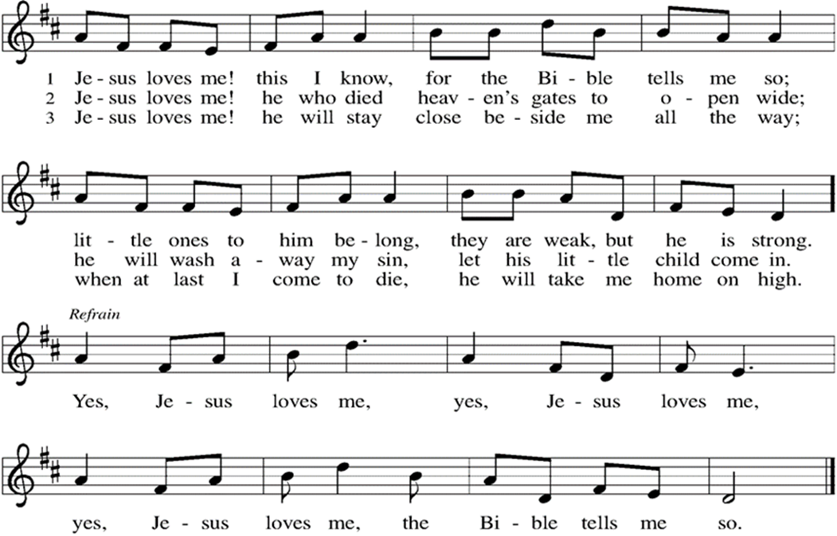

**Greeting**

WA:The grace of our Lord, Jesus Christ, the love of God, and the communion of the Holy Spirit be with you all. **C:** **And also with you.**

**Prayer of the Day**

WA: Let us pray together.

**C: Eternal God, you listen to the cries of those in pain. Grant us persistence to do what is right. When the world is broken, work through us to repair it. When systems are unjust, give us the will to carry on and work toward your justice. Amen.**

**WORD**

*God speaks to us in scripture readings, preaching and song.*

**First Reading: Genesis 32:22-31**

*Returning to the home he had fled many years before after stealing his brother’s birthright and his father’s blessing, Jacob wrestles all night long with a divine adversary who ultimately blesse him and changes his name to “Israel,” a name that means “he wrestles with God.”*

L: 22 The same night [Jacob] got up and took his two wives, his two maids, and his eleven children and crossed the ford of the Jabbok.23 He took them and sent them across the stream, and likewise everything that he had. 24 Jacob was left alone, and a man wrestled with him until daybreak. 25 When the man saw that he did not prevail against Jacob, he struck him on the hip socket, and Jacob’s hip was put out of joint as he wrestled with him. 26 Then he said, “Let me go, for the day is breaking.” But Jacob said, “I will not let you go, unless you bless me.” 27 So he said to him, “What is your name?” And he said, “Jacob.” 28 Then the man said, “You shall no longer be called Jacob, but Israel, for you have striven with God and with humans and have prevailed.” 29 Then Jacob asked him, “Please tell me your name.” But he said, “Why is it that you ask my name?” And there he blessed him. 30 So Jacob called the place Peniel, saying, “For I have seen God face to face, yet my life is preserved.” 31 The sun rose upon him as he passed Penuel, limping because of his hip. L: Word of God, word of life. **C: Thanks be to God.**

**Second Reading: 2 Timothy 3:14-4:5**

*The writer of this letter continues his instruction of Timothy, his younger colleague in ministry, by emphasizing the importance of faithful teaching despite opposition.* L: 14 But as for you, continue in what you have learned and firmly believed, knowing from whom you learned it 15 and how from childhood you have known sacred writings that are able to instruct you for salvation through faith in Christ Jesus. 16 All scripture is inspired by God and is useful for teaching, for reproof, for correction, and for training in righteousness, 17 so that the person of God may be proficient, equipped for every good work.  
  4:1 In the presence of God and of Christ Jesus, who is to judge the living and the dead, and in view of his appearing and his kingdom, I solemnly urge you: 2 proclaim the message; be persistent whether the time is favorable or unfavorable; convince, rebuke, and encourage with the utmost patience in teaching. 3 For the time is coming when people will not put up with sound teaching, but, having their ears tickled, they will accumulate for themselves teachers to suit their own desires 4 and will turn away from listening to the truth and wander away to myths. 5 As for you, be sober in everything, endure suffering, do the work of an evangelist, carry out your ministry fully. L: Word of God, word of life. **C: Thanks be to God.**

*Please stand as you are able*

**+Gospel Acclamation**  **ELW** setting 8 *(p. 188)*

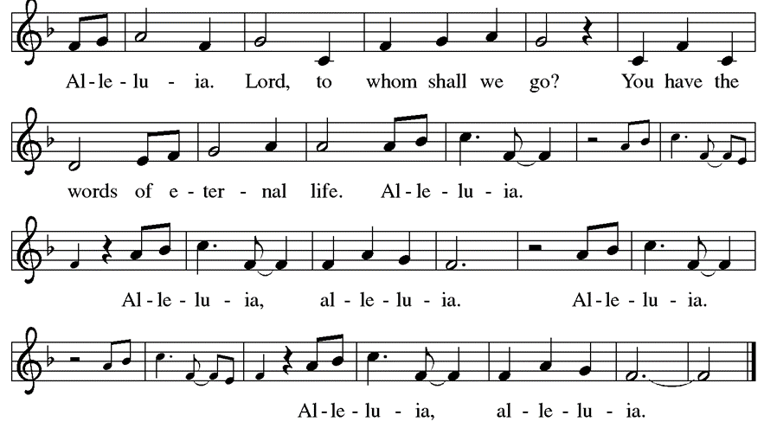

**Gospel Reading: Luke 18:1-8**

Jesus tells a parable of an unjust judge who is worn down by a widow’s pleas. Jesus is calling God’s people to cry out for justice and deliverance. For if an unethical judge will ultimately grant the plea of a persistent widow, how much more will God respond to those who call. P: The Holy Gospel according to Luke. **C: Glory to you, O Lord.**

P:  1 Then Jesus told them a parable about their need to pray always and not to lose heart. 2He said, “In a certain city there was a judge who neither feared God nor had respect for people. 3 In that city there was a widow who kept coming to him and saying, ‘Grant me justice against my accuser.’ 4 For a while he refused, but later he said to himself, ‘Though I have no fear of God and no respect for anyone, 5 yet because this widow keeps bothering me, I will grant her justice, so that she may not wear me out by continually coming.’ ” 6 And the Lord said, “Listen to what the unjust judge says. 7 And will not God grant justice to his chosen ones who cry to him day and night? Will he delay long in helping them? 8I tell you, he will quickly grant justice to them. And yet, when the Son of Man comes, will he find faith on earth?” P: The Gospel of the Lord. **C: Praise to you, O Christ.**

**Sermon** Rev. Jeremiah Smith

*P**lease stand as you are able.*

**Hymn of the Day: Lord, Keep Us Steadfast in Your Word ELW #517**



**Prayers of the People**  
WA: Renewed in God’s everlasting grace, let us pray for the church, the world, and all creation. *(a brief silence)*

WA: We pray for the church universal. O God, who unites the church across the globe, bring unity and peace to a world divided by hatred and opposition. Turn our hearts toward the gospel of Jesus Christ. God of grace,

**C: receive our prayer.**

WA: We pray for all nations, states, cities, and towns. O God, you rule over all the earth. Grant our elected officials humility in their decision-making for the sake of the entire world.  God of grace, **C: receive our prayer.**

WA: We pray for those who suffer in body, mind, or spirit. O God, who heals and strengthens, our help comes from you in times of need. Support, comfort, and heal those who suffer, especially those we name aloud or in the silence of our hearts…. God of grace, **C: receive our prayer.**

WA: We pray for Parkside Lutheran. O God, who guides this congregation, encourage us to share the good news of Jesus Christ. Nurture our relationships with the community, that we serve and advocate for those who come to us in need. God of grace, **C: receive our prayer.**

WA: We offer thanksgiving for the faithful departed. O God, whose promises never end, we thank you for all the saints who have shown us the way of your Son, Jesus Christ. God of grace, **C: receive our prayer.**

WA: We offer our prayers, O God, trusting in your everlasting grace and mercy, through Jesus Christ our Lord. **C: Amen.**

**Peace**

P: The peace of Christ be with you always. **C: And also with you.**

**Meal**

*God feeds us with the presence of Jesus Christ*

**Offering** *Congregation may be seated*

We are grateful to those who help sustain our mission. To donate online, please use QR code:



**Offering Music:** *“Lord, Listen to Your Children” by Handt Hanson*

*Leigh Beenau and Steve Paradowski*

**Offering Prayer**

WA: Let us pray together:

**C: God of life, you have blessed us with every good gift. Open us to share all that we have been given and to love the world in Jesus’ name. Amen.**

*Please stand as you are able*

***+* Offertory Song “We are an Offering”*****ELW 692***

**We lift our voices, we lift our hands, we lift our lives up to you;**

**We are an offering. Lord, use our voices, Lord, use our hands,**

**Lord, use our lives, they are yours; We are an offering.**

**All that we have, all that we are, all that we hope to be-**

**we give to you, we give to you.**

**We lift our voices, we lift our hands, we lift our lives up to you;**

**We are an offering. We are an offering.**

**GREAT THANKSGIVING**

P: The Lord be with you. **C: And also with you.**

P: Lift up your hearts. **C: We lift them to the Lord.**

P: Let us give thanks to the Lord our God.

**C: It is right to give our thanks and praise.**

**Preface:**

P: It is indeed right, our duty and our joy, that we should at all times and in all places give thanks and praise to you, almighty and merciful God, through our Savior Jesus Christ; who on this day overcame death and the grave, and by his glorious resurrection opened to us the way of everlasting life. And so, with all the choirs of angels, with the church on earth and the host of heaven, we praise your name and join their unending hymn:

**Holy Holy Holy ELw** setting 8*(p. 190)*

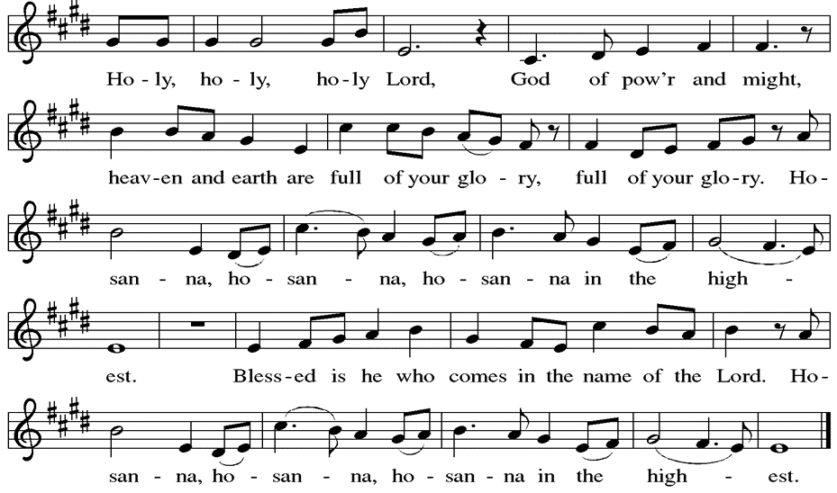

**Thanksgiving at the Table**

P: Holy God, you alone are holy, you alone are God. The universe declares your praise: beyond the stars; beneath the sea; within each cell; with every breath.

**C: We praise you, O God.**

P: Generations bless your faithfulness: through the water; by night and day; across the wilderness; out of exile; into the future.

**C: We bless you, O God.**

P: We give you thanks for your dear Son: at the heart of human life; near to those who suffer; beside the sinner; among the poor; with us now.

**C: We thank you, O God.**

P: In the night in which he was betrayed, our Lord Jesus took bread, and gave thanks; broke it, and gave it to his disciples, saying: Take and eat; this is my body, given for you. Do this for the remembrance of me. Again, after supper, he took the cup, gave thanks, and gave it for all to drink, saying: This cup is the new covenant in my blood, shed for you and for all people for the forgiveness of sin. Do this for the remembrance of me.

Remembering his love for us on the way, at the table, and to the end, we proclaim the mystery of faith.

**C: Christ has died. Christ is risen. Christ will come again.**

P: We pray for the gift of your Spirit: in our gathering; within this meal; among your people; throughout the world.

Blessing, praise, and thanks to you, holy God, through Christ Jesus, by your Spirit, in your church, without end.

**C: Amen**

**Lord’s Prayer**

P:Lord, remember us in your kingdom and teach us to pray.

**C: Our Father, who art in heaven, hallowed be thy name, thy kingdom come, thy will be done, on earth as it is in heaven. Give us this day our daily bread; and forgive us our trespasses, as we forgive those who trespass against us; and lead us not into temptation, but deliver us from evil. For thine is the kingdom, and the power, and the glory, forever and ever. Amen.**

**Invitation to the Table**

*At Parkside Lutheran Church we have an open table. We believe the invitation to receive comes from Jesus himself and all are welcome at Christ’s table. More than just Bread and Wine these are tangible signs of God’s love for you! If you do not wish to receive communion but would like a blessing, come forward and cross your arms over your chest. The Pastor will give you a blessing before you return to your seat via the side aisle. You’ll receive communion bread* in your hands and a small cup containing white wine or grape juice. When giving the bread and cup, the communion ministers say:*

*“*The body of Christ, given for you. The blood of Christ, shed for you.” *and each person may respond:* Amen. *Please let Pastor know if you need gluten-free bread

P: Jesus welcomes sinners and eats with them. Come to this meal of mercy.

**The Communion Distribution**

**Communion Song** ELWsetting 8 *(p. 191)  
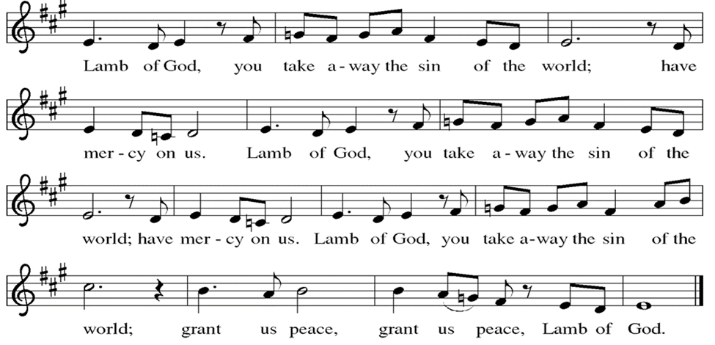*

**Communion Song:** *“Make Me a Channel of Your Peace” Prayer of St. Francis*

*Leigh Beenau and Steve Paradowski*

**Communion Song: Sanctuary  
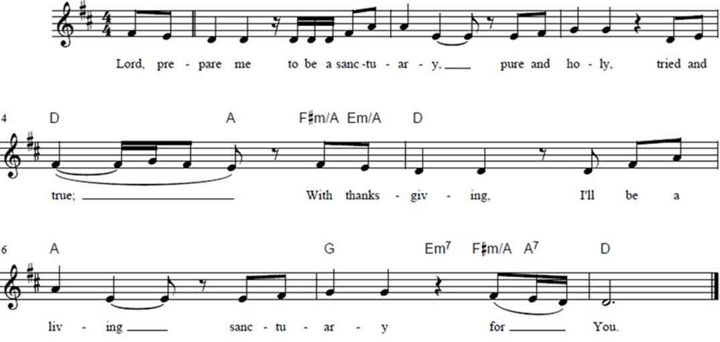**

**Post Communion Blessing**

P: The Body and Blood of our Lord and Savior, Jesus Christ, strengthen you and keep you in God's grace. **C: Amen.**

**Prayer After Communion**

WA: Let us pray together.

**C: Abundant God, you have nourished us with life, love, and grace. Fill us to the brim with your care, that we may go into the world with open arms and open hearts to share your peace with the world. Amen.**

**Sending -** *God blesses us and sends us in mission to the world.*

**Blessing**

P: May God bless you and keep you. May God’s mercy flow freely through you. May you be filled with the abundance of God’s love ☩ and held in God’s peace. **C: Amen.**

**Sending Hymn: Jesus Calls Us O’er the Tumult ELW #696**



**Dismissal and Postlude**

WA: Parkside Lutheran Church is rediscovering the radical love of Jesus.

**C: Gathering All. Serving All. Caring for All.**

WA: Go in peace. Do not lose heart.

**C: Thanks be to God.**

*ELW Music licensed from Sundays & Seasons, Augsburg Fortress CCLI MUSIC License # 11440069 , CCLI*

*Streaming License#21835523 Do not duplicate any music or Liturgy herein without license and permission*

*To sponsor Altar flowers or a Soloist in honor of a loved one*

*or to mark a special occasion. Contact the office for more info.*

**PARKSIDE STAFF:**

• The Rev.  Jeremiah Smith: prjeremiahpsmith@gmail.com

• Kris Pope & Suzanne Gracie, Admin. Assistants (Church Office): parksidelutheran@gmail.com

• Mike Hooker, Music Director: [mrhooker@me.com](mailto:mrhooker@me.com)

CHURCH OFFICE HOURS: M/T/R 10:00am-3:00pm   (716)836-1361

**SCHEDULES and Events:**

|  |  |  |
| --- | --- | --- |
| Acolytes: |  | Worship Assistants |
| 10/19 – Lorenzo & Emmet |  | 10/19 - Susan |
| 10/26 – David & Grace |  | 10/26 - Vince |
| Readers: |  | Ushers: |
| 10/19 – John F |  | 10/19 – Charlie R & Sue S |
| 10/26 – Kathie |  | 10/26 – John V & Zack |

**Coming up:** *contact office for more info –* [*parksidelutheran@gmail.com*](mailto:parksidelutheran@gmail.com), *(716)836-1361*

* October 19th – Intergenerational First Communion Class, after Worship
* October 22nd – Choir Rehearsal at 6pm
* October 25th – Halloween Event 4 – 6pm - ***Donations of Candy, Donut Holes & Hot Cocoa are needed – see sign-up sheet or donate to our “Community & Holiday Events” fund on Tithely ~~>***
* October 26th – Choir Rehearsal at 9:15am
* October 26th – First Communion
* ***November 2nd – All Saints Sunday.*** If you would like to have a friend or loved one remembered during the worship services on All Saints Sunday, fill out a form in the Narthex or use the QR Code ~~>
* November 19th – International Thanksgiving Dinner.

Visit the Events Section of our website for more information about these and other Events at Parkside.

Detailed announcements and more are found in the e-newsletter. Sign up for e-newsletter on our website parksidelutheran.org or via constant contact with the QR code. You can find the full bulletin in the Worship section of our website www.parksidelutheran.org.