Name of Assembly: United Apostolic Church
Type of service: Bible Study
Date: October 14th, 2025
Series Topic: “Questions from Corinth”
Lesson 2: “Who should we follow?” (Part 2)
Scripture Text: 1 Corinthians 1-10-13; 3:1-9

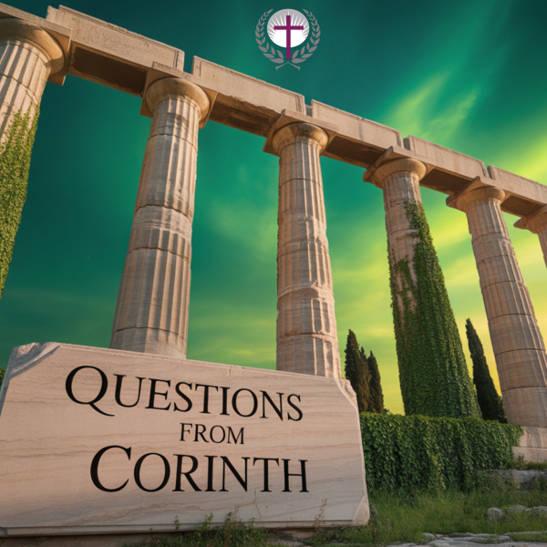
INTRODUCTION

Division in the body of Christ grieves the heart of God and hinders the church’s witness to the world. When Jesus prayed in John 17:21 that His disciples “may be one,” He understood that unity would be our most powerful testimony. Yet throughout church history and in many congregations today, we face the painful reality of conflict, misunderstanding, and fractured relationships. The good news is that Scripture provides us with profound wisdom and practical guidance for both preventing division before it takes root and healing wounds that already exist.

As members of God’s family, we have a sacred responsibility to actively pursue peace and unity. This isn’t about superficial harmony or avoiding difficult conversations—rather, it’s about cultivating the kind of authentic, Christ-centered community where truth and grace walk hand in hand.

Our approach must be both preventative and redemptive. Like a wise gardener who both waters healthy plants and tends to diseased ones, we must simultaneously build strong foundations of unity while also knowing how to restore relationships when they fracture. This requires courage, humility, and a deep commitment to the gospel that reconciles us first to God and then to one another. In this portion of Lesson 2, we’ll examine specific biblical principles and actionable steps that can transform how we handle conflict and pursue the unity for which Christ prayed.
Biblical Responses to Division

“¹⁰ Now I beseech you, brethren, by the name of our Lord Jesus Christ, that ye all speak the same thing, and that there be no divisions among you; but that ye be perfectly joined together in the same mind and in the same judgment” – 1 Corinthians 1:10.

Paul doesn’t simply diagnose the problem of division—he provides clear, biblical solutions. His response to the Corinthian church offers timeless wisdom for addressing and preventing factionalism in the body of Christ.

These biblical principles call us to a higher standard, one rooted in spiritual maturity, Christ-centered thinking, and humble, servant-hearted leadership and fellowship.

Key # 1 - Strive for unity!

- Unity must be grounded in allegiance to Christ alone, not to human leaders, preferences, or traditions.

- All believers are baptized into Christ, making Him our common identity and the true foundation of our fellowship.

- Unity means being aligned in purpose, vision, and values—thinking and acting as one body with Christ as the head.

- This isn’t a call for uniformity in all matters, but for fundamental unity in the gospel, in devotion to Christ, and in love for one another.

Key # 2 - Spiritual Maturity and Growth!

- Move from Milk to Solid Food. Advance beyond basic spiritual truths to a deeper understanding and application of Scripture (Hebrews 5:12-14). Mature believers can handle complexity and nuance without causing division.

- Cultivate Christlike Character. Grow in understanding, humility, patience, and love. Replace childish quarrels with mature, grace-filled dialogue that seeks understanding rather than victory.

- Develop the Mind of Christ. Adopt the servant-hearted, humble mindset of Jesus (Philippians 2:5-8). Consider others’ interests above your own and pursue unity over personal preference.

- Practice Discernment. Learn to distinguish between essential doctrines worth defending and secondary matters where grace and flexibility should prevail—major on the majors.

- Spiritual maturity is marked by the ability to disagree graciously, prioritize relationships over being right, and maintain unity even amid diversity of opinion on non-essential matters.

Key # 3 - Avoid Personality Cults and Factionalism!

- Avoid Celebrity Leaders. Resist the temptation to elevate human leaders to the status of celebrity or guru. All Christian leaders are servants, not stars. Paul reminds us: “So then, no more boasting about human leaders! All things are yours, whether Paul or Apollos or Cephas...and you are of Christ, and Christ is of God” - 1 Corinthians 3:21-23.

- Focus on Message, Not Messenger. Evaluate teaching by its faithfulness to Scripture and the gospel, not by the charisma, eloquence, or popularity of the teacher.

- Celebrate Diverse Gifts. Recognize that God distributes different gifts throughout the body (1 Corinthians 12). Different leaders bring different strengths—all necessary, none is superior.

- Apostles, prophets, and teachers serve different functions
- Variety strengthens rather than divides the church
- Each part needs the others to function fully

Practical Steps to Mitigate Division

- Foster Open Communication. Create safe spaces for honest and loving dialogue where concerns can be openly shared. Promote healthy conversations instead of letting problems linger in silence or spread through gossip.

- Prioritize Reconciliation. Make forgiveness and reconciliation more important than winning arguments or proving you’re right. Pursue peace actively. “If it be possible, as much as lieth in you, live peaceably with all men” – Romans 12:18.

- Encourage Servant Leadership. Develop leaders who model humility and service rather than seeking prominence.

- Encourage Unity Regularly. Make biblical unity a consistent theme in our conversations. Model unity so that others can recognize what healthy, unified leadership looks like.

- Address Issues Early. Don’t ignore the warning signs of division. Address conflicts and disagreements while they’re small, before they grow into entrenched factions that are much harder to reconcile.

When Divisions Exist: How to Biblically Deal with Them

Despite our best efforts at prevention, divisions sometimes arise within church communities. When they do, Scripture offers clear guidance for addressing and healing these rifts in ways that honor God and restore unity.

The goal is always restoration and reconciliation, not punishment or victory for one side over another. Biblical conflict resolution aims to heal the body, not merely to determine who is right.

Address Conflict Early and Biblically

- Step 1: Private Conversation. Following Jesus’ teaching in Matthew 18:15, go directly to the person with whom you have a conflict. Speak privately, humbly, and with the goal of reconciliation rather than accusation.

- Step 2: Bring Witnesses. If private conversation doesn't resolve the issue, involve one or two other mature believers who can help facilitate understanding and reconciliation (Matthew 18:16).

- Step 3: Involve Church Leadership. When the matter remains unresolved, bring it before church leaders who can provide wisdom, discernment, and authority to address the situation (Matthew 18:17).

Throughout these steps, we must base all discussions and decisions on God’s Word. Biblical truth, not personal preference or opinion, must guide the process of addressing division. Always keep the goal in mind: not winning an argument, but restoring relationships, protecting the body, and glorifying God through unity.

Conclusion

We cannot manufacture genuine unity through human effort alone. True, lasting unity is a work of the Holy Spirit in the hearts of believers. Paul reminds us to maintain “the unity of the Spirit through the bond of peace” (Ephesians 4:3), acknowledging that the Spirit creates and sustains unity among God’s people. As a result, we must pursue unity by our actions and our prayers.

The Corinthian church shows us that division is a real and serious threat to the body of Christ. It undermines our witness, stunts our growth, and contradicts the gospel we proclaim. Yet division is not inevitable. Through spiritual maturity, rejection of worldly patterns, biblical conflict resolution, and above all, a relentless focus on Christ, the church can both prevent and overcome factionalism.

Let’s pursue unity by making the following commitments:

- Growing in spiritual maturity and developing a Christ-like character.
- Rejecting personality cults and celebrity culture.
- Prioritizing reconciliation over being right.
- Addressing conflicts early and biblically.


Lord willing, next week, we will continue this series on “Questions from Corinth” and focus on “Is it okay to tolerate sin in the church?” I encourage you to read 1 Corinthians 5-6.

PERSONAL NOTES
………………………………………………………………………………………………………………………………………………………………………………………………………………………………………………………………………………………………………………………………………………………………………………………………………………………………………………………………………………………………………………………………………………………………………………………………………………………………………………………………………………………………………………………………………………………………………………………………………………………………………………………………………………………………………………………………………………………………

