**This Week in the Parish**

*This week, from Tuesday to Friday, Morning and Evening Prayer will be prayed and live streamed at*

*St. George’s Chapel at 8:30 a.m. and 5:00 p.m.*

**Tuesday** 11 a.m. Holy Eucharist (Spencer Home)

**Wednesday** 10:30 a.m.Bible Study (St. George’s)

1:00 p.m. Bible Study (St. James)

2:00 p.m. Willing Workers (St. George’s)

**Thursday**  10:00 a.m. Holy Eucharist (St. George’s)

11:30 a.m. Sermons of St. Leo (ZOOM)

**Saturday**  8:30 a.m. Alpha and Confirmation Class (St. Mary’s) It’s never too late to join!

____________________________________________________

**DAILY BIBLE READINGS**

**A modified schedule from the Prayer Book’s Table of Lessons**

Sunday I Kings 1: 32- End Galatians 2

Monday I Chronicles 22: 2- End Galatians 3

Tuesday I Chronicles 28:1-29:9 Galatians 4:1-5:1

Wednesday I Chronicles 29: 10- End Galatians 5: 2- End

Thursday I kings 3 Galatians 6

Friday I kings 4: 21-End I Corinthians 1:1-25

Saturday I Kings 5 I Corinthians 1: 26-2 End

***Let us remember before God those of our brethren who have departed this life and are at rest.***

**Suzanne Irving Deborah Osiowy**

**______________________________________________________**

**Happy Birthday!**

**Bolaji Daisi aka ‘Bobo’ (18th) and**

**belatedly to Christine Stam (7th)**

The Feast of All Saints is fast approaching. If you wish, write the names of your faithful departed loved ones on the page at the back of the church to be remembered on Sunday Nov. 2nd.

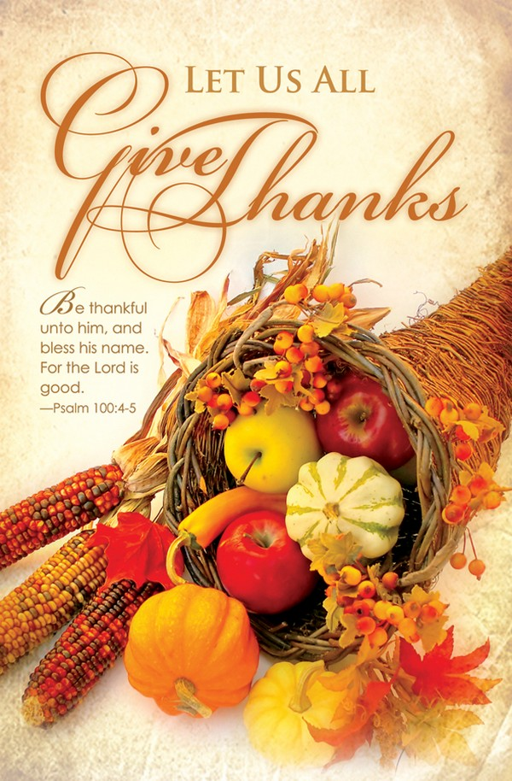

**Welcome to the Parish of the Six Saints and**

**Happy Thanksgiving!**

**Services this morning are being offered at:**

St. Mary’s (39 Mill St., Hillsborough) 9:00 a.m.

St. Andrew’s (105 Elmwood Dr.) 9:00 a.m.

St. George’s (51 Church St.) 8:00 a.m., 9:15 a.m., 10:00 a.m. and 5:00 p.m.

St. James (101 Fairview Dr.) 11:00 a.m.



**Please join us for food and fellowship after**

**Service!**

**_____**__________________________________________________

**The Collects for Harvest Thanksgiving and Trinity 17:**

O ALMIGHTY and everlasting God, who crownest the year with thy goodness, and hast given unto us the fruits of the earth in their season: Give us grateful hearts, that we may unfeignedly thank thee for all thy loving-kindness, and worthily magnify thy holy Name; through Jesus Christ our Lord. Amen.

LORD, we pray thee that thy grace may always prevent and follow us, and make us continually to be given to all good works; through Jesus Christ our Lord. Amen.

**The Introit Psalm**

Righteous art thou, O Lord, and true is thy judgement: **deal with thy servant according unto thy merciful Kindness**. Blessed are those that are undefiled in the way: **and walk in the law of the Lord**. Glory be… and to the Holy Ghost. **As it was… and ever shall be... Amen**

**Today’s Readings: Harvest Thanksgiving (Trinity 17)**

Psalms at Morning Prayer 65 and 67

The Lesson: Isaiah 55. 1-3, 10-12

The Gradual: 92. 1-4

The Epistle: St. James 3. 13-18

The Gospel: St. John 6. 27-35

**Next Sunday’s Readings: (Trinity 18)_**

Psalms at Morning Prayer 105 Part 1

The Lesson: 2 Samuel 7:8-14

The Gradual: 122:6-9

The Epistle: I Corinthians 1:4-8

The Gospel: Mark 12:28-37

**COMING UP ….**

**The Parish Choir will practice Monday, Oct. 20th at 7:00 pm at St. George’s** in preparation for the next Parish Service on October 26th. Everyone is welcome!

**____________________________________________________**

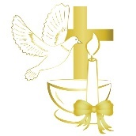**🌿Join Us for a Joyful Sunday! 🌿**

We invite you to a special celebration of Parish **Communion** and **Confirmation** with **Archbishop Edwards**, followed by a **Potluck Lunch** at St. George’s Church. 🕥October 26, Sunday at 10:30 AM 📍There will also be an opportunity to thank Maria Mutch for her service as Office Administrator, and to welcome Savitha Balakrishnan our new Parish Administrator; as well as to see Fr. Chris and Carolyn off as they prepare to leave Moncton for the Parish of Stanley. Bring a dish to share and enjoy fellowship, faith, and community together. All are warmly welcome! ❤️

🗓️ **Date:** Monday, **October 14th** 🕑 **Time:** **2:00 p.m.**   
📍 **Location:** St Georges Ladies’ Parlor

All **St. George’s** **Willing Workers** are invited to gather for our upcoming meeting! Let’s come together in fellowship, share ideas, and plan our next steps in service. Your participation and enthusiasm make a difference — **see you there!** 🌷

**St. James’ Turkey Supper:** Saturday, Nov 1st from 5:00 to 7:00 pm.

**St. George’s CEC Meeting:** Sunday, Oct. 19th at 12 Noon

**Six Saints’ Vestry Meeting:** Tues., Oct. 21st at 6:30 pm (St. Andrew’s)



**Parish Visitors:** there are approximately 60 shut-ins in the Parish of the Six Saints. If you would be willing to visit one or two of these people, please call or email the Parish Office. Thank you!

**Singing With the Saints!** Bearing witness to God: Father, Son and Holy Spirit from 12:30 p.m. to 2:30 p.m. on All Saints’ Day, Saturday, November 1st. This outdoor, ecumenical, gathering, will be held at Aberdeen Park (corner of Botsford and St. George Streets) sponsored by the Parish of the Six Saints. Please begin to pray for this event.



**🌼 GriefShare Begins at St. George’s! 🌼**

**Help and encouragement after the death of a loved one:** A Grief Share support group is a safe, welcoming place where people understand the difficult emotions of grief. At this 13- week group, you’ll receive valuable guidance and tips, leading you to relief, comfort, and peace of mind🗓 **Start Date & Time:** Tuesday, Nov 18 | 1:30 – 3:00 PM  
🤗 **Everyone is welcome!** 👤 **Facilitator:** Rev. Wendy Amos Binks 📧 [**wamamosinks@yahoo.com**](mailto:wamamosinks@yahoo.com)**,** 📞 **506-688-2800** Come share, listen, and find support in a warm, caring community. 💛

**Apple Day Fundraiser 🍎**

Our Beavers, Cubs, and Scouts will be canvassing for **Apple Day** on Saturday, **October 18th** at the Farmers Market on **Westmorland Street** from **8:00 a.m. to 2:00 p.m**. Come out and support our youth!

**Welcome Allison!** Following next Sunday’s 10:00 am Service at St. George’s, a warm welcome to the Six Saints will be extended to Kelly VanBuskirk and his wife, Allison, following their wedding yesterday at St. Ninian’s Cathedral in Antigonish. Thank you for your prayers for these newly weds!

**The Rector’s Corner**

As you may be aware, in preparation for the Rector’s departure, the Six Saints’ Vestry recently approved the creation of a new full-time position of Parish Administrator, replacing the old position of Office Administrator. The interviewing process has been completed and Savitha Balakrishnan has been hired.

The Wardens, Vicar and Rector wish to thank all those who applied. Interviews were intense, involving a three-hour simulation in the parish office answering staged telephone calls and door-bell rings, while working on a Sunday bulletin. Under and around the whole process was prayer for discernment of the Lord’s will.

The Wardens, Vicar and Rector also wish to thank Maria Mutch for the key role she has played in faithful service to the Parish over the past year. Maria’s generous, compassionate and sweet way was a gift to us all, as a brand-new parish. Her thorough and gracious approach with Savitha on the ‘hand-over’ has been exactly what was needed. Please join us at the Parish service on Sunday, October 26th (10:30 am) at St. George’s when we will take an opportunity to welcome Savitha, and express our appreciation to Maria.

According to her training, you will receive this cheery greeting when you call the Parish Office: *“Good morning, Parish of the Six Saints. This is Savitha speaking. How may I help you.”* If you are going by, pleasestop by the Parish Office and meet Savitha. Her hours are 8:00 am to 3:00 pm, Monday to Friday, excluding statutory holidays.

**Riversong In Concert**

**Saturday, October 18, 2025** – **7:00 p.m. ,** Mount Royal United Church, 106 Mount Royal Boulevard, Moncton, Adults: $20:00, Children under 12: Free.

**Sunday, October 19, 2025,** Harvey Hall, 29 Mary’s Point Road, Harvey. **For more information visit facebook.com/RiversongNB**