All Saints Anglican Church
6904 Lougheed Highway, Agassiz, B.C. V0M 1A0
Bulletin October 6th, 2025 – October 12th, 2025

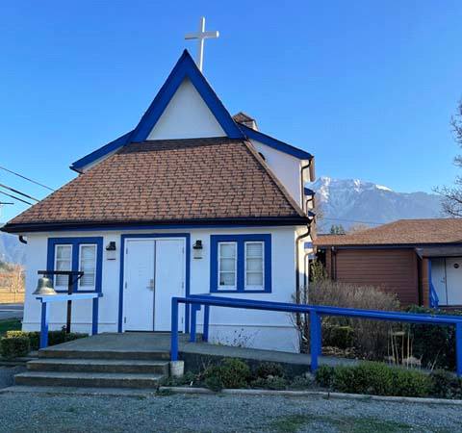

‘The ground we walk does not belong to us; for thousands of years it has been - and remains - the territory of the Stó:lō. We are grateful for their sharing.

Phone: 604-796-3553
Website: www.allsaints-agassiz.ca
https://www.facebook.com/groups/AllSaintsFamily
OUR DOOR IS OPEN AND ALL ARE WELCOME
October 12th, 2025, Harvest Thanksgiving
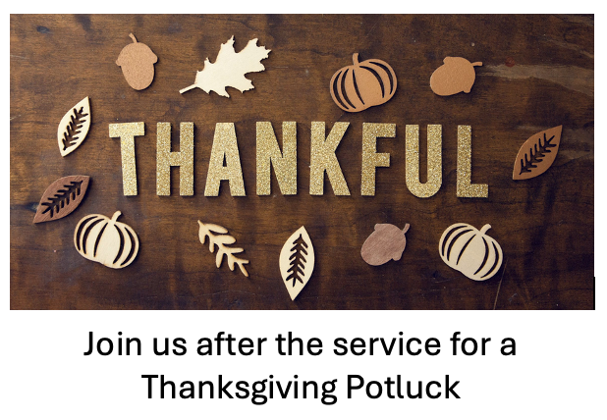
Priest in Charge: The Reverend Philip Barker
Hosts: Graham Featherstone/Jennifer Pinlac
Intercessor: Jennifer Pinlac
Lay Administrator: Dorothy Cresswell
Announcer: Virginia Jennings
Organ/Piano: Francesca Froehlich

Vicar’s cell phone: Revd. Philip Barker. 778-867-2461
Vicar’s Warden: Ginny Jennings. 604-796-2206
People’s Warden: Lynn Laughlin. 604-799-5131
Parish email: revpb1950@gmail.com
Please contact either warden if you have an issue that needs to be brought to the attention of the Vicar - or contact the Vicar direct (see above for details).

Wardens Pitch
- Book Club resumed on Zoom on September 3rd. Our new book is an exciting contemporary autobiography entitled "God's Double Agent: The True Story of a Chinese Christian's Fight for Freedom" by Bob Fu with Nancy French. It is available on Kindle or in paperback for $24.00 on Amazon. Please email Sheila at sjbarker0369@gmail.com if you would like to join the group discussions or have her order a book for you.

- Bible Study with Karol is every Saturday morning 8:30-9:00 on Zoom.

- Prayer Requests can be given on a piece of paper to either of the Wardens or the Vicar or entered in the Prayer Request Book on the lectern. Alternatively, you can contact Anthea Lewis at antheamlewis@shaw.ca for Pray First Prayer Circle, which is a confidential online prayer circle.

- Music Requests may be given to the Wardens or the Vicar.

- AA meets in the hall every Tuesday and Friday at noon.

- Every Thursday in the hall 1100-1200 we have a social time with coffee, games if you like or just talk.

- At 1000-1100 on Thursdays there is an Interactive Bible Study on the day’s Lectionary readings. All are welcome – discover the treasures in this amazing book!

- 5th Sunday of each month will be a potluck lunch after the service.

- Don’t forget our Craft Fair on October 25th
Ministerial Meandering – Returning soon

Truth and Reconciliation
I am writing to invite you to join me for a series of informal (but structured) small group conversations about reconciliation. I am actively working on my own learning about this huge topic and I am inviting you to come along with me on this journey.
I recently signed up to learn how to host other settlers and non-Indigenous people in conversations that support us to build new practices to help us understand how to be in better relationship with Indigenous peoples. The program is called Table Talks, and has been developed by an Indigenous led organization based in syilx territory called IndigenEYEZ.
The Table Talks approach is informative, challenging and fun. I will host a series of 8 1hr conversations after coffee time on Sundays. If you’re interested in learning more about this opportunity to feel engaged, inspired and mobilized, please join me for a Table Talks information session on Sunday, September 28th, from 12-1.00 pm in the church.
If you’re interested in finding out more, please RSVP to Sheila sjbarker0379@gmail.com

Chuckle
Forbidden fruit creates many jams.

Birthdays this MonthOctober

Maureen Moore – 7th

Diocesan Cycle of Prayer: We Pray for the Clergy and Congregation of:

St. Laurence, Coquitlam – The Revd Philip Cochrane, The Revd Patricia Ratcliffe
The Deanery of Yale – The Revd Paul Bowie, Regional Dean

Anglican Church of Canada Cycle of Prayer: We Pray for:

The Rt. Rev. David Lehmann, Bishop, clergy and people of the of the Diocese of Caledonia. The Dean, Council, and congregations of the North Region of the British Columbia Synod. For People and ministries working to address issues of poverty, homelessness, and affordable housing.

Collect

Almighty God, in our baptism you adopted us for your own. Quicken, we pray, your Spirit within us, that we, being renewed both in body and mind, may worship you in sincerity and truth; through Jesus Christ our Lord, who lives and reigns with you and the Holy Spirit, one God, now and for ever.

Readings

Deuteronomy 26:1-11 Valerie Hamilton

26 When you have entered the land the Lord your God is giving you as an inheritance and have taken possession of it and settled in it, ² take some of the firstfruits of all that you produce from the soil of the land the Lord your God is giving you and put them in a basket. Then go to the place the Lord your God will choose as a dwelling for his Name ³ and say to the priest in office at the time, “I declare today to the Lord your God that I have come to the land the Lord swore to our ancestors to give us.”
⁴ The priest shall take the basket from your hands and set it down in front of the altar of the Lord your God.
⁵ Then you shall declare before the Lord your God: “My father was a wandering Aramean, and he went down into Egypt with a few people and lived there and became a great nation, powerful and numerous.
⁶ But the Egyptians mistreated us and made us suffer, subjecting us to harsh labor. ⁷ Then we cried out to the Lord, the God of our ancestors, and the Lord heard our voice and saw our misery, toil and oppression.
⁸ So the Lord brought us out of Egypt with a mighty hand and an outstretched arm, with great terror and with signs and wonders.
⁹ He brought us to this place and gave us this land, a land flowing with milk and honey; ¹⁰ and now I bring the firstfruits of the soil that you, Lord, have given me.” Place the basket before the Lord your God and bow down before him.
¹¹ Then you and the Levites and the foreigners residing among you shall rejoice in all the good things the Lord your God has given to you and your household.

Psalm 100

¹ Shout for joy to the Lord, all the earth.
² Worship the Lord with gladness;
come before him with joyful songs.
³ Know that the Lord is God.
It is he who made us, and we are his;
we are his people, the sheep of his pasture.
⁴ Enter his gates with thanksgiving
and his courts with praise;
give thanks to him and praise his name.
⁵ For the Lord is good and his love endures forever;
his faithfulness continues through all generations.

Philippians 4:4-9 David Hamilton

⁴ Rejoice in the Lord always. I will say it again: Rejoice!
⁵ Let your gentleness be evident to all. The Lord is near.
⁶ Do not be anxious about anything, but in every situation, by prayer and petition, with thanksgiving, present your requests to God.
⁷ And the peace of God, which transcends all understanding, will guard your hearts and your minds in Christ Jesus.
⁸ Finally, brothers and sisters, whatever is true, whatever is noble, whatever is right, whatever is pure, whatever is lovely, whatever is admirable—if anything is excellent or praiseworthy—think about such things.
⁹ Whatever you have learned or received or heard from me, or seen in me—put it into practice. And the God of peace will be with you.

John 6:25-35 Douglas MacAdams

²⁵ When they found him on the other side of the lake, they asked him, “Rabbi, when did you get here?”
²⁶ Jesus answered, “Very truly I tell you, you are looking for me, not because you saw the signs I performed but because you ate the loaves and had your fill.
²⁷ Do not work for food that spoils, but for food that endures to eternal life, which the Son of Man will give you. For on him God the Father has placed his seal of approval.”
²⁸ Then they asked him, “What must we do to do the works God requires?”
²⁹ Jesus answered, “The work of God is this: to believe in the one he has sent.”
³⁰ So they asked him, “What sign then will you give that we may see it and believe you? What will you do? ³¹ Our ancestors ate the manna in the wilderness; as it is written: ‘He gave them bread from heaven to eat.’[”
³² Jesus said to them, “Very truly I tell you, it is not Moses who has given you the bread from heaven, but it is my Father who gives you the true bread from heaven. ³³ For the bread of God is the bread that comes down from heaven and gives life to the world.”
³⁴ “Sir,” they said, “always give us this bread.”
³⁵ Then Jesus declared, “I am the bread of life. Whoever comes to me will never go hungry, and whoever believes in me will never be thirsty.

