Announcements

Monday, October 13
Beaver Valley Band Banquet hall 5:30p.m.

Tuesday, October 14
Community dinner prep Kitchen 9:15a.m.
Bell practice Banquet hall 7:00p.m.

Wednesday, October 15
M & P meeting Board room 10:00a.m.
Community dinner Kitchen / Banquet hall 5:00p.m.
Bay Wind Flutes Sanctuary 5:00p.m.
Choir practice Banquet hall 7:00p.m.

Thursday, October 16
Horticulture Library 1:30p.m.
Board meeting Board room 7:00p.m.
Cemetery Board meeting Library 7:00p.m.
Thursday night group Banquet hall 8:00p.m.

Friday, October 17
Horticulture Library 1:30p.m.

Coming event: Save the date - Wed. October. 29 from 3:45 to 5 p.m. Kid’s Hallowe’en Party in the Banquet Hall. Please register by calling the church office or using the QR code on the posters located on the bulletin boards in the church hall.

Sunday, October 19 - If God’s way is written on our hearts, how do we cultivate practices which enable us to “Live Whole-Heartedly”.
Sunday, October 26 – God’s love and grace are Up amazing! Let’s celebrate how “My Cup Overflows”.
Coffee and Chat Times - Just drop in to share in some informal conversation. Let Beth know if you would like to see these continue beyond the end of October.
Tuesday, October 14 at 3 p.m. at Gordon’s Market and Cafe (1 Hume St., Unit 107)
*Mon. Oct. 20 at 10:30 a.m. at Espresso Post (139 Hurontario St.)
*Lunch on Thurs. Oct. 30 at 11:45 at Georgian Bay Family Restaurant (401 Hume St.). If you know you are coming to lunch, let Beth know by noon on Tues. Oct 28 so we can make an appropriate sized reservation.

Rev. Beth Kerr (she/her)
Diaconal Minister
Trinity United Church
140 Maple Street,
Collingwood, ON L9Y 2P8
www.collingwoodunitedchurch.ca
705-445-3901 (church)
204-872-2370 (cell)
Please note: Friday and Saturday are my sabbath days. I will reply to emails received on those days on the following Monday. For emergencies, please contact my cell phone.

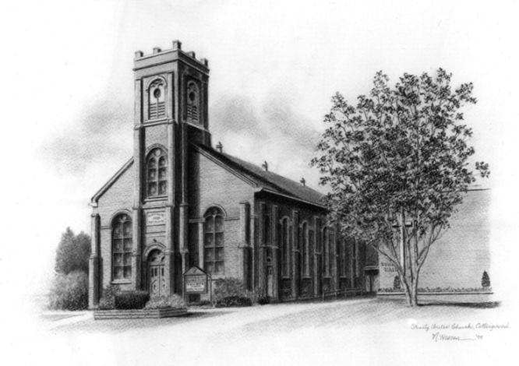

Trinity United Church: Collingwood
Minister: Rev. Beth Kerr, 204.872.2370 (cell)
Minister’s Email minister@collingwoodunitedchurch.ca
Ministry of Music: Paul Sloan, 705.730.3121 (cell)
Choir Director: Lesley Joosten, 705.984.3243
Handbell Director: Maryellen Burgess, 705.443.1422 (cell)
UCW President: Joy Barr 705.445.0726
Office Assistant: Lori Forsythe
Church Office: office@collingwoodunitedchurch.ca
Office Hours: Tuesday to Friday, 8:30 am-12:00 pm
140 Maple Street, Collingwood, ON L9Y 2P8
Telephone: 705.445.3901
Website: www.collingwoodunitedchurch.ca

