This Week at PPBC

**Tuesday, October 14, 2025**

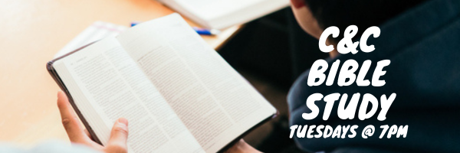

**Wednesdays @ 6:30pm**



**Friday, October 17, 2025**

**Friday, October 17, 2025**

Join us Friday nights at the church from 7:30 pm - 9:30 pm for a time of Bible study and games! All youth in grades 7-12 are welcome.

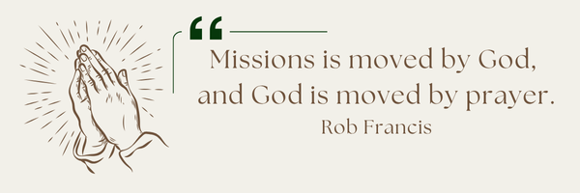

**A Prayer Request from Maria:**Pray for unity, spiritual growth, commitment for 2 groups I am discipling. One group is English ladies (12) and the other is Spanish mixed (11). Pray also for healing. Few months ago I had a fall in my building. I didn't think it was too serious. I now have to have an x-ray on my right leg. I thought it was sciatica but it is not. Pray for healing and the right diagnosis.

Notes

Sunday Ministry Schedules

Below are ministry schedules for Nursery, Jr. Church, Greeters, Ushers, and Sound & Video:

**Nursery  
Oct 12:**Brenda Clemens, Rosalie McLaren, Stephanie Anderson **Oct 19:**Jan Gerrow, Hannah Colwell, Karis Henkleman

**Jr. Church; ages 3 to grade 1   
Oct 12:**Ellianne McLaren, Mikayla Ferguson **Oct 19:**Christine McLaren, Kelsey Schoenrock

**Jr. Church; Grades 2 to 6  
Oct 12:**Gregg & Karen Anderson, Tiffany Green **Oct 19:**Miriam Bolsonello, Jen Owens

**Greeters  
Oct 12:**Steve & Wendy Angrove  
**Oct 19:**Leno & Donna Araujo

**Ushers  
Oct 12:** Joe Colwell, Matt Saunders **Oct 19:** Nick Woytowich, Roy Wilson

**Sound & Video  
Oct 12:**Sound:  Jordan Anderson | Video: Josh Myers **Oct 19**: Sound:  Charlie Deane | Video: William Conley

All are welcome to attend our time of Worship and discussion.

Morning Service

Song – *Praise to The Lord the Almighty*

Welcome

Song – *O for a Thousand Tongues to Sing*

Scripture

Prayer

Song - How Great is the Greatness of God

Song – *Holy Spirit*

Message – *Pastor Jim Clemens*

Song – *Holy Spirit*

Membership Classes

Sunday, October 19th @ 4pm

Contact the Office if you plan to attend

Praise & Prayer Highlights

**PRAY**for our nursery ministry. **PRAY** for wisdom and discernment as we look to accommodate for our growing numbers in the nursery. **PRAY** that God would sustain our volunteers and grow us in our faithfulness to Christ.

**PRAY** for Joan Mabley's ongoing health & recovery as she is now home. **PRAY** for her and the family as they look for care to meet Joan's needs.

**PRAY** for Rob & Shelley VanUden's 6yo great-niece Bryte and her family. **PRAY**for her health and for the family as they try to make decisions on her care.

**PRAY** for the Loback family and their farm Hinterland Growers, as they recover from a robbery last week.**PRAISE** that no one was hurt.

**PRAY**for Bert & Ada Faber and their ongoing health concerns.

**PRAY** for Betty Collins' friend Jan and her ongoing health concerns.

**PRAY** for Dennis Tomcheski and his ongoing health concerns.

**PRAY** for the *Arms of Jesus Families*, as they mourn the loss of a mother.**PRAY** for Jose, his family and everyone in Guatemala as they try to support him and his family in their time of grief.

**Giving**

Just as a reminder, there are several ways you can give:

**In Person** using the offering box located on the back wall of the sanctuary. Donation envelopes are available at the Welcome Centre. Please contact the church office if you would like a box of donation envelopes (office@portperrybaptist.ca)

**Through your online banking**, you may send electronic transfers to ppbcdonations@gmail.com.

**You can also give through Canada Helps**. Donation receipts will be provided by Canada Helps, and transaction fees apply.

***********************************************************************

**Weekly Newsletter**

The PPBC Newsletter is emailed to the church family every Friday. If you would like to be added to the weekly email list, please contact the office by phone: 905-985-8681 or by email: [office@portperrybaptist.ca](mailto:office@portperrybaptist.ca).

*****************************************************************

**Church Information:**

**Location:**

2210 Hwy 7A

Port Perry, ON

L9L 1B4

**Office Hours:**

Monday: 8:30am – 4:00pm

Tuesday: 8:30am – 4:00pm

Wednesday: Closed

Thursday: 8:30am – 4:00pm

Friday: 8:30 am - 3:00 pm

**Contact:**

Phone: 905.985.8681

Email: office@portperrybaptist.ca

Website: www.portperrybaptist.ca

**Staff:**

Sr. Pastor – Rev. Jim Clemens

Administrative Assistant – Madeline Werner

Family Ministries Director – Josh Anderson

**PPBC Newsletter**

**Sunday, October 12th, 2025**



**Sunday Starting Point**

**Sunday, October 12, 2025 - 9:30 am**

*“Beginning the day with the Word and prayer”*

**Adults:**Adults will meet in the sanctuary for a time of study and prayer. Psalm 134.

**Youth:**Jr High (Grades 7-8) will meet in room 18 with Kate Anderson to study the book of Ephesians.

**Children**:

Children ages 3 - grade 6 will meet in room 26

*(Please note nursery is unavailable during Starting Point)*

**Sunday Morning Worship**

**Sunday, October 12, 2025 - 10:30 am**

We are meeting in the sanctuary and will continue to live-stream for those who are unable to attend.

***Message:****Jesus’ Journey to Jerusalem*

***Scripture:****Mark 9-12*

*Pastor Jim Clemens*