SHRINE TOUR
OCTOBER 20, 2025
National Shrine of St. Rita of Cascia
Church and Shrine of St. Anne
Malvern Retreat House Shrine of St. Carlo Acutis
These Shrines are part of the Diocese Jubilee Year Indulgences and Passport Pilgrimage
Bus will depart SPN at 8:20am, return approximately 4:00pm
Cost for bus will be approx $30 cash or check payable to SPN
Bring a bag lunch as our schedule will be very tight.
Please be prepared for $5 free will offering at each Shrine
Reservations and payment due by October 12.
Please contact Eileen at 215-696-2089 or adultfaithformation@spnparish.org

NATIONAL SHRINE OF ST. RITA ST. CARLO ACUTIS
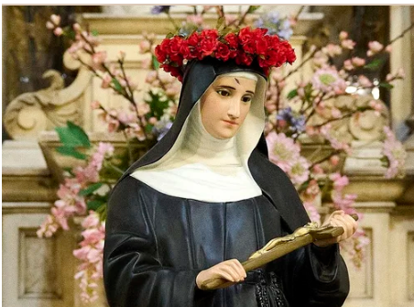

CHURCH AND SHRINE OF ST. ANNE
