This Week at PPBC

**Tuesday, October 7, 2025**

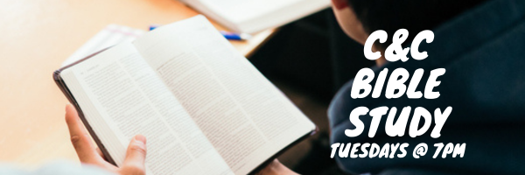

**Wednesdays @ 6:30pm**



**Friday, October 10, 2025**



**Saturday, October 11, 2025**

All men are welcome at the church from 7:30 am - 9:30 am for breakfast and Bible Study

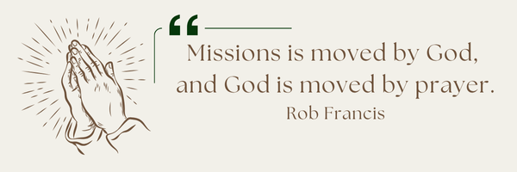

**A Prayer Request from the Lambs:** Thank youJesus for His goodness and care of their family. Their granddaughter, Emelia, after such a difficult time at birth, is thriving. She is now 5 months. Thank you for your prayers! Big sister Olivia started school this September. Carly, the Lambs’ youngest daughter, is writing her exam for her nursing license this month. Please keep her in your prayers. The Lambs are looking forward to spending time with family in the UK mid-October – November.

Notes

Sunday Ministry Schedules

Below are ministry schedules for Nursery, Jr. Church, Greeters, Ushers, and Sound & Video:

**Nursery**  
**Oct 5:**Kathryn denOuden, Amber Saunders, Brantley Colwell  
**Oct 12:**Brenda Clemens, Rosalie McLaren, Stephanie Anderson

**Jr. Church; ages 3 to grade 1**  
**Oct 5:** Justine McKenzie, Hailey Ferguson  
**Oct 12:** Ellianne McLaren, Mikayla Ferguson

**Jr. Church; Grades 2 to 6**  
**Oct 5:**Mary Deli, Kim St-Onge  
**Oct 12:**Gregg & Karen Anderson, Tiffany Green

**Greeters**  
**Oct 5:**Roy & Elizabeth Werner  
**Oct 12:**Paul & Helen Jones

**Ushers**  
**Oct 5: Gregg Anderson,** Graeme Foster  
**Oct 12: Joe Colwell,** Matt Saunders

**Sound & Video**  
**Oct 5:**Sound:  Wyatt Werner | Video: Josh Bolsonello  
**Oct 12:**Sound:  Jordan Anderson | Video: Josh Myers

Morning Service

Song – *Jesus Shall Reign*

Welcome

Song – *My Hope is in The Lord #406*

Baptism – *Andrew Millson*

Song- *All I Have is Christ*

Scripture – Mark 8:27-38

Message – *Pastor Jim Clemens*

Song – *Behold The Lamb*

Communion

Song – *Jesus Thank You*

Membership Classes

Sunday, October 19th @ 4pm

Sign-up in the foyer or contact the Office

Praise & Prayer Highlights

**PRAY**for our nursery ministry. **PRAY** for wisdom and discernment as we look to accommodate for our growing numbers in the nursery. **PRAY** that God would sustain our volunteers and grow us in our faithfulness to Christ.

**PRAY** for Joan Mabley's ongoing health & recovery as she is moved home.

**PRAY** for Rob & Shelley VanUden's 6yo great-niece Bryte and her family. **PRAY**for her health and for the family as they try to make decisions on her care.

**PRAY** for the Loback family and their farm Hinterland Growers, as they recover from a robbery last week.**PRAISE** that no one was hurt.

**PRAY**for Bert & Ada Faber and their ongoing health concerns.

**PRAY** for Betty Collins' friend Jan and her ongoing health concerns.

**PRAY** for Dennis Tomcheski and his ongoing health concerns.

**PRAY** for the *Arms of Jesus Families*, as they mourn the loss of a mother.**PRAY** for Jose, his family and everyone in Guatemala as they try to support him and his family in their time of grief.

**Giving**

Just as a reminder, there are several ways you can give:

**In Person** using the offering box located on the back wall of the sanctuary. Donation envelopes are available at the Welcome Centre. Please contact the church office if you would like a box of donation envelopes (office@portperrybaptist.ca)

**Through your online banking**, you may send electronic transfers to ppbcdonations@gmail.com.

**You can also give through Canada Helps**. Donation receipts will be provided by Canada Helps, and transaction fees apply.

***********************************************************************

**Weekly Newsletter**

The PPBC Newsletter is emailed to the church family every Friday. If you would like to be added to the weekly email list, please contact the office by phone: 905-985-8681 or by email: [office@portperrybaptist.ca](mailto:office@portperrybaptist.ca).

*****************************************************************

**Church Information:**

**Location:**

2210 Hwy 7A

Port Perry, ON

L9L 1B4

**Office Hours:**

Monday: 8:30am – 4:00pm

Tuesday: 8:30am – 4:00pm

Wednesday: Closed

Thursday: 8:30am – 4:00pm

Friday: 8:30 am - 3:00 pm

**Contact:**

Phone: 905.985.8681

Email: office@portperrybaptist.ca

Website: www.portperrybaptist.ca

**Staff:**

Sr. Pastor – Rev. Jim Clemens

Administrative Assistant – Madeline Werner

Family Ministries Director – Josh Anderson

**PPBC Newsletter**

**Sunday, October 5th, 2025**



**Sunday Starting Point**

**Sunday, October 5, 2025 - 9:30 am**

*“Beginning the day with the Word and prayer”*

**Adults:**Adults will meet in the sanctuary for a time of study and prayer. Psalm 134.

**Youth:**Jr High (Grades 7-8) will meet in room 18 with Kate Anderson to study the book of Ephesians.

**Children**:

Children ages 3 - grade 6 will meet in room 26

*(Please note nursery is unavailable during Starting Point)*

**Sunday Morning Worship**

**Sunday, October 5, 2025 - 10:30 am**

We are meeting in the sanctuary and will continue to live-stream for those who are unable to attend.

***Message:****Jesus’ Ministry Continues*

***Scripture:****Mark 5-8*

*Pastor Jim Clemens*