

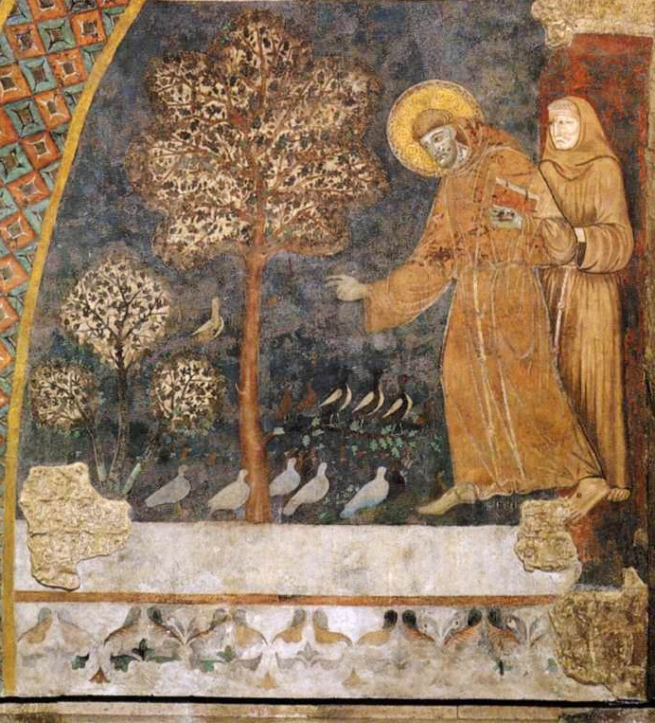

5 October 2025, Pentecost 17
St Francis of Assisi, Season of Creation
Holy Eucharist
with Blessing of the Animals
Service outline, Parish News & Events
8 am HOLY COMMUNION__________________
Celebrant and preacher: Fr. Allen Doerksen
9.30 am FAMILY COMMUNION________________
Celebrant and preacher: Fr. Allen Doerksen
The Gathering of the Community
Worship Songs
Welcome
Territorial Acknowledgement
Greeting Book of Occasional Services,
The Episcopal Church
Song of Praise Gloria (Glory to God) tune: Pulkingham
Collect
The Story of Faith is Proclaimed
First Reading: Isaiah 32:14-18
Gospel Acclamation: Alleluia (sung)
Gospel: Luke 17:5-10
Gospel Acclamation: Alleluia (sung)
Sermon
A short period of silent reflection follows,
signalled by the sound of a bell
Litany for All Creation
Confession and Absolution Season of Creation
Blessing of the Animals - children are invited to help Fr Allen bless the animals
The Peace BAS 192
Offertory Hymn
Prayer over the Gifts
Doxology Praise God from whom all blessings flow

The Celebration of the Eucharist
Eucharistic Prayer Season of Creation #1
Sanctus: Holy, holy, holy Lord
The Lord’s Prayer (sung) BAS 211
Breaking of the Bread BAS 212 #1
The Communion
Music during Communion
Prayer after Communion
Doxology (Glory to God) BAS 214
Blessing & Sending Season of Creation –
New patterns for worship
Announcements & Birthday Box
Closing Song
Dismissal

Welcome to St Philip!
Please join us for coffee and fellowship after the 9.30 service.
The abbreviation BAS in the service order refers to page numbers in the Book of Alternative Services, the green volume in the pews. CP is Common Praise, the blue hymn book.
Welcome to Communion
We want you to feel welcome at St. Philip. All are encouraged to come forward to receive the bread (communion wafer) and wine. If you prefer to receive a blessing, please keep your head and hands down. If you are more comfortable not drinking from the cup, you may keep your head down and let it pass, or return to your pew after receiving the bread. Please tell the person distributing the bread if you require a gluten-free wafer. Prayer Ministers are available during Communion at the 9:30 am service, at the side of the altar.

Offering
It is Anglican custom to receive a financial offering in our worship, as an expression of gratitude to God. Please do not feel compelled to participate in this offering. Your presence is gift enough.
Services this week
5 October - St Francis, Blessing of the Animals
8am Holy Communion
9am Community Prayers downstairs in the youth room
9.30am Holy Eucharist with Blessing of the Animals, in-person and streamed via Facebook Live
Celebrant and preacher: Fr. Allen Doerksen
Altar Guild: Jackie Prowse, Beth Macdonald
Usher: Daniel Varga
Musicians: Dave Conway, Amanda Weinerman, Bruce Fyfe
Readers: Gaye Stone, Joe Weicker
Prayers of the People: Chris Harvey
Children's ministry: Melinda Weicker
Powerpoint slides: Clayton Savage, Mark Evans-Ehricht
Facebook Live: Karishma Iyer
Coffee: Lillian Konkin and Jennifer Clarke
Offerings counters: Betty Davidson, Felicity Bradley
7 October, Tuesday 10.30am Contemplative Prayer
9 October, Thursday 10am service and following discussion. The book for Thursday discussion this fall is S. Mark Heim's Saved from Sacrifice: A Theology of the Cross.
Parish News & Notices
Syrian Fundraiser for Mar Elias - thank you
Thank you to everyone who helped out with this event with their hard work, prayers, and/or financial contributions! We are overwhelmed by the outpouring of support and the generosity of everyone!
On Saturday Sept 27, we fed 67 people and raised $4942 for Mar Elias! This money will be such a blessing to the community in Syria and the dinner was certainly a blessing in fellowship to all of us who joined in.
Thank you again for your support!
- St Philip Missions Committee and Habbous
Thanksgiving Family Service
Next Sunday, October 12th, we will celebrate Harvest Thanksgiving with a Family Service. Children and their families are invited to participate in worship by:
- greeting people at the front door and making sure those who want them have leaflets
- processing the cross during the opening hymn, for the Gospel reading, and during the final song
- reading the first Bible reading
- bringing the eucharistic elements forward to the altar
- bringing the offering plates forward to the altar
- helping the server and deacon to set the Communion table and clear away after communion
If you and your family are interested, please contact Fr Allen, so he can provide the guidance needed for the different roles ahead of time. There is a sign-up sheet in the narthex.
Flowers for Thanksgiving – from the Altar Guild
This Sunday, an Altar Guild member will have a collection envelope in the Narthex for monetary contributions, to be used toward purchasing flowers for decorating the church for Thanksgiving (12 October).
In past years we’ve also collected food donations for the Shelbourne Community Kitchen at Thanksgiving, but they suggest monetary donations through their website for the best food value, because they have access to bulk purchasing, wholesale prices, and discounts, to make every dollar go further than we can by buying individually in the grocery store. Donation options are outlined on their website: https://www.shelbournecommunitykitchen.ca/support-our-work/
Decorating: on Saturday, Oct. 11th, come join the Altar Guild from 9am in decorating the church for Thanksgiving! We’ll be adding colour and celebration through flowers and Fall displays… your help is needed!
Do you have greenery and/or flowers to donate toward decorating? Please drop them off at the church on Friday the 10th, outside the ramp doors. Buckets of water will be available.
Thursday book study schedule
Week Three – Chapter Two (The Cross No One Sees)
Wed, Oct 8, 7 pm Zoom Study
Thurs, Oct 9, 10 am Eucharist + Study (starts ca. 10:30 am)
Week Four – Chapter 3, Part 1 (The Voice of Job: Sacrifice Revealed and Contested) pp. 64-84
Wed, Oct 15, 7 pm Zoom Study
Thurs, Oct 16, 10 am Eucharist + Study (starts ca. 10:30 am)
The Zoom link is in the e-newsletter, or contact Anna: admin@stphilipvictoria.ca
Contemplative Prayer
Please join us on Tuesday mornings, 10:30 - 11:30, meeting in the choir area of the nave (at the front of the church), for a 20 minute contemplative sit with a time of prayer following.
Long-term Housing Rental Request
From Alecs and Lucie Kotesovsky: Our family of five (2 adults, 3 children) is looking for a long-term rental property (apartment or house) in the Greater Victoria or Saanich Peninsula area with the move-in date on or around November 1, 2025. We are seeking a property with 2 or 3 bedrooms. If you have a suitable place available or anticipate availability around this date, please contact Lucie at 778-533-7877 or lucie.kotesovska@seznam.cz . Thank you very much for any tips and information.

Prayers & readings for Sun 28 Sept & the following week:
We pray for Anna, our bishop, and Allen, our rector. In our parish cycle of prayer, we pray for our bookkeeper.
This week our diocese prays for the parish of St Peter, Comox, and their interim priest, Alan Naylor.
This week the Anglican Church of Canada prays for The Rt. Rev. Anna Greenwood-Lee, Bishop, and clergy and people of the Diocese of British Columbia.
Remember missing and murdered Indigenous women, girls, and 2SLGBTQQIA people and their families, and pray for an end to gender-based violence.
In the Anglican Communion cycle of prayer, we pray for the The Anglican Church of Tanzania.
Collect: Most high, omnipotent, good Lord, grant your people grace to renounce gladly the vanities of this world; that, following the way of blessed Francis, we may, for love of you, delight in your whole creation with perfect joy; through Jesus Christ our Lord, who lives and reigns with you and the Holy Spirit, one God, for ever and ever. Amen. (Book of Occasional Services)
Anglican Communion Cycle of Prayer for the week:
- Mon 6 Oct The Diocese of Panama – Iglesia Anglicana de la Region Central de America
- Tues 7 Oct The Diocese of Pankshin – Nigeria
- Wed 8 Oct The Diocese of Panrieng – South Sudan
- Thurs 9 Oct The Diocese of Panyana – South Sudan
- Fri 10 Oct The Diocese of Paraguay – The Anglican Church of S. America
- Sat 11 Oct The Diocese of Paraná – Igreja Episcopal Anglicana do Brasil
Lectionary for Sunday 5 October (Pentecost 17): Lamentations 1:1-6 and Lamentations 3:19-26; 2 Timothy 1:1-14; Luke 17:5-10. This week the first reading at St Philip is Isaiah 32:14-18, the theme passage for this year's Season of Creation
Daily readings below are related to the weekly Sunday Gospel lection and sermon.
- Mon 6 Oct Psalm 3; Habakkuk 1:5-17; James 1:2-11
- Tues 7 Oct Psalm 3; Habakkuk 2:5-11; 1 John 5:1-5, 13-21
- Wed 8 Oct Ps 3; Habakkuk 2:12-20; Mark 11:12-14, 20-24
- Thurs 9 Oct Ps 111; Leviticus 14:33-53; 2 Timothy 1:13-18
- Fri 10 Oct Psalm 111; Numbers 4:34-5:4; 2 Timothy 2:1-7
- Sat 11 Oct Psalm 111; Numbers 12:1-15; Luke 5:12-16

Liturgical resources for the Season of Creation are taken from
https://drive.google.com/file/d/10Oorr0z_GrFfYaqVpQ1nS_knnTe9nzrv/view . Liturgical resources for the Blessing of the Animals are taken from
https://www.episcopalchurch.org/wp-content/uploads/sites/2/2021/01/lm_book_of_occasional_services_2018.pdf
Cover image: St. Francis preaching to the birds outside of Bevagna (by Master of St. Francis), from a sequence of frescoes in the Lower Church, Basilica di San Francesco, Assisi, Italy, ca. 1255. Public domain. https://en.wikipedia.org/wiki/Francis_of_Assisi#/media/File:Francis_preaching_the_birds.fresco._master_of_st_francis._Assisi.jpg

Rector: Rev. Allen Doerksen (incumbent@stphilipvictoria.ca,
work cell 236-508-2928; day off: Friday)
Warden: Judith Armstrong (jarmstrong@stphilipvictoria.ca)
Warden: Larry Anthony (lanthony@stphilipvictoria.ca)
Parish Office Hours: Mon 1-4.30, Wed & Thurs 9-4.30
250-592-6823 | admin@stphilipvictoria.ca
Facebook including live streams: https://www.facebook.com/stphilipoakbay
Instagram: https://www.instagram.com/stphilipoakbay/

Thank you for avoiding scented products at church.

