**THE CHURCH OF** **ST. PHILIP NERI**

PENNSBURG, PENNSYLVANIA FOUNDED 1919

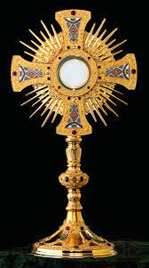**Annual Solemn**

**Forty Hours Devotions**

**Eucharistic Devotions**

Monday, October 6th

8:00 am Holy Mass

Followed by Exposition/Adoration

6:30pm Evening prayer

Homily, Benediction and Reposition

Tuesday, October 7th

8:00am Holy Mass

Followed by Exposition/Adoration

6:30pm Evening Prayer

Homily, Benediction and Reposition

Wednesday, October 8th

8:00am Holy Mass

Followed by Exposition/ Adoration

6:30pm Evening Prayer

Homily, Outdoor Candlelight Procession, Benediction and Reposition

“Could you not keep Watch for one hour with me?” Mark 14:37

Homilists: Reverend Michael Saban

Deacon Michael Franks

Deacon Matthew Horvath