**2nd annual**

**MEN’S FIRESIDE CHAT**

**Wings, hoagies, Beverages…**

**friday, October 10, 7pm**

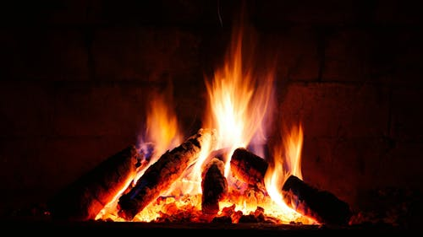

**JOIN FATHER SABAN, MEN FROM THE PARISH AND BRING A FRIEND!!**

**Relax and enjoy a fireside chat**

**with Father and friends**

**Bring a lawn chair or beach chair.**

**Registration after all masses September 27 & 28 in the narthex. We need a head count for food!**