**PARISH HOUSE: October Items of the Month**

**Items Needed:** Soup, Mac n Cheese, Shampoo

**Upcoming Events:**

No 4th Sunday Lunch today

**October 1st** – 6:15pm Choir Practice

7:00pm Team Meeting

**October 8th** – 7:00pm Charge Conference

**October 11th** – 9:00am UMW Meeting

**October 15th –** Bible Study – Romans 8

**October 25th –** 8:00am Men’s Meeting

**Tithes and Offerings:** Give your gifts, tithes, and offerings through PayPal. It is quick, easy, and safe! Just use the camera on your phone to scan the QR Code. *All donations will be placed into our General Account unless otherwise stated.*

**TENNERTON**

*United Methodist Church*

September 28, 2025

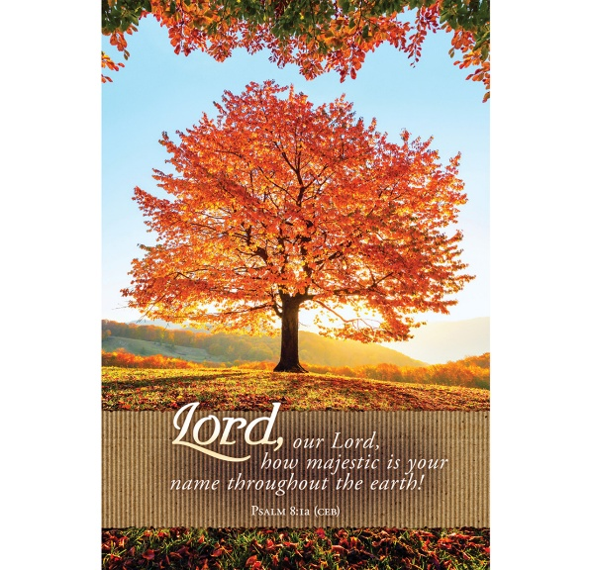

**Pastor Jim Minutelli**

**304-629-9398**

**Office**: 126 Tallmansville Rd.  
Buckhannon, WV 26201

**Office Phone:** 304-472-1064  
**Sermon by Phone:** 304-460-0029  
**Website:** <https://tennertonumc.org>  
**Email:** [umc.tennerton@gmail.com](mailto:umc.tennerton@gmail.com)   
**Facebook:** <https://www.facebook.com/thetennertonumc>  
**Prayer Concerns:** Call Candy George @ 304-613-6424

**JOYS & CONCERNS**

**WELCOME/OPENING PRAYER** Pastor

**\*OPENING** **HYMN:** “Spirit Song”

12/1 UMH 347

**CALL TO WORSHIP:** Nicene Creed UMH 880

**\*OFFERING/DOXOLOGY/PRAYER**

UMH 95

**CHOIR:** “There Is Power In The Blood”

HHH 101

**CHILDREN MESSAGE** Vickie Snyder

**ANNOUNCEMENTS** *(ON BACK PAGE)*

**READING:**

**\*HYMN:** **“**The Church’s One Foundation”

19/2 UMH 545

**SCRIPTURE READING:**

**SERMON:**

**\*CLOSING HYMN:** “The Old Rugged Cross”

17/30 UMH 504

**\*BENEDICTION**

**GREETERS & WORSHIP LEADERS** *If you would like to be a greeter or lead worship service,   
print your name on the clip board on the front pew.*

***This Week*   
GREETER(S):** Neale Hinkle & Linda Ball

**WORSHIP LEADER:** Kathy Black

***Next Week*   
GREETER(S):** Betsy Flitcraft

**WORSHIP LEADER:** Lynn Frum

**OCTOBER BIRTHDAYS**Susie Sheets – 3rd, Chris Carson – 6th,

Tressie George - 11th,

Alecsis Butler – 13th, Ron Sheets – 29th

“The smallest seed of faith is

better than the largest fruit

of happiness.”

Henry David Thoreau

***\*Please stand if you are able. Don’t Forget to Feed the Pig***