

**Word & Actions**

**Alignment Game**

FIRST: Print 3 copies of the PDF: Memory Game for Session 1.3 onto two-sided cardstock. Or Print 3 copies of the four pages as separate pages and then glue them onto some cardstock or construction paper. Now, cut apart into cards.

1. Spread the cards on the floor (or table) face down in rows and columns.

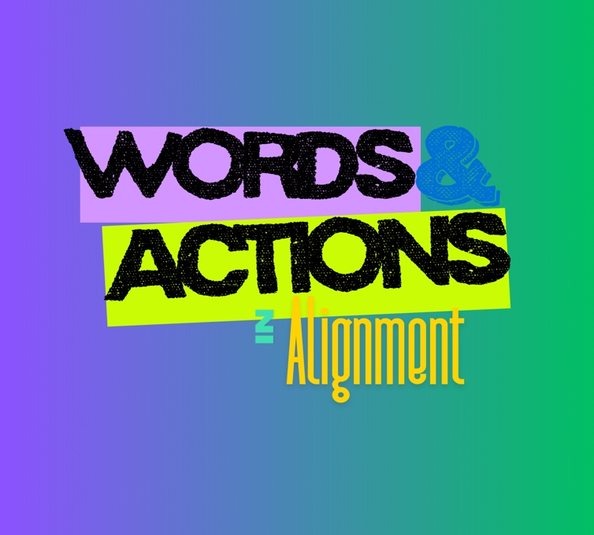

1. First person flips over one card.
2. They then chose another card and flips it over.
   1. If it aligns (is a match) to the first card and makes set, player takes both cards and gets another turn.
   2. If the new card does not align (or match) with the first card, then both cards are turned over and the next person takes their turn.
3. At the end, person with the most sets of cards wins.

Variation: if there is a large group of students playing, make teams and have someone from each team choose for their team each time. You could also play Teacher vs. Students.