First United Church
Hanna, AB



Annual Report
2024

TABLE OF CONTENTS
AGENDA
MINUTES OF MARCH 10, 2024 ANNUAL CONGREGATIONAL MEETING 1
MINUTES OF APRIL 7, 2024 CONGREGATIONAL MEETING 7
MINISTERS REPORT 10
WORSHIP / MISSION & OUTREACH REPORT 12
CENTER STREET THRIFT STORE REPORT 15
MEMORIAL PARK REPORT 22
PASTORAL CARE REPORT 23
MINISTRY AND PERSONNEL REPORT 24
CHRISTIAN EDUCATION REPORT 26
FUNERAL LUNCH REPORT 26
TRUSTEES REPORT 27
PROPERTY REPORT 29
FINANCE COMMITTEE
FINANCE REPORT 31
BALANCE SHEET 34
PROPOSED BUDGET & INCOME COMPARISON 35
PROPOSED BUDGET – OPERATING ACCOUNT 37
2024 COMMITTEE MEMBERS 39

THANK YOU TO ALL COMMITTEE CHAIRS/ MEMBERS FOR YOUR TIME
AND EFFORT THROUGHOUT THE YEAR AND IN PREPARING THESE REPORTS.

FIRST UNITED CHURCH – HANNA, ALBERTA

ANNUAL CONGREGATIONAL MEETING AGENDA
FEBRUARY 23, 2025
- Call to Order

- Welcome and Opening Worship

- Opening of Annual Congregational Meeting

“I NOW DECLARE THE ANNUAL CONGREGATIONAL MEETING FOR THIS FIRST UNITED CHURCH, HANNA, DULY CONSTITUTED FOR THE DUTIES ASSIGNED TO IT, ON THIS 23RD DAY OF FEBRUARY 2025. MAY GOD BLESS US IN ALL OUR UNDERTAKINGS.”

- All Present be Allowed to Vote – require a motion

- Adopt Agenda

- Nominations & Installations – for today’s annual meeting
  - Nomination of Annual Congregational Meeting Chairperson
  - Nomination of Annual Congregational Meeting Secretary
  - Installation of Annual Congregational Meeting Chairperson and Secretary

- Congregational Meeting Minutes
  - Annual Meeting Sunday, March 10, 2024
  - Congregational Meeting Sunday, April 7, 2024

- Business Arising from the Minutes


- Budget 2024

- Annual Reports
  - Approval of Annual Reports

- Election of Governing Bodies
  - Chairperson
  - Vice Chair
  - Secretary
  - Committee Members
  - Presbytery Representative

- New Business

- Courtesies

- Adjournment

- 1 –

First United Church – Hanna Alberta
Congregational Meeting
Sunday March 10, 2024 – 12:30 P.M.
PRESENT:

Council Chair Winona Gutsche
Council Secretary Rhonda Lund
Student Minister Carrie Symondson
Chinook Winds Region Representative Roxanne Williams – by Video

Betty Gall Gloria Hutton Linda Quaschnick
Liz Gourlay Jean Lypka Clarke Snell
Opal Hendrickson Maxine Nill Gwen Snell
Donna Hickle Geraldo Pérez Neala-Rea Sprinkhuysen

1.0 Call to Order
Chairperson of Hanna First United Church Council, Winona Gutsche called the Annual Congregational meeting to order at 12:31 pm.

2.0 Welcoming and Opening Worship
Winona Gutsche welcomed everyone to the meeting and introduced herself as Chairperson for the Church Council, Rhonda Lund as Secretary for Church Council and Neala-Rea Sprinkhuysen as Church Treasurer. She advised that our Chinook Winds Region representative, Roxanne Williams was joining the meeting by video link. Carrie Symondson, Student Minister for Hanna First United Church introduced Roxanne to those present.

Carrie Symondson opened the meeting with a prayer for God’s wisdom and guidance as we make decisions for the coming year.

3.0 Opening of Annual Congregational Meeting
Winona Gutsche opened the meeting with the following declaration: “I now declare the annual congregational meeting for this First United Church, Hanna duly constituted for the duties assigned to it, on this 10th day of March 2024. May God bless us in all our undertakings.”

4.0 Motion for all Present to be allowed to vote.
Motion No. 1. Moved by Gwen Snell that all present are allowed to vote at this Congregational Meeting. Motion seconded by Donna Hickle. Carried.

5.0 Adopt Agenda
Motion No. 2. Moved by Gwen Snell that the Agenda for the March 10, 2024 Annual Congregational Meeting of the Hanna First United Church be approved as presented. Motion seconded by Jean Lypka. Carried.

6.0 Nominations and Installation – Chairperson & Secretary

6.1 Nomination of Annual Congregational Meeting Chairperson

Motion No. 3. Moved by Gwen Snell that Winona Gutsche be appointed as Chairperson for the Annual Congregational Meeting.

Motion seconded by Maxine Nill. Carried.
- 2 –

6.2 Nomination of Annual Congregational Meeting Secretary

Motion No. 4. Moved by Linda Quaschnick that Rhonda Lund be appointed as Secretary for the Annual Congregational Meeting.

Motion seconded by Jean Lypka. Carried.

6.3 Installation of Annual Congregational Meeting Chairperson and Secretary

Winona Gutsche and Rhonda Lund took their positions for the meeting.

7.0 Congregational Meeting Minutes
Motion No. 5. Moved by Gwen Snell that the Minutes of the Annual Congregational Meeting held February 26, 2023 be adopted as presented.

Motion seconded by Gloria Hutton. Carried.

8.0 Business Arising from the Minutes
No items of business were brought forward.

9.0 Budget 2024

Neala-Rea Sprinkhuysen reviewed the 2024 Proposed Budget as printed on pages 30-32 of the Annual Report. As always, the budget proposes verry conservative earnings and expenses. Unfortunately, revenues are not keeping up with expenses and we are projecting a larger shortfall than the 2023 budget.
In response to the proposed budget, the following items were discussed:
- Budget includes a withdrawal from the investment fund as we do not have the revenue to cover expenses. At this point we have a guaranteed monthly income of $750.00 and average monthly expenses of $9,000.
- The Thrift Store has already contributed an additional $12,000 to operating in 2024.
- The Mohl investment fund provides $10,000 per year for operating, but that fund will be depleted in 2025.
- There are funds in Guaranteed Investment Certificates, but those funds were not donated for operating. Also, the memorial account has funds that are not used for operating as they are donated in memory of people.
- Support for the Thrift Store helps us to maintain the church. It was noted that the Thrift Store donates to other organizations as well, including the Hospital Auxiliary Rummage sale.
- Fundraising options to bring in revenue were discussed. We are open to ideas, but there is no guarantee that we would raise significant funds.
  - We don’t have the manpower and donations of supplies that we used to have, and we do not have a commercial kitchen.
  - If we were to hold a turkey, ham, or beef dinner we would need to charge a fee like community organizations rather than have a free will offering.
  - We cannot hold raffles as churches are not allowed to gamble.
  - We can do bake sales, etc., but how much would it bring in?
  - Partnering with other organizations for fundraising, but must align with what we can do and what we have to work with.

- 3 –

  - We do what we can based on our abilities to bring people into the church and raise funds based on what our abilities are:
    - The Thrift Store is a huge commitment for volunteers.
    - Stage Hanna Choir brings people together in the church.

- Regarding expenses, the following items were noted:
  - The budget does not include extra or unnecessary items – just essential operating costs.
  - Expenses are increasing (annual assessment to United Church of Canada, insurance, salaries & benefits, utilities)
  - Budget does not include funds for unexpected expenses (i.e.: roof repair and copier/printer purchase in 2023)
  - There are no funds included for preventative maintenance for the church or manse.
  - There are funds in the memorial account or GICs that have been donated with restrictions that the funds be used for projects rather than operations.

Winona Gutsche thanked everyone for their input and encouraged them to bring ideas forward to the council.

Motion No. 6. Moved by Maxine Nill that the 2024 Proposed Operating Budget for Hanna First United Church be approved as presented.

Motion seconded by Clarke Snell. Carried.

Chair Winona Gutsche thanked the members of the Finance Committee and the Treasurer for their work on the 2024 proposed budget.

10.0 Annual Reports

Winona Gutsche stated that as congregation members have had the opportunity to read the Committee Reports in the Annual Report, committee representatives will not review the reports but will answer any questions from the congregation.

Motion No. 7. Moved by Gloria Hutton that the Committee Reports in the Annual Report be accepted as presented. Motion seconded by Betty Gall. Carried.

Winona Gutsche thanked the members of the committees for the time & effort they give to the church each year.

11.0 Election of Governing Bodies

11.1 Chairperson

Motion No. 8. Moved by Gloria Hutton that Winona Gutsche be nominated for Chairperson of the Hanna First United Church Council for a one-year term.

Motion seconded by Linda Quaschnick. Carried.

Motion No 9. Moved by Betty Gall that nominations for Council Chairperson cease.

Motion seconded by Jean Lypka. Carried.

Winona Gutsche accepted the position of Council Chairperson and thanked the congregation.

- 4 –

11.2 Vice Chairperson

Motion No. 10. Moved by Linda Quaschnick that Tyler Creasy be nominated for Vice Chairperson of the Hanna First United Church Council for a one-year term.

Motion seconded by Gloria Hutton. Carried.

Motion No 11. Moved by Jean Lypka that nominations for Council Vice Chairperson cease.

Motion seconded by Betty Gall. Carried.

Tyler Creasy was not present but had indicated he would accept the position of Council Vice Chairperson.

11.3 Secretary

Motion No. 12. Moved by Gwen Snell that Rhonda Lund be nominated for Secretary of the Hanna First United Church Council for a one-year term.
Motion seconded by Gloria Hutton. Carried.

Motion No 13. Moved by Maxine Nill that nominations for Council Secretary cease.

Motions seconded by Jean Lypka. Carried.

Rhonda Lund accepted the position of Council Secretary and thanked the congregation.

11.4 Committee Members

Winona reviewed the list of committee members for the following term.

Motion No. 14. Moved by Donna Hickle that the following people be appointed to the various Committees of Hanna First United Church until the next annual congregational meeting.
- FINANCE – Linda Quaschnick, Rhonda Lund, Richard Preston & Treasurer Neala-Rea Sprinkhuysen
- BOARD OF TRUSTEES – Tyler Creasy, Cliff Buchanan, Liz Gourlay & Marilyn Forbes
- WORSHIP – Jean Lypka, Denise Weins, Gloria Hutton & Sandra Wade
- CHRISTIAN EDUCATION – Not Active
- PASTORAL CARE – Linda Quaschnick, Gail Smigg, Donna Hickle & Liz Gourlay
- MEMORIAL PARK – Winona Gutsche, Lynette Barker, Gwen Snell & Clarke Snell
- MINISTRY & PERSONNEL – Winona Gutsche & Alan Lund
- MISSION & OUTREACH – Not Active
- PROPERTY – Gwen Snell, Ira Ross & Alan Lund
- THRIFT STORE – Gloria Hutton, Linda Quaschnick, Charlotte Preston
- FUNERAL LUNCH – MaryAnn Campion, Charlotte Preston, Linda Quaschnick, Karen Gordon & Rhonda Lund.

Motion seconded by Betty Gall. Carried.

It was noted that there has not been a need for the funeral lunch committee during the past year.
- 5 –

11.5 Chinook Winds Regional Council Representative

Hanna First United Church has not had a representative appointed to Chinook Winds Region for a number of years.

Roxanne Williams advised that she is the appointed representative from her congregation. She stated that she receives newsletters from Chinook Winds that she reviews for items that pertain to the congregation and forwards the information to the board chair. The region asks that you attend the region meetings, but that can be done through zoom video conference.
Having a representative keeps your church members in the know and provides educational information. Roxanne stated that Carrie Symondson does an excellent job keeping the board informed.

Winona Gutsche noted that the Chinook Winds Region representative appointment will remain open for someone from the congregation to volunteer.

12.0 New Business

Winona Gutsche asked Carrie Symondson to speak to the congregation regarding Remit 1: Establishing an Autonomous National Indigenous Organization.

Carrie Symondson advised that if the remit is approved:
- It will allow for the creation of separate indigenous churches within the United Church of Canada.
- The changes will only affect the churches on the reserves, not other churches.
- It will take the indigenous churches out of the Remit process and give them the freedom to determine how they will operate within their culture and with a cultural perspective. This will be their opportunity to worship according to their beliefs.
- The indigenous church will not make changes that will affect the rest of the united churches.
- There will be two distinct churches under the United Church of Canada.

Winona Gutsche confirmed that the church council will vote for the Remit at the next meeting, but the council would like input from the congregation. She opened the meeting for discussion. The following items were noted or discussed:
- The remit is giving the indigenous community the freedom to bring their own spirituality, beliefs and practices into their services. At this point, the United Church of Canada dictates everything.
- There should be no impact financially at this point because there is already a line in the United Church of Canada budget for the indigenous churches.
- The UCC has had a relationship with indigenous churches for over 40 years.
- The indigenous churches may choose not to go ahead with the changes, but they are asking for the right to make the decision. The remit allows the process to happen under the UCC mandate.
- There will be no changes to sacraments such as communion or baptism.
- Ministers will be able to move from indigenous to non-indigenous churches (with some training).
- The remit requires a majority vote to pass, not a unanimous vote, so if we vote against the remit and we are in the minority, the remit will still pass.
- The indigenous churches do not want to establish their own church, only bring their own culture into their services that are based on united church principles.

- 6 –

- Not separating the churches, just allowing the indigenous churches the opportunity to embrace some local customs within the United Church and Christianity. The indigenous churches would have the same principles and ethics but would be allowed to bring their culture back into their services.
- The indigenous churches will remain part of the United Church whether the remit is passed or not.

Motion No. 15. Moved by Gwen Snell that the congregation of Hanna First United Church direct the church council to vote yes to Remit #1: Establishing an Autonomous National Indigenous Organization within the United Church of Canada at the council meeting scheduled for March 13, 2024.

Motion seconded by Donna Hickle. Carried.

Winona Gutsche thanked Roxanne Williams and Carrie Symondson for their input and explanation of Remit #1. She thanked everyone for participating in the discussion and the final decision.

Winona Gutsche asked the members present for input on an idea to send a letter to Hanna and area residents to let people know who we are and what is happening in our church. With the updated membership list, the letter could be sent by email to members who have provided their email address. After discussion, it was the consensus that a letter be prepared and mailed to anyone with a Hanna mailbox, emailed to members and advertised on social media.

Carrie Symondson advised that she will be leaving this week for Saskatoon to take her last class and be interviewed for approval to become an ordained minister. Roxanne Williams and Winona Gutsche congratulated Carrie and wished her well.

Gwen Snell reminded everyone that the Stage Hanna Musical Chorus will be holding a concert on Friday, April 5 at 7:00 p.m. in the church and will be taking a silver collection that will be donated to the church.

13.0 Courtesies

Winona Gutsche extended appreciation to everyone who came to the meeting and participated in the discussion as everyone’s’ voice is important. She thanked everyone who has agreed to serve on the committees or boards and Rhonda Lund for accepting the secretary position. She also thanked the congregation for electing her as chairperson for another term. Winona thanked Carrie Symondson and Roxanne Williams for their guidance and support during the past year.

14.0 Adjournment

Winona Gutsche declared the meeting adjourned at 1:45 pm

_______________________________ ____________________________
Chair Winona Gutsche Secretary Rhonda Lund
- 7 –

First United Church – Hanna Alberta
Congregational Meeting
Sunday April 7, 2024 – 12:00 P.M.
PRESENT:

Council Chair Winona Gutsche
Council Secretary Rhonda Lund
Chinook Winds Region Representative Roxanne Williams – by video link

Cliff Buchanan Donna Hickle Gail Smigg
Grace Buchanan Gloria Hutton Marge Sorenson
Tyler Creasy Alan Lund Linda Quaschnick
Laura Creasy Jean Lypka Clarke Snell
Doreen Fitchett Maxine Nill Gwen Snell
Liz Gourlay Grace Pattinson Sandra Wade
Denise Wiens

1.0 Call to Order
Chairperson of Hanna First United Church Council, Winona Gutsche called the Congregational meeting to order at 12:04 pm.

2.0 Agenda
Moved by Gwen Snell that the Agenda for April 7, 2024 congregational meeting be adopted as presented. Motion seconded by Clarke Snell. Carried.

3.0 Welcoming and Opening Worship
Winona Gutsche welcomed everyone to the meeting and advised that our Chinook Winds Region representative, Roxanne Williams was joining the meeting by video link.

3.0 Opening of Congregational Meeting
Winona Gutsche opened the meeting with the following declaration: “I now declare the congregational meeting for this First United Church, Hanna duly constituted for the duties assigned to it, on this 7th day of April 2024. May God bless us in all our undertakings.”

4.0 Motion for all Present to be allowed to vote.
Motion No. 23. Moved by Tyler Creasy that all present are allowed to vote at this Congregational Meeting.

Motion seconded by Jean Lypka. Carried.

5.0 New Business
Winona Gutsche advised that the only item on the agenda today is the United Church contract with our student minister, Carrie Symondson. The current contract between First United Church and Carrie Symondson was for a student minister. The contract was for a .75 position for two years. This agreement expires in June 2024. During her term with Hanna First United, Carrie has been completing her education and has been accepted for ordination in the United Church of Canada. We congratulate her on this achievement.

Winona Gutsche advised that she has met informally with Carrie to discuss our options moving forward and she has confirmed that a .75 position would be acceptable to her and be sufficient for the needs of the congregation.
- 8 –

Rhonda Lund, representing the finance committee, confirmed that a meeting was held with members of Ministry & Personnel, Finance, Carrie’s Lay Supervision Team and the church treasurer to discuss our options for a new contract with Carrie. The consensus from the committee meeting was that the recommendation to the congregation would be to offer a contract to Carrie Symondson to be minister of Hanna First United Church at a .75 position with salary based on the United Church of Canada scale plus 10%. This would fit within the budget that was passed at the annual meeting, as the difference between the student position and the ordained minister position would be approximately $200.00 per month and only affect the budget for the last 6 months of the year.

Winona reviewed the report from Neala-Rea regarding church finances. We receive approximately $1,300.00 in revenue each month and expenses are approximately $10,000.00. We have needed to take money from our investment funds. She noted that the Thrift Store has been an amazing asset to us and without their generosity, we would have a very difficult time operating. We have been fortunate enough to have an investment fund and some large donations, but we cannot operate once those funds are depleted.

Winona Gutsche advised that the recommendation of the committee was to offer the position to Carrie for one year term, due to our financial position. It was noted that the contract could be extended if Carrie was willing to accept the terms.

The congregation discussed a number of items including:
- If the congregation is not in favor of hiring a minister but wants to keep our doors open as a church, the members need to volunteer and be more involved in holding services.
- If the congregation wants to change the terms of the recommendation and Carrie does not accept the terms, a search committee would have to be formed to find a new minister under new terms.
- Shared services between First United and Redeemer Lutheran has been discussed at the council level and a committee level.
  - Would require Chinook Winds input and approval. This is a larger proposal than sharing Lent or Advent services.
  - Not sure how it would save us money – still need a minister.
  - Would be another item that would need volunteers to coordinate.
  - Some members may not want to attend a different church each week.
- Shared services between First United and surrounding United Churches
  - Would require interest from other United Churches.
  - We would still have our basic expenses for operating the building.
  - This may be an option to consider in the future, but for now we have time to explore other options.
- Are we closing for the summer and how does that impact staff? Winona confirmed that in 2023 the church was closed for the month of July and staff used that month for vacation time. Also, if we close for a month, we do not need to look for pulpit supply. Winona will discuss a closure for 2024 with Carrie and bring it up at the April 10 Council meeting.

Roxanne Williams suggested that staff at Chinook Winds Region may have some advice or be able to provide some options for First United as they move forward. She advised that with Carrie as an ordained minister, she will be able to contact Rev. Dr. Karen Medland at Chinook Winds Region, as she may be able to provide assistance to First United.
- 9 –

Gloria Hutton stated that her opinion is the congregation owes Carrie a big vote of thanks for wanting to stay at First United. We are very lucky that she would consider us when she has other options as an ordained minister.

Motion No. 24. Moved by Gloria Hutton that Carrie Symondson be offered the position as ordained minister for Hanna First United Church at a .75 position with salary based on the United Church of Canada scale plus 10%, for a one year term effective
June 1 2024. Motion seconded by Jean Pattinson. Carried.

Winona Gutsche extended appreciation to everyone who came to the meeting and participated in the discussion. She also thanked Roxanne Williams for her guidance.

Roxanne Williams congratulated the congregation on their decision to offer the position of minister in Hanna First United Church to Carrie Symondson.

6.0 Adjournment
Winona Gutsche declared the meeting adjourned at 12:23 p.m.

_______________________________ ____________________________
Chair Winona Gutsche Secretary Rhonda Lund

- 10 -
Minister’s Report – 2024

I’m pleased to be serving the community of Hanna, First United. We have a tremendous crew of people coordinating their time and effort to provide an energetic worship environment filled with spiritual engagement, music, and support. Fellowship is strong, as seen during the refreshments after the service; most who attend will stay to visit. A sense of belonging is essential, and newcomers quickly find themselves engaged in conversation.

We have an outstanding group of volunteers in our Thrift store contributing thousands of hours annually, and dedicated individuals to provide leadership, compassion and care through the executive council, trustees and various committees. The church cannot exist without its people, and I’m blessed to be in community with those who emphasize unity, support and encouragement.

Our building is active throughout the week hosting different functions. These include Center Street Thrift, Stage Hanna Musical Theatre Chorus rehearsals, bible studies, worship, fellowship socials and special events. In 2024, we had two musical performances with the Hanna & District Community Band. In December, they coordinated with Stage Hanna Musical Theatre Chorus to provide an engaging concert enjoyed by many.

First United has been working closely with those of the Lutheran Community to offer fellowship, faith formation, and encouragement. This includes grief and bereavement support with Laurie Palmer from Hanna Funeral Services. Together, we held the Advent Candlelight Service of Lament and have plans for a monthly social for people to talk about the hard things; a place where death is not a taboo subject. May all who attend find compassion, a listening ear and spiritual engagement within a supportive environment.


Hanna, First United, is a small, but vibrant community of believers engaged in spiritual growth, faith formation and fellowship. I’m grateful for the support I received during my student residency, and the continuing encouragement given after my ordination last June.
I look forward to what the future may bring.

Carrie Symondson
Ordained Minister

- 11 –


Eternal Wisdom, Holy Spirit,
You provide us with needed knowledge,
And teach us the ways of God.
We come to you for fulfillment and nourishment,
Grant to us hearts thirsting for closeness with you,
So that we may engage in spiritual worship,
With an outpouring of enthusiastic praise,
And a desire for service.
Let your loving compassion and merciful grace,
Be known to all we meet,
So they may encounter you,
Because of their interactions with us.
In this we pray, through God’s Son,
Jesus the Christ, Our Lord and Saviour.
Amen

- 12 -

Worship Committee ~ 2024

Members:
Jean Lypka (Chair), Gloria Hutton, Sandra Wade, Denise Wiens

Thank-you to:
- Tricia Gladdish, our church Secretary, for arranging the roster for weekly readers, and all the other things she does to make our services run smoothly.
- Denise Wiens, our pianist, and our choir members for sharing their talents weekly. Music adds so much and is so important in our services each week.
- All who so willingly run our PowerPoint and read the scriptures and Minutes for Missions
- Gloria Hutton, who keeps our sanctuary beautifully decorated.
- All who help decorate for Christmas and take the decorations down after Christmas.
- Tyler Creasy who trimmed and cleaned the candles for our Advent Wreath.
- All those who help prepare and serve communion.
- All the ladies who make coffee & tea and provide yummy treats each week and clean up after coffee.

All who help in any way make our services and after service fellowship so much better - you are all very much appreciated!

Activities/Accomplishments in 2024:
We are very pleased that Rev. Carrie Symondson, agreed to stay on with us at the end of her 20-month ministry education time commitment. We are committed to continue supporting Carrie in her ministry.

In conjunction with Hanna Funeral Services and Pastor Matt from Redeemer Lutheran, we hosted the Blue Christmas Candlelight service. This is a beautiful service for anyone who finds Christmas a difficult time, whether due to loss or loneliness.

- 13-

This service was very well attended. Many expressed their appreciation for the sincere and gentle acknowledgement of their grief at a time when most are celebrating.

We are currently doing a Bible study on Unshakeable Hope, which is very good! This is held on Tuesday evenings at 6:30. Each week is a stand-alone study, not dependent on the previous weeks. All are welcome! Please join us any time you are able.

Communion is held on the last Sunday of each month. If you would consider helping serve communion, please let Carrie know. It is very easy to do, and it would be nice to have a few more willing helpers.

We now have a 5-member choir!! If you, or someone you know, would like to sing in the choir, please let Jean Lypka know!!! Also, if you have any favorite hymns, please let us know and we will do our best to include them in upcoming services.

Goals/Plans for 2025:
Carrie is planning on doing a new Bible Study – Something Sacred, Reflections on Music and Faith. This Lenten devotional explores how the power of music can deepen our connection to God and form us as disciples of Christ. Stay tuned for details.

Wednesday morning coffee and chat at the church is ongoing. It is so nice to be able to come and just enjoy a cup of coffee and visit. Please join us whenever you can! Wednesdays at 10 AM.

Also, we are now joining the residents at the Lodge for coffee on Saturday mornings at 10 AM. All are welcome!!

- 14 -

Financial Information (fundraising, expenses etc.):
We had looked at purchasing new candles for the Advent Wreath, but thanks
to Tyler, that was not necessary, as he was able to trim the candles and clean
the candles up. Thank you so much, Tyler! We are still looking to purchase a new round table to hold the advent wreath, as the one we have been using is borrowed.

Mission and Service Report for 2024:
We are very pleased that, with a contribution from the Thrift Store, we were able to meet our giving goal of $4000 for 2024!

Our gifts for M&S are how we live out the call of the church to do God’s mission. M&S is the heart and soul of The United Church of Canada. If M&S giving is already a regular part of your life, thank you so much! If you have not given, please consider making Mission and Service giving a regular part of your life of faith. Loving our neighbor is at the heart of our Mission and Service.

Any other news or information you would like to share with the congregation:
The Worship Committee is seeking new members to join us. If helping with planning and enhancing the worship life of our congregation is something that interests you, please talk to any of our members!

Submitted by: Jean Lypka (Chair)


- 15 -

Executive: Gloria Hutton
Linda Quaschnick
Charlotte Preston

Store Manager: Tammi Hafso

A year in review ~ The year 2024 was once again very successful and rewarding. The generosity of the community with their ample donations and customer support never ceases to surprise us. Although at times, our volunteers are a bit overwhelmed with the volume of donations, they work diligently to keep our store stocked and up to date with quality merchandise.

The volunteers are truly the backbone of the store and without them the
Thrift Store would not be able to continue. It is not easy standing, sorting,
lifting all the donations and the list goes on. These faithful group of volunteers gave 3,361.5 hours to the store in 2024. And we owe them our gratitude and never-ending appreciation for allowing the store to carry on. We also owe our gratitude to our 7,089 customers who supported us in 2024.

When we have more donations than the store can handle, we save them for Inclusion Alberta, a family based non-profit organization that advocates on behalf of children and adults with developmental disabilities and their families. This organization comes and picks up the bags and pays us by the pound. In 2024 this resulted in revenue of $1,200.00

We also save for approximately 6 months to donate to the Hanna hospital ladies Auxiliary for their semi-annual rummage sales. As most know all the funds raised at these sales is used to support our Hanna health care facilities. Value donated $5000.00 +. Financially this year far exceeded our expectations.

Our yearly commitment to the church
Mission and Service $2,250.00
Operating Account $25,000.00
Discretionary $17,000.000

-16 -

In Kind Donations made in 2024
- Family in need ($15.00)
- Kidney foundation 11 bags ($400.00)
- Mustard Seed - 2 bags of clothes
- Home Care (25.00)
- Lodge (100.00)
- Food Bank Clothes (135.00)
- Hanna Museum- vintage clothes (90.00)
- Hospital (5.00)
- Individual- Comforter (6.00)
- Foodbank- winter coats (220.00) & Toiletries (50.00)
- Baskets of Hope Mountains N Rose Women’s Shelters (50.00)
- Young mom ($25.00) toys ($9.00)
- Museum- Halloween decorations ($55.00)
Total values = $1,235.00

Cash Donations
- Hanna Food Bank and JCC food programs for a total of $7,000.00
- Along with cash donations we also provided gift certificates to the food bank in the values of $630.00 which are distributed with their Christmas hampers

The Thrift Store is blessed with confident, trustworthy paid staff and volunteers. With their support the Center Street Thrift Store will continue to provide a much-needed service not just to the church but to the community at large.

Respectfully submitted,
Gloria Hutton



- 17 –

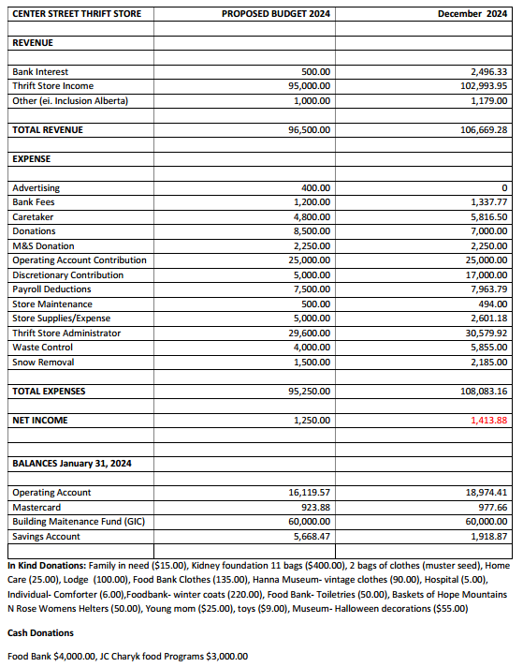
Thrift Store – Proposed Budget 2024 / Actual 2024

- 18 –

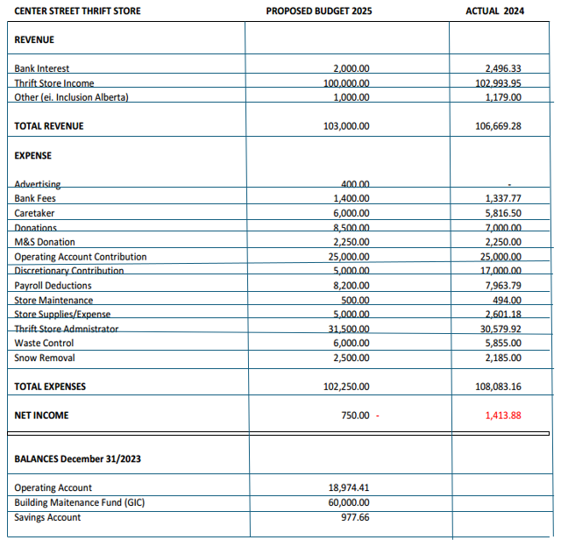
THRIFT STORE ~ PROPOSED BUDGET 2025 / ACTUAL 2024

- 19 –
THRIFT STORE ~ VOLUNTEER HOURS

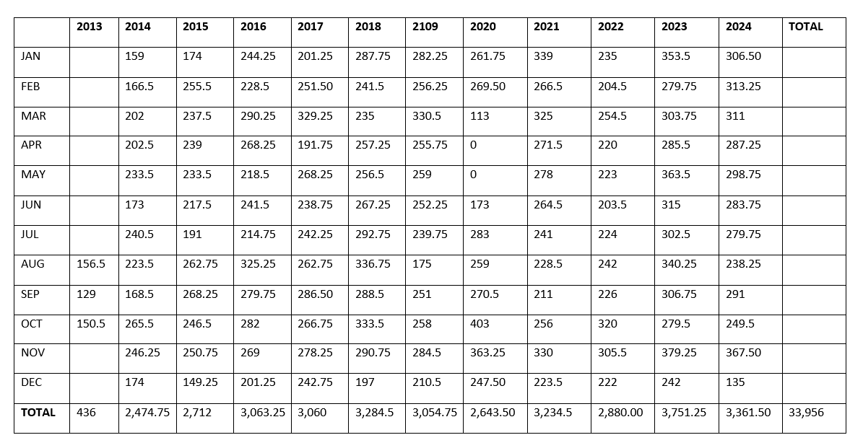

-20-
THRIFT STORE ~ SALES COMPARISON

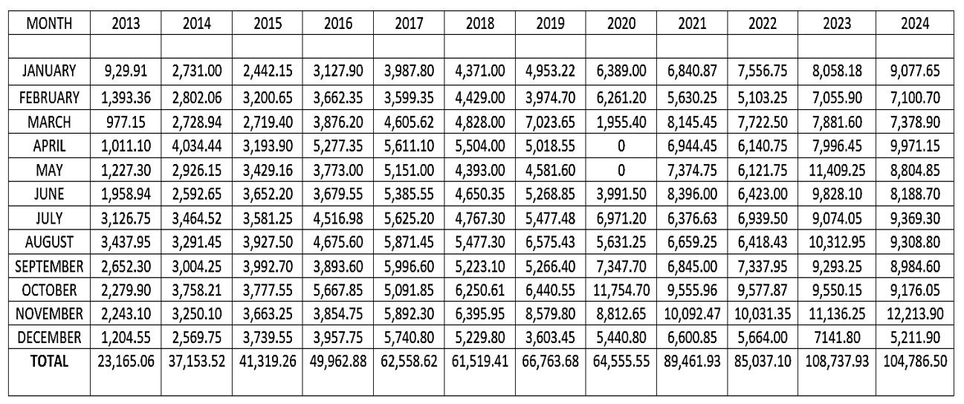

-21-
THRIFT STORE ~ NUMBER OF CUSTOMERS

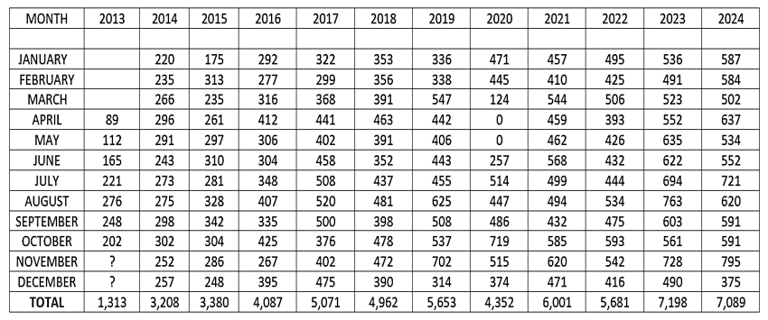

- 22 -

Memorial Park ~ 2024

Members:
Winona Gutsche, Lynette Barker, Gwen Snell

Thank-you’s:
We would like to thank Ray Heilman and his family for cutting the grass at the Church, the Church Park the manse property. Ray also raked up the fall leaves does extras when required.

The flowers planted were beautiful this year; thank you to the committee and members of our Congregation who helped with watering and weeding the flowers.

Our committee also sets ups / takes down the Christmas Nativity Scene. This year Garrett Beaudoin let us borrow hay bales to hold up the nativity scene.

Thank you to members of our community and congregation who made donations to the park.

Activities/Accomplishments in 2024:
Regular maintenance and upkeep of the park

Goals/Plans for 2025:
Continue to keep the park beautiful for all to enjoy.

The parks committee has not fundraised in a couple years, due to covid and our committee being busy with day-to-day routines.

Any other news or information you would like to share with the congregation:
We would like to thank everyone who helps at the park even if they are not on the committee. It is appreciated.

Submitted by: Winona Gutsche (Chair)


- 23 -

Pastoral Care ~ 2024

Members: Elizabeth Gourlay, Donna Hickle,
Linda Quaschnick & Gayle Smigg

Our minister, Carrie, is available for pastoral concerns and visits.
Please Call: 854-9190

Our pastoral care team fosters connection and belonging within the community. Social engagements and visitations are ongoing activities. Donna has been faithfully sending birthday/anniversary blessings, notes wishing for a speedy recovery, and those expressing condolences.

2024 was a tough year for our community, as we saw nearly a dozen members transition into the afterlife. The number grows when considering close relations who do not live in Hanna. Our pastoral care team provides care for those who make known their needs. Unfortunately, we are not always informed. We ask for your help. Please call the church, as you are our primary source of information.

Suffering alone can lead to isolation. If a friend or family member comes to mind; you already know they need help. Our minister is available to meet in your home, or at the church. Carrie works to create a safe space, one without judgement, to engage with individuals as they share their stories. If further help is required, she will offer referrals.

Fellowship is essential for maintaining connection and developing a strong sense of belonging within a community. We offer several opportunities throughout the week. Refreshments are provided after the 10:00 AM worship service; most in attendance stay to visit. On Wednesdays, we have a midweek social at 10:00 AM in the fellowship room, and on Saturdays our minister hosts a ‘Coffee Group’ at the Lodge. It has become a popular activity serving all faith communities within Hanna.

Our minister is available to meet throughout the day, including evenings and weekends.

If you have a pastoral emergency, call Carrie, at 854-9190

Though she takes breaks from the phone, she does check her messages. Please state your emergency and Carrie will promptly return your call.
- 24 -



Members: Winona Gutsche & Alan Lund

Thank-you:
The committee members are very grateful for the support and assistance from Carrie Symondson, Neala-Rea Sprinkhuysen and Tricia Gladdish during the year.

Activities/Accomplishments in 2024:
In January, the committee chair and treasurer met to review the cleaning contract and put together a proposal regarding cleaning hours required based on prior year averages. The proposal was reviewed with the Thrift Store executive as well, prior to being amended to 8 hours per week (6 – thrift store and 2 – church). The committee chair met with Patricia Kautz, the interim caretaker, to review the contract. Later in the year, Perry Laughlin resigned as caretaker and Patricia Kautz was offered the contract for caretaking services for Hanna First United Church, which she accepted.

It was discovered that there was an oversight when the agreement was signed in July 2022 to hire Neala-Rea Sprinkhuysen as treasurer. The United Church of Canada requires that members of council must be full members of the congregation. As Neala-Rea is not a member of First United Church, an exemption of the requirement was needed from Chinook Winds Region to approve her contract. The necessary steps were taken to ensure Neala-Rea Sprinkhuysen could remain as treasurer for Hanna First United Church.

At the April 7 Congregational Meeting it was recommended that Council offer Carrie Symondson the position of minister for Hanna First United Church based on the recommendation presented at the meeting.

- 25 -

A motion was passed at the April 10 church council meeting that the congregation of Hanna First United Church approves the Call for Ordination for Carrie Symondson to serve as word, sacrament, and pastoral care minister of Hanna First United Church for a one year term
at a .75 position with salary based on the United Church of Canada scale plus 10%, when her contract ends as a student.

Rev. Symondson was ordained at a service held June 1st at Mill Woods United Church in Edmonton. A covenanting service for Rev. Symondson will be held at Hanna First United Church, with representatives from Chinook Winds Region and our congregation.

This year the Church Council developed a brochure highlighting the church,
our ministry, the thrift store and all that we have to offer. This brochure was mailed to the residents of Hanna in hope that we would attract families to join our church and to remind the current members of what
we have.

Committee chair, Winona Gutsche, kept the church council informed of staff changes throughout the year, including medical leave, office hour changes, vacation time and continuing education requirements.

As the December council meeting was cancelled, the committee recommended salary adjustments at the January 8, 2025 meeting. The recommendation was to provide a cost-of-living increase for the minister, office administrator and thrift store manager based on recommendation of the United Church of Canada and input from the treasurer and thrift store executive. The rates for pulpit supply and the music director were also increased at that meeting. Increases were effective January 1, 2025.

The Ministry and Personnel Committee members encourage you to approach us with concerns, questions or accolades regarding church operations.

Submitted by: Winona Gutsche, Chair

- 26 -

CHRISTIAN EDUCATION
Christian Education has nothing to report for 2024
as there was not an active Sunday School
due to lack of attendance.

****************************************
FUNERAL LUNCH COMMITTEE

Members:
Mary Ann Campion, Charlotte Preston, Linda Quaschnick & Karen Gordon

Activities & Accomplishments in 2024:
October 23rd: Frank Neufeld
We served 75 guests for Franks luncheon. Thank you to those who donated lunch items and to the volunteers. Our committee is always ready if the need arises.

Respectfully submitted by:
Mary Ann Campion, Charlotte Preston,
Linda Quaschnick & Karen Gordon

- 27 -

BOARD OF TRUSTEES

MEMBERS: Tyler Creasy, Liz Gourlay, Cliff Buchanan, Marilyn Forbes

THANK YOU: Thank you to the Mohl Family for their gracious donation again of $10,000. Thank you to the Thrift Store for annual contributions to the church operating fund and Thrift Store GIC. Thank you to Ray Hickle and the Sloan Family for their previous investments that continue to help our church carry on.

We lost Marylin Forbes on May 24th of this year. She was a dedicated member of
the board of trustees. We thank her for all she did for our church - she will be missed.

ACTIVITIES / ACCOMPLISHMENTS IN 2024:
March 19th Board Meeting – Discussed UHT (Underused Housing Tax Form).
Forms were completed and signed by each board member for 2022/2023 and submitted before the deadline of April 30th.

June 2nd – Confirmation was received in the mail from the Calgary Land Titles Office. The names on the Memorial Park Land Title have been updated to the current board of trustee’s names.

June 28th Board Meeting – Discussed the motion from April 10th Council Meeting (request to transfer $30,000 from the United Church Investment to the General Operating Account to cover church expenses). The intent is that the United Church Investment will be replenished in January of 2025 from the Thrift Store GIC when it matures.

July 2nd – Cliff Buchanan and Tyler Creasy went into the Royal Bank to complete the $30,000 transfer and to review the investment.

September 27th Board Meeting – Discussed Insurance. Received the HUB Self Insurance Quote for $11,466.01. Compared it against our current policy. It is cheaper but does not contain certain things that our current provider does (i.e.. extra insurance for volunteers) and some lower coverage than our current provider. After much discussion, decided to talk to the current provider to see what they could offer us in reduction of premiums.

- 28-

October 24th – Zoom Meeting with current insurance provider. Through this meeting the trustees were able to decrease the premiums (increased deductible to $5000), added liability umbrella insurance. increased abuse liability, extended liability to green space behind the church and included extra equipment breakdown and volunteer insurance. Premium is $10,991.68 for 2025 plus $348 for equipment breakdown and $300 for volunteer insurance for a total of $11,639.68. Premiums for 2024 were $14,015.85 so this is a savings of $2,376.17 with more coverage. Tyler Creasy filled out the Insurance Statement of Value to the best of his ability.

GOALS / PLANS FOR 2025: To recruit more members for the board and to update the land titles. Annual review of United Church Investment.

FINANCIAL INFORMATION: The United Church Investment gained $3,181.76 in interest – the balance was $72,658.70 on December 31st, 2023, and the balance was $45,840.46 on December 31st, 2024 – this includes the $30,000 withdrawal to help with operating expenses. The balances in our other investments are as follows: Thrift Store GIC - $60,000, Mohl Fund $10,000 and the Hickle GIC - $10,100.39. The insurance cost in 2024 was $14,015.85 and will be $11,639.68 in 2025.

Submitted By: Tyler Creasy – Chair, Board Of Trustees



- 29 -

PROPERTY REPORT - 2024



Members: Gwen Snell, Alan Lund

Thank You’s: The committee members are grateful
for the assistance from other members of the
congregation to clean, organize and maintain
the church, our thrift store and the manse.

Activities and Accomplishments in 2024:
Our committee continues to try to maintain our church property through regular maintenance and repairs. We are a small committee and appreciate the support of our church volunteers and local contractors in helping to keep things in good repair.
While we do try to keep on top of things, sometimes we miss something – thank you to those who reach out directly and let us know of issues so that we can look after them in a timely manner.

General Maintenance and repairs included:
- Church sign on the exterior was updated to reflect Minister Carrie Symondson, as she is no longer a student minster.
- General sewer cleaning maintenance
- Eavestrough maintenance – cleaning and repairs as needed
- Irrigation maintenance – including church and park properties
- Window and door inspections – repairs and replacement where required
- Replacement of lights, etc.
- The choir room, furnace room and storage room under the main stairs were cleaned , with items being given to the thrift store or taken to the Regional Waste Site.
- Annual inspections such as the fire extinguisher and chair lift are coordinated by Trish Gladdish (thank you Trish!)
- The grand piano that was donated to the church 8 years ago required a major repair this year. Thanks to Denise Weins for coordinating these repairs and piano tuning as needed.

Larger maintenance items included:
- Ray Heilman and Family continued their contract to look after mowing and yard maintenance for the summer and snow removal for the winter. We are very pleased and thankful for the excellent care and service which they provide.

- 30 -

- Plumbing issues and furnace (boiler) maintenance were completed by Sinclair Plumbing and Heating. Tyler Creasy has also been assisting us with the required monthly system checks and record keeping.
- Additional Roof repairs for the church were completed by Cooper Roofing of Red Deer. They repaired seams and vents as we experienced some leaking unrelated to the work completed by Cooper Roofing in 2023..
- Minor electrical work was completed with the assistance of Ermel Electric of Hanna – which included the replacement of the light at the Thrift Store sorting area.
- Our church is checked annually by a professional service for ant or rodent concerns. This is preventative and ensures that we do not have an issue. Also, two low frequency noise emitters were purchased to repel bats from the sanctuary. This is the only solution, as bats are a protected species.

Goals/Plans for 2025:
- We have a solution for the ice buildup and some volunteer assistance to try to address the ice build up over the thrift store entrance. Once the weather is better and conditions are safer installation of a heat tape will proceed. WE are also planning to have gutter guards installed to keep leaves and pine needles from blocking the flow of water in the eaves.
- Replacement of Manse furnace remains on our list. But as long as It appears to be operating fine and there are no further issues, we will keep it operating as is.
- There are concerns about the wood rot around some of the church windows. We will look into a possible solution with an affordable cost.

Financial information (fundraising, expenses, etc.)
As noted in our goals/plans we will consider any upgrades or changes in conjunction with need and budget.

We have an aging facility that will continue to require maintenance and repairs that will increase over time. We will continue to endeavor to maintain a safe, comfortable facility while being responsible with any expenditures required.

Respectfully submitted by:

Gwen Snell & Alan Lund

- 31 -

Finance Committee - 2024


Members:
Linda Quaschnick, Chair
Neala-Rea Sprinkhuysen, Treasurer
Rhonda Lund, Secretary
Richard Preston

As always, we begin each year developing a budget to present to the annual congregational meeting. Working closely with our treasurer Neala-Rea Sprinkhuysen, Church Council and Rev. Symondson, the finance committee presented a conservative budget which allows for the work of the church to continue. We recommended staff salary increases based on information from the United Church of Canada and made every effort to account for maintenance and upkeep of the church and manse.

The committee members appreciate Neala-Rea for her diligence as our treasurer in keeping the committee and council informed as we moved through the year.

Church finances continue to present challenges for the committee as costs are increasing (utilities, insurance, etc.) and offerings are not keeping pace. With the average monthly expenses of $10,200 and the average monthly offerings of $1,300, the committee has had to rely on other sources of revenue.

In April the Finance committee met with representatives from the Thrift Store and the Board of Trustees to review options for financing. The Thrift Store executive offered to provide $30,000 to finance ongoing expenses, however they could not withdraw the funds from their guaranteed investment certificate without significant penalty.

The Board of Trustees agreed to withdraw the required funds from the investment account, with the acknowledgement that the funds would be replaced in January 2025 when the Thrift Store GIC was renewed. The Council members accepted the recommendation from the joint committee and made the difficult decision to request the Board of Trustees to withdraw $30,000 from the investment account to ensure there would be revenue to pay expenses until the fall fundraising campaign.

We are very grateful for the legacy funds that have been given to our church over the years and the stewardship of the Board of Trustees to invest and maintain the funds. It is not the intention or expectation that the investment funds be depleted each year for operating expenses, however we found ourselves without any other option.
- 32 -

Although the $30,000 withdrawn in 2024 will be replaced in 2025, the investment account is slowly being depleted and we cannot commit to any fundraising events as we no longer have the volunteer base for donations of goods and manpower.

When the fall fundraising letter was prepared for the members of the congregation, it highlighted the many positive things happening in Hanna First United Church and thanked all those who contribute to the work and finances of the church. However, we felt it necessary to inform the congregation of the economic difficulties that the church is facing. The letter emphasized the fact that the church investment account is being used for operating expenses and we do not have the ability to replenish the account. We do not want to mislead people to believe the church can continue to operate in this manner.

Some items that affected the 2024 budget include:
- Closed the church to Sunday Services for the month of July (provides vacation time for staff without paying for pulpit supply)
- Maintained the commitment for Mission and Service to $4,000 (reduced in 2023 from $5,000). The Thrift Store provides $2,250 toward this commitment.
- Stage Hanna Musical Chorus was provided rehearsal space in the sanctuary at no cost. The Chorus, with the Hanna & District Community Band, held two concerts during the year (April 5 and December 13) and donated $732.60 from the free will offerings to the church.
- Canada Post was on strike when the fall fundraising letters were due to be sent. Many members received their letter by email, but the total received was less than budgeted.

2024 Financial Overview:

2024 Revenue
- Donations $ 2,269.28
- Rental Income $600.00
- Fall Fundraising Offerings $17,300.00 (4,670. below 2023)
- Offerings $30,947.00 (8,602. above 2023)
(Includes a $10,000 donation)
- Annual Thrift Store support $42,000.00 (12,000. above budget)
- Annual Mohl Fund Investment $10,000.00
- Investment Fund $30,000.00
(To be replenished by Thrift Store)

Total Revenue Over 2024 Budget $133,116.28

- 33-

2024 Expenses $125,919.35 (10,769.89 under 2023)

Total Expenses Over 2023 Budget $7,196.93

We are sincerely grateful for the financial blessings we received in 2024:
- Continued congregational support through weekly and monthly offerings.
- Generous congregational support for our fall fundraising campaign.
- Centre Street Thrift Store support $42,000.00
- Mohl Investment Fund support $10,000.00*
- Security of our Investment funds
  - Ray Hickle Memorial $10,000.00
  - General Investments $42,840.46
* It is important to note that the Mohl Investment Fund was set up to provide $10,000 per year to assist with staff costs. The final funds from this account will be withdrawn in 2025.

We want to extend our heartfelt appreciation to the following:
- Neala-Rea Sprinkhuysen for her assistance as treasurer.
- Laura Creasy, our former treasurer, for her assistance when we have questions.
- Cindy Hickle for auditing our financial records.
- Chair Winona Gutsche and members of Church Council for their support and assistance when needed.
- Members of our congregation who provide offerings throughout the year on a consistent basis as well as those who are able to provide very generous legacy donations to our church.
- Centre Street Thrift Store manager and volunteers over the past 12 years for their recognition of our financial need and provision of essential funding to our church. It is truly appreciated. This vital organization serves the needs of the community by accepting donations and preparing them for sale, as well as donating funds or goods to other organizations in need.

As the banking world changes with online services, we find that we are changing with it in the way we accept donations and pay invoices. If you have any questions regarding how to make a donation or offering online, please contact a member of the committee or Tricia at the church office.

-34-

BALANCE SHEET

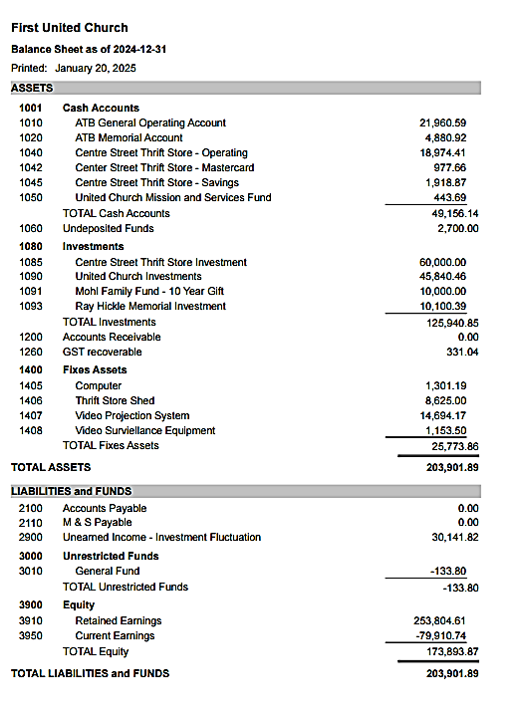

-35-

PROPOSED BUDGET AND INCOME COMPARISON

-36-

PROPOSED BUDGET AND INCOME COMPARISON

-37-

PROPOSED BUDGET ~ OPERATING ACCOUNT

- 38 -

-39-

2024 Church Committee Members

CHAIR: Winona Gutsche
SECRETARY: Rhonda Lund
VICE CHAIR: Tyler Creasy
FINANCE: Linda Quaschnick, Rhonda Lund, Richard Preston
& Neala-Rea Sprinkhuysen – Treasurer

BOARD OF TRUSTEES: Tyler Creasy, Cliff Buchanan, Liz Gourlay & Marilyn Forbes
WORSHIP: Jean Lypka, Denise Weins, Gloria Hutton & Sandra Wade
CHRISTIAN EDUCATION: Not Active
PASTORAL CARE: Linda Quaschnick, Gail Smigg, Donna Hickle & Liz Gourlay
MEMORIAL PARK: Winona Gutsche, Lynette Barker, Gwen Snell & Clarke Snell
MINISTRY & PERSONNEL: Winona Gutsche & Alan Lund
MISSION & OUTREACH: Not Active
PROPERTY: Gwen Snell, Ira Ross & Alan Lund
THRIFT STORE: Gloria Hutton, Linda Quaschnick, Charlotte Preston

FUNERAL LUNCH: MaryAnn Campion, Charlotte Preston, Karen Gordon & Rhonda Lund

