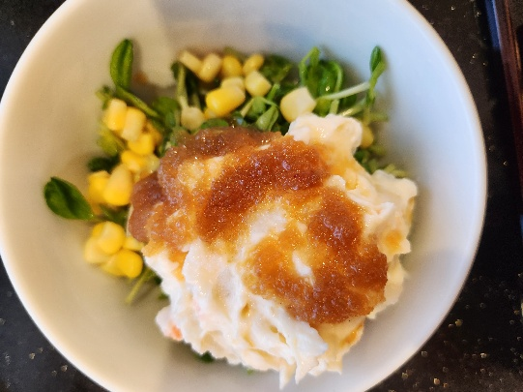
Japanese potato salad seems to be served throughout the day and evening here--as a side dish for lunch, as an afternoon snack, and as an appetizer with cold drinks, especially whiskey and beer. Here, we present an easy version that takes only a few minutes to prepare, then keep in the fridge. The secret ingredient? Just a touch of miso paste!
Japanese Potato Salad
serves 2

Ingredients:
2 medium white potatoes
1 green onion, slices thinly
1 ear of corn, kernels cut off
1 carrot, grated
2 T mayonnaise, mixed with 1 tsp or so miso paste

To Make:
-Boil potatoes until they are soft, with their jackets on--this keeps the potatoes sweet
-Peel potatoes while warm, dice roughly and add onion. Stir well.
-When potatoes are cool to the touch, add other veg, mayo and miso paste mixture.
-Refrigerate until cold, then serve with a few additional slices green onion, a sprinkling of furikake seasoning and/or drizzle of sesame dressing (both from your local Trader Joe’s).

