**St. Paul**

**UNITED CHURCH OF CHRIST**

**September 7, 2025 10:30am**

***Welcome!*** Whether you are a guest, friend or member, we are delighted that you are here. Large print bulletins are available at either door. Ask a greeter for any directions you may need.

*“Please note that this service will be live-streamed on Facebook. If you do not wish to be visible on camera, please let an usher know so we can take appropriate measures to ensure*

*your privacy."*

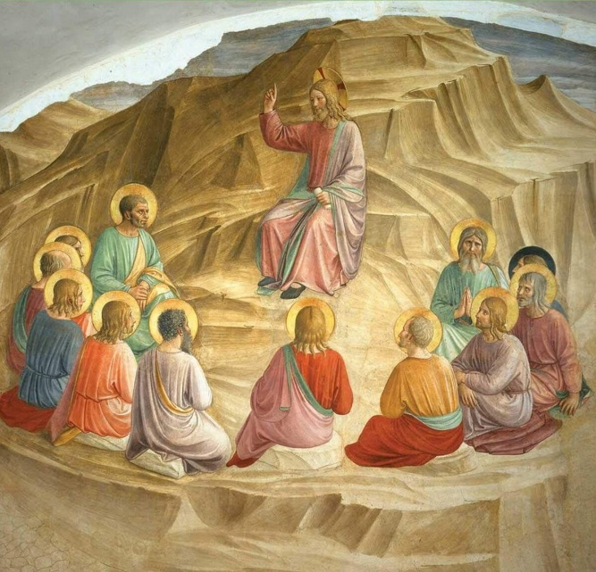

Rev. Jim Oleson, Pastor

Christopher Dickmeyer, Musician

Joyce Noble, Liturgist

***Thirteenth Sunday after Pentecost***

*\*Please rise in body or spirit*

**Ringing of the Bell**

**Welcome & Announcements**

*In the last days, says God, I will pour out my Spirit upon all people. Your sons and daughters shall prophesy. Your young people shall see visions, and your old people shall dream dreams. People of God, we have been baptized into one Spirit and one body through Jesus Christ. Let us worship today.*

**Prelude and Lighting of the Candles**

**\*** **Call to Worship**

Leader:To take the clay of our lives, and shape disciples:

**People: God calls us to the Potter’s House**

Leader:To receive and mend those who are broken from life experiences:

**People: God calls us to the Potter’s House**

Leader:To love and heal those who are wounded from war:

**People: God calls us to the Potter’s House**

Leader:To shelter all who are outcast and heavily burdened:

**People: God calls us to the Potter’s House**

Leader:Let us enter this place of transformation:

**People: And worship our God!**

**\*Invocation**

**Faithful God, you draw near to us in our joy and in our grief, in our hope and in our despair.**

**When we are bowed down, you raise us anew. We turn to you now in search of your healing touch. God of compassion and love, move among us this hour. Open our eyes, dispel our fears, and show us the real life you have to offer. We pray this in the name of the Risen One, Jesus the Christ. Amen.**

**\*Hymn of Praise** #42New Century O For A Thousand Tongues to Sing

**\*Prayer for Transformation** **and New Life**   
**God of all life, ever creating and recreating, come with the saving grace of Christ Jesus into the unruly kingdom of our lives. Deal radically with our tarnished souls which were meant for brighter things.**

**Reach into the bank of our memories, down into the spring of our feelings, deep into the tender places where faith and hope struggle towards more light, liberty and joy.**

**Forgive all that you find fallen, reclaim that which is rebellious, expel that which is alien, and strengthen that which is sane, loving and beautiful.**

**By your Spirit living within us, enable us to become in reality as well as hope and intention the true sisters and brothers of the Son of God. This we pray in his name. Amen.**

<pause for silent reflection >

**Words of Grace**   
**Leader:** In the person of Jesus, God invites us to discover the freedom and new life that God offers us. God’s forgiveness heals us. God’s grace dispels our weariness and discouragement. God’s love clears our vision. God’s compassion lifts our burdens.

**People: We are made new! Thanks be to God!**

**\*Response of Praise**

**Glory be to the Father, and to the Son, and to the Holy Ghost; As it was in the beginning, is now, and ever shall be, World without end. Amen. Amen.**

**Written Word** Jeremiah 18:1-11

Philemon 1:1-21

Luke 14:25-33

**Hymn** #386 New Century The Church’s One Foundation

**Message** Extreme Jesus Rev. Jim Oleson

Luke 14:25-33

**Church in Prayer**

**Pastoral Prayer**

**Lord’s Prayer** (Debts, Debtors)

**Offertory**

**Invitation to Generosity**

**\*Doxology** (Tune: Old Hundredth)

**Praise God, from Whom all blessings flow; Praise Him, all creatures here below;**

**Praise Him above, ye heavenly host; Praise Father, Son, and Holy Ghost. Amen.**

**\*Prayer of Dedication**

**Gracious God, we thank you for the opportunity to give our time, talent, and treasure for the building of your Kingdom on earth. Bless every gift, tithe, and offering that’s deposited into your Kingdom today; we offer this prayer in your mighty name. Amen**

**The Lord’s Supper**

**INVITATION TO CHRIST’S TABLE**

**COMMUNION PRAYER**

**WORDS OF INSTITUTION**

**SHARING OF THE BREAD AND CUP**

(Please hold each of the elements as it is distributed so that we may partake each together. The inner ring of cups in each tray holds juice rather than wine.)

**\* THANKSGIVING PRAYER (unison)**

**Bountiful God, we give you thanks that you have refreshed us at your table by granting us the presence of Christ. Strengthen our faith, increase our love for one another and send us forth into the world in courage and peace, rejoicing in the power of your Holy Spirit. Amen.**

**\*Closing Hymn #**403New Century My Hope Is Built on Nothing Less

\***Commission and Benediction**

**\*Christ’s Light Leads Us into the World**

**\*Congregational Response** #76 New Century Sent Forth by God’s Blessing

(Verse 1)

**\*Ringing of the Bell and Postlude**

903 Meier Road, Old Monroe, Missouri 63369

[stpauluccom@gmail.com](mailto:stpauluccom@gmail.com)

Website: stpauluccom.com

636-665-5329

**OFFICE HOURS**

Wednesday: 9:00am – 3:00pm

Friday: 9:00am - Noon

It Happens

Here St. Paul UCC

Weekly Calendar

September 7th - September 14th

**September 7th**  ***Thirteenth Sunday after***

***Pentecost***

10:30am Worship

11:30am Fellowship Hour

September 9th

5:00PM Worship Committee

**September 14th**  ***Fourteenth Sunday after***

***Pentecost***

10:30am Worship

11:30am Fellowship Hour

Noon Stewardship Committee

***Looking Ahead***

September 22nd

5:15pm Council Meeting

________________________________________________________________________________________

**OUR GIVING IN 2025**

**Needed weekly to meet our commitments** $**2317.02 $ 2317.02**

General Fund Offering August 31st $ 300 .00 August Average $ 1285.00 Stewardship Offering August 31st $ 0.00 July Average $ 1237.25

______ ____________________________________________________ ____________________ ________

**HAPPENING IN OUR COMMUNITY**

**Saturday, September 20:** Pasta with the Pastor at St. John’s UCC in Weldon Springs. Serving from 5:00 to 9:00pm.

**Sunday, September 21:** St. Paul’s UCC in Marthasville, Annual Chicken Dinner & Country Store. Dine in or carry-out from 11:00am to 5:00pm.

**Saturday, November 1**: Holiday Bazaar & Silent Auction at St. John’s UCC in Weldon Springs. Fun for the whole family from 9:00am to 3:00pm.

**Thank you to all our volunteers!**

**Greeters/Ushers**

Stan & Ann Rolf

**Acolyte**

Ann Rolf

**Liturgist**

Joyce Noble

**Fellowship Hour**

Messenger

In our prayers …

This week we added Mike S., Britney, Debbie and Tony.

We continue to keep in our prayers: Lauretta, Rich M., Steve, Mark H., Larry (Sharon’s grandson), Rick, Lynn and Ron D., Bill D., Cheryl V., Tosha D., Pat, Kenneth G., Christian, Laurie S., and Marlene. We also pray for the victims of the flooding in Elsberry.

We lift up in our prayers those who need prayers for their *long-term circumstances*: Carol Jean P.

The Food Pantry needs the following items:

Toilet Paper, Shampoo/Conditioner, Soap,

Soup, PB/Jelly, Cereal, Canned Fruit.

**PLEASE, NO:** Mac & Cheese, Diced Tomatoes,

Corn or Green Beans!

Emergency Planning is checking into a CPR/AED refresher course.  There are 2 options: refresher course without certification at no cost or a certification course at the cost of $40. Let Joyce Noble know if you are interested.