**FALL CLEANUP - CHURCH GROUNDS**

**SATURDAY, OCTOBER 11th**

**(Rain Date: Saturday, October 18th**

**10:00 AM - 2:00 PM**

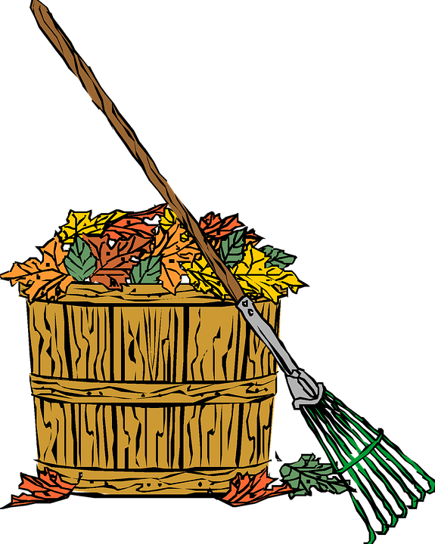

**THE GARDEN CLUB IS IN NEED OF VOLUNTEERS TO HELP CLEAN UP**

**OUR CHURCH GROUNDS FOR THE FALL**

**MANY HANDS MAKE THE JOB**

**A GREAT DEAL EASIER**

**Coffee and donuts will be provided**

If you have any questions regarding the clean-up, contact

**Lee Johnson @ 267-261-1294**