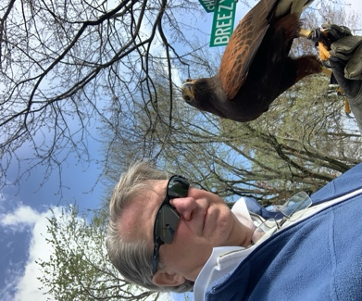 | Rev. Dr. Edward C. Andercheck  Rev. Andercheck is an Anglican Catholic Priest, theologian and author. He has served as Rector of St. Mary’s Anglican Church in Wilmington, Delaware and as a Deacon at St. Annes Anglican Church in Charlotte Hall, Maryland.

He has always had the heart of a Pastor and prior to ordination had volunteered for decades in church lay and youth ministries, while working on Wall Street as a financial services executive.

He earned a Bachelor of Business Administration from The George Washington University, a Master of Theological Studies from Vanderbilt University and a Doctor of Ministry from Duke University.

Rev. Andercheck initially studied Church History and Divine Scripture at St. Meinrad’s Benedictine Archabbey, where he became an Oblate. After completion of his doctorate at Duke he studied ecclesiology at the Catholic University of America, School of Canon Law. Rev. Andercheck is a published author; he has written books and articles on spirituality, ecumenism, and ecclesiology.

In his spare time, Pastor Andercheck enjoys medieval history, sailing and practicing the ancient sport of falconry and gardening, His lifelong partner and wife of 45 years, Barbara, supervises his gardening. Barbara is a kindergarten teacher at St. Anthony of Padua Catholic School in Washington, D.C.; they reside alongside the Calvert Cliffs of Chesapeake Beach in Maryland. They are the proud parents of three joy filled grownup children, Brita, Ned and Lee.

Ed sees in the words of Matthew 18:4, “Whoever humbles himself like this child is the greatest in the kingdom of heaven.” a fresh vision for Christian ministry. It is the attribute of humility that can overcome challenges and ignite a spark for the renewal of church in our times.

