
Deaconess Catherine Inserra 2025
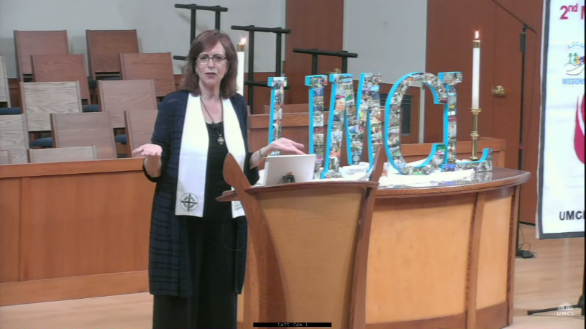
Catherine been serving as the Manager of Community Relations since February 2019 with Kids Above All (formerly ChildServ), a Methodist-affiliated, child-serving agency building better lives for children since 1894. Originally established as the Methodist Deaconess Orphanage in Lake Bluff, IL, Lucy Rider Meyer, founder and social visionary, is credited for starting over 40 institutions in her lifetime, training 5000 women to serve, and for the revival of the Deaconess movement.

Through her work with Kids Above All, Deaconess Catherine builds mission partnerships with faith communities throughout the Chicagoland area along with community groups in Kane, Cook, Lake and DuPage counties. These partnerships support all kinds of resources including mission giving, backpacks and school supplies, items for babies, holiday gifts, grants, and in-kind support for the 4,540 kids ages 0-24 who are currently receiving services. Catherine’s outreach continues to uphold the 131 year mission of Kids Above All to build better lives for kids and families impacted by poverty, violence and injustice.

Deaconess Catherine received a Certificate of Spiritual Direction from Garrett Evangelical Theological Seminary (GETS) in Evanston, IL in 2010. Catherine was consecrated to the Order of Deaconesses and Home Missioners in May of 2018 at the United Women in Faith’s (aka UMW’s) Women’s Assembly in Columbus, OH having successfully completed seminary coursework. Catherine is committed to ministries of love, justice and service. She is currently serving as the Kids Above All’s liaison to United Voices for Children board in the Northern IL Conference (NIC) of the United Methodist Church and on the NIC United Women in Faith’s executive board as the Spiritual Growth Coordinator.
Contact Catherine to preach, to share a mission message, or to connect in a meaningful partnership including to participate in annual drives, and/or to coordinate a volunteer opportunity at the Better Life Distribution Center in Des Plaines.
Deaconess Catherine Inserra
Manager of Faith & Community Relations
cinserra@kidsaboveall.org
Cell phone: 874/224.2870
www.kidsaboveall.org

