CHURCH INFORMATION
Rosebush United Methodist Church
3805 School Road, P.O. Box 187
Rosebush, MI 48878
Phone: 989-433-2957
Website: www.rosebushumc.com
Email: rosebushumc@gmail.com

Sunday Worship Service begins at 11:00am
Fellowship Time follows Worship

Pastor: Rev. Dr. Ray Francis
Office Phone: 989-588-2931
Cell Phone: 989-330-9135
Website: www.farwellumc.com
Email: office@farwellumc.com

Admin: Lori Thompson

LISTENING DEVICES, LARGE PRINT HYMNALS & BIBLES ARE
AVAILABLE. One of our ushers will be happy to assist you! CHILDREN’S BIBLES are also available. If you are interested, please let us know.

Our Mission:
To experience Christ’s Love, Grow as Christians and Share God with Others.

Our Purpose:
To make and train disciples to become devoted followers of Jesus Christ who are equipped to fulfill God’s Call on their lives

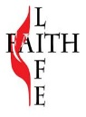
W E L C O M E
to
ROSEBUSH UNITED
METHODIST CHURCH

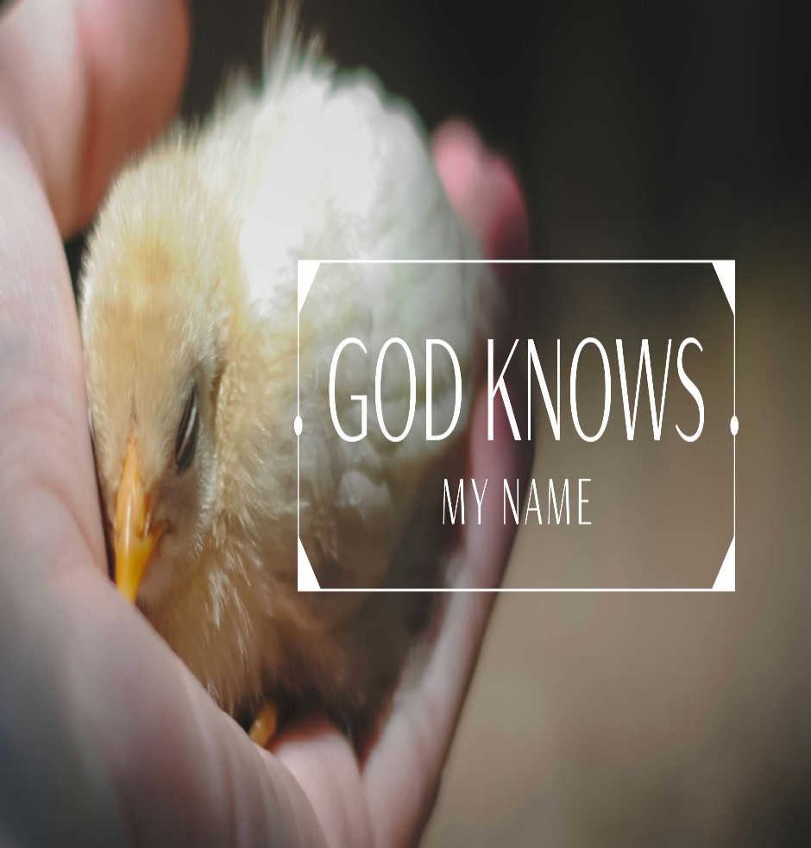

Sunday September 7, 2025
Thirteenth Sunday after Pentecost

ORDER OF WORSHIP
Attendance Sunday, August 31^{sh} = 27

Gathering Song: “Kingdom of God” (please be seated) Video

Welcome & Announcements Liturgist: Christel Mars

Prelude: “I Will Call Upon The Lord” (please remain seated) Video

Opening Prayer (on screen) Liturgist: Christel Mars

Scripture Reading: Psalm 1 Liturgist: Christel Mars

(*) Opening Hymn: “Where He Leads Me” (UMH 338) Video

Scripture Reading: Luke 14: 25-33 Liturgist: Christel Mars

Call to Worship (on screen) Liturgist: Christel Mars

(*) Hymn of Preparation: “I Have Decided to Follow Jesus” (TFWS 2129) Video

Prayers, Joys & Concerns Pastor Ray Francis

The Lord’s Prayer Pastor Ray Francis

Offering / (*) Doxology (UMH# 95) Pastor Ray Francis

Anthem: “One by One” Video

Message: “God Knows My Name” Pastor Ray Francis

Holy Communion Pastor Ray Francis
(*) Closing Hymn: “Cry of My Heart” (TFWS 2165) Video

(*) Blessing / Benediction Pastor Ray Francis
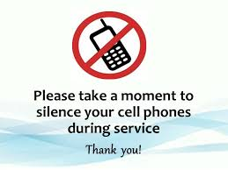

(All videos are downloaded from YouTube)
(*) Please stand if you are able

PRAYERS, PRAISES & CONCERNS – PLEASE HELP US KEEP THESE REQUESTS UP TO DATE!

THANK YOU, GOD for all that YOU have done for us in the past, all that YOU are doing for us now, and what YOU will continue to do for us in the future. Hold our church, our members and attendees in your hands and show us the direction you need us to go. Thank you also for our volunteers who help with worship services, dinners, events, and all that we need to do to make our church work.

PRAYERS:
Family of Rob Werner
Family of Richard Berry (Lori’s uncle)
Family of Troy Opdyke

Shooting Victims in Minneapolis
Those traveling for the holiday weekend
Larry Baker (Lori’s brother – cancer in remission, please continue prayers)

CONTINUED: All anonymous, unspoken and continuing requests, Monica Holmes (cancer), Ellie Berry, Bill (Kathy Fransted’s brother – strength and recovery), Jackie Curtis, Patti VanOrden, John E Fetterly (Mary’s grandson), Alan Birks (Lori’s cousin who has cancer); THOSE IN MILITARY SERVICE: Hunter Lynch, Jonah Ervin.

FOR THOSE IN OUR NEIGHBORHOOD, STATE, COUNTRY & WORLD:
Staff & residents at Rosebush Manor, those struggling with financial issues, depression, anxiety, loss, addiction, mental health issues, homelessness, joblessness, victims of persecution, those in Ministry and Missions, The United Methodist Church & Our Conference and District Leaders, our service men and women, our state and national leaders, and the condition of our Country and our World – Pray for Peace everywhere.

September Anniversaries  Ron & Karen Gale Sep 8  Don & Trish Cotter Sep 22 | September Birthdays  Julie McConnell Sep 2  Susan Berkhoudt Sep 4  Jim Bissett Sep 9  Nancy Brecht Sep 14  Rick Ervin Sep 17  Robin Bahr Sep 22  JoEtta Ervin Sep 25

ANNOUNCEMENTS & UPCOMING EVENTS:

HELP NEEDED – sign up to brink cookies and/or to help with the upcoming Annual Charge Conference and the Lay Leader/Servant

CRAFT VENDOR SHOW and COOKIE WALK – Saturday, November 15. 9:00am to 2:00pm. We will have a sign up soon for those who wish to help and make cookies.

TRUNK-N-TREAT, FRIDAY, OCTOBER 31 – Save the date. More information coming soon!

CHRISTMAS SOCIAL – EVERYONE WELCOME! Tuesday, December 2 at 7:00pm. (Instead of the Ladies’ Christmas Tea)

HANDBELL NEWS! Bells will continue to hold practice on Wednesdays at 5:30. We generally practice for an hour. First practice will be September 10th. We welcome everyone who would like to join us even if just to give it a try.

BABY BOTTLE CAMPAIGN NEWS! Our church raised over $420 this year to invest in the amazing work that Life Choices of Central Michigan perform in our community. A letter from Life Choices is on the table in the entryway if you would like to review it.

DRIVE THROUGH BBQ PULLED PORK DINNER – Saturday, October 4, 4pm to 6pm, Coleman Faith UMC, 203 Jefferson Street, Coleman. $12 per meal. Poster on UWF Bulletin Board for more information.

UPCOMING EVENTS:
NEXT AD BOARD MEETING: MONDAY, SEPTEMBER 8 @ 6:00pm

NEXT LADIES’ UWF MEETING: TUESDAY, OCTOBER 7 @ NOON – Potluck Lunch. Bring a friend!

ANNUAL CHARGE CONFERENCE – Sunday, October 5, at 2:00pm at RUMC.

DISTRICT FALL LAY LEADER CLASSES – Saturday, November 1 and Saturday, November 8 at RUMC. More information on table in entryway.

ALL SAINTS SUNDAY, November 2. If you have a loved one to be recognized in our celebration, please send / email / text their picture and dates to Lori. We still need someone to read the names. We have someone to ring the bell and light the candles. We will also need to know if we need to mail out invitation(s) for a loved one. Any questions, please contact Lori.

SEPTEMBER SERVICE HELPERS:

YOUR HELP IS NEEDED! Please consider helping as an Usher, Greeter or Liturgist. A sign-up sheet is available on the table by the front door. Your help is greatly appreciated! Thank you! Any questions, please ask Lori.

Communion: | September 7 – Robin Bahr
Liturgists: |  | Fellowship
Sept 7  Sept 14  Sept 21  Sept 28 | Christel Mars  Mary Hafer  Susan Berkhoudt  Pastor Ray | Sept 7  Sept 14  Sept 21  Sept 28 | Donna Anderson  Susan Berkhoudt  Nancy Brecht  Carolyn Shaner
Greeters / Ushers
Sept 7  Sept 14  Sept 21  Sept 28 | Robin Bahr  Susan Berkhoudt

COMING UP THIS WEEK AT RUMC . . .

Monday, September 8 6:00pm Ad Board Meeting

Tuesday, September 9 8:30am TOPS Group

Wednesday, September 10

Thursday, September 11

Friday, September 12

Saturday, September 13

Sunday, September 14 11:00am – Worship

