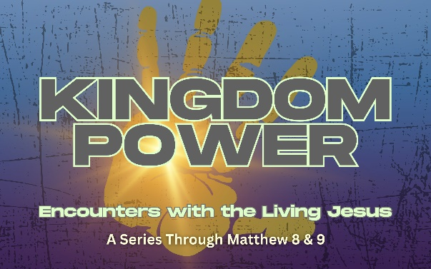
Sermon Notes: “The Untouchable”

Matthew 8:1-4

9.7.25

“If you are willing”:
- The Leper's Faith: The leper questioned Jesus' willingness, not His power.
  - Whatever your “leprosy” looks like, Jesus' response hasn't changed: “I am willing.” His method might surprise you and His timing might test you, but His heart toward you is settled.

God's Willingness vs. God's Timing and Wisdom
- His immediate response reveals His heart: “I AM WILLING."

- What we don't always understand are His methods,
His timing, or His bigger picture.

“I am willing”:
- Jesus deliberately touched the leper first, then healed him.

- Jesus enters our mess before fixing it.

- You don't have to clean up your life before coming to Jesus.

So What?

- Our transformation should be visible and verifiable to others.

  - Inward: What makes you feel untouchable/unworthy?

- Jesus is willing to come near to people everyone else avoids.

  - Outward: How do we treat the “untouchable”?

ICEBREAKER: "The Risk Taker" Share about a time when you took a significant risk to help someone else. What made you willing to put yourself at risk? How did it turn out?
For Study, Reflection, Discussion:
- Review the sermon notes from Sunday. Was there a particular point that stuck with you? What was it and why did it resonate with you?
READ: Matthew 8:1-4
- The leper said, "if you are willing" rather than "if you are able." Why do you think he questioned Jesus' willingness rather than his power? What does this reveal about how people often view God today?
- Darin mentioned different types of "leprosy" - things that make us feel untouchable (addiction, shame, past mistakes, etc.). What are some modern "leprosies" that cause people to isolate themselves from community or from God? (Be as personal as you are willing to be.)
- The sermon addressed what happens when we pray for healing and don't get the immediate result we want. How do you reconcile Jesus' willingness to heal with the reality that not everyone experiences instant healing?
- Jesus told the leper to show himself to the priest - to make his healing public and official. Why might someone want to keep their healing or transformation private? What are the benefits of sharing your story with others?
Deploy:
This week’s deployment:
- INWARD FOCUS: Identify your "leprosy" - What's the thing you've been hiding that makes you feel untouchable? This week, take one small step toward healing (call a counselor, confess to a trusted friend, join a support group, etc.)
- OUTWARD FOCUS: Reach the untouchable - Identify someone in your life who feels isolated or avoided by others. Take one tangible step to "touch" their life this week (visit, call, invite for coffee, offer practical help, etc.)
Don’t Forget:
- Big Thank you to everyone who helped at the Church at the Lake service. What a great success! Over 350 in attendance and 13 Baptisms!
- Launching this Week: Life Groups and Sunday Schools!!
- All Church F.U.N. Night Pumpkin Carving and Chili Contests! Oct 12th
Prayer:
Jesus, thank you that your heart toward us never changes. When we doubt whether you're willing to help us, remind us of your immediate response to the leper: 'I am willing.'
For those hiding their own brokenness - give them courage to let you come close. Help them believe you enter our mess before you fix it.
For those you're calling to reach the untouchable - give us your heart for the people others avoid. Help us risk our comfort to love like you love.
Help us remember our healing isn't just for us - it's testimony for others who wonder if you're still willing to touch broken lives.
In Jesus' name, Amen.

