VICTORY FELLOWSHIP
WORSHIP TO ALMIGHTY GOD
September 7, 2025 - 11am

SONG OF WELCOME: This is the Day

PRELUDE / MINISTRY OF ACOLYTES

Call to Worship: Psalm 31:1-5 NLT

SONG OF PRAISE: Sunday Sermons

GREETINGS & ANNOUNCEMENTS

PRAYER REQUESTS
From the COMMUNITY of FAITH
(You are welcome to join Pastor Rod at the altar during prayer)

Call to Prayer: Seek Ye First (vs. 1)

PASTORAL PRAYER OF INTERCESSION

Response: Seek Ye First (vs. 3)

CHILDRENS MESSAGE: Captain America

SCRIPTURE READING: Ephesians 6:13-16 NLT

OUR TITHES & OFFERINGS
DOXOLOGY:
Praise God, from Whom All Blessings Flow #622

SONG OF REFLECTION: Only Believe

SACRAMENT OF HOLY COMMUNION:
(We all take at the same time–first the bread, then the cup)

WORDS OF REMEMBRANCE
THE LORD’S PRAYER (#632)
GIVING THE BREAD / GIVING THE CUP
PASSING THE PEACE OF CHRIST
(Children can go to King’s Kids with Jaime Grabski)

PASTOR ROD PREACHING GOD’S WORD:

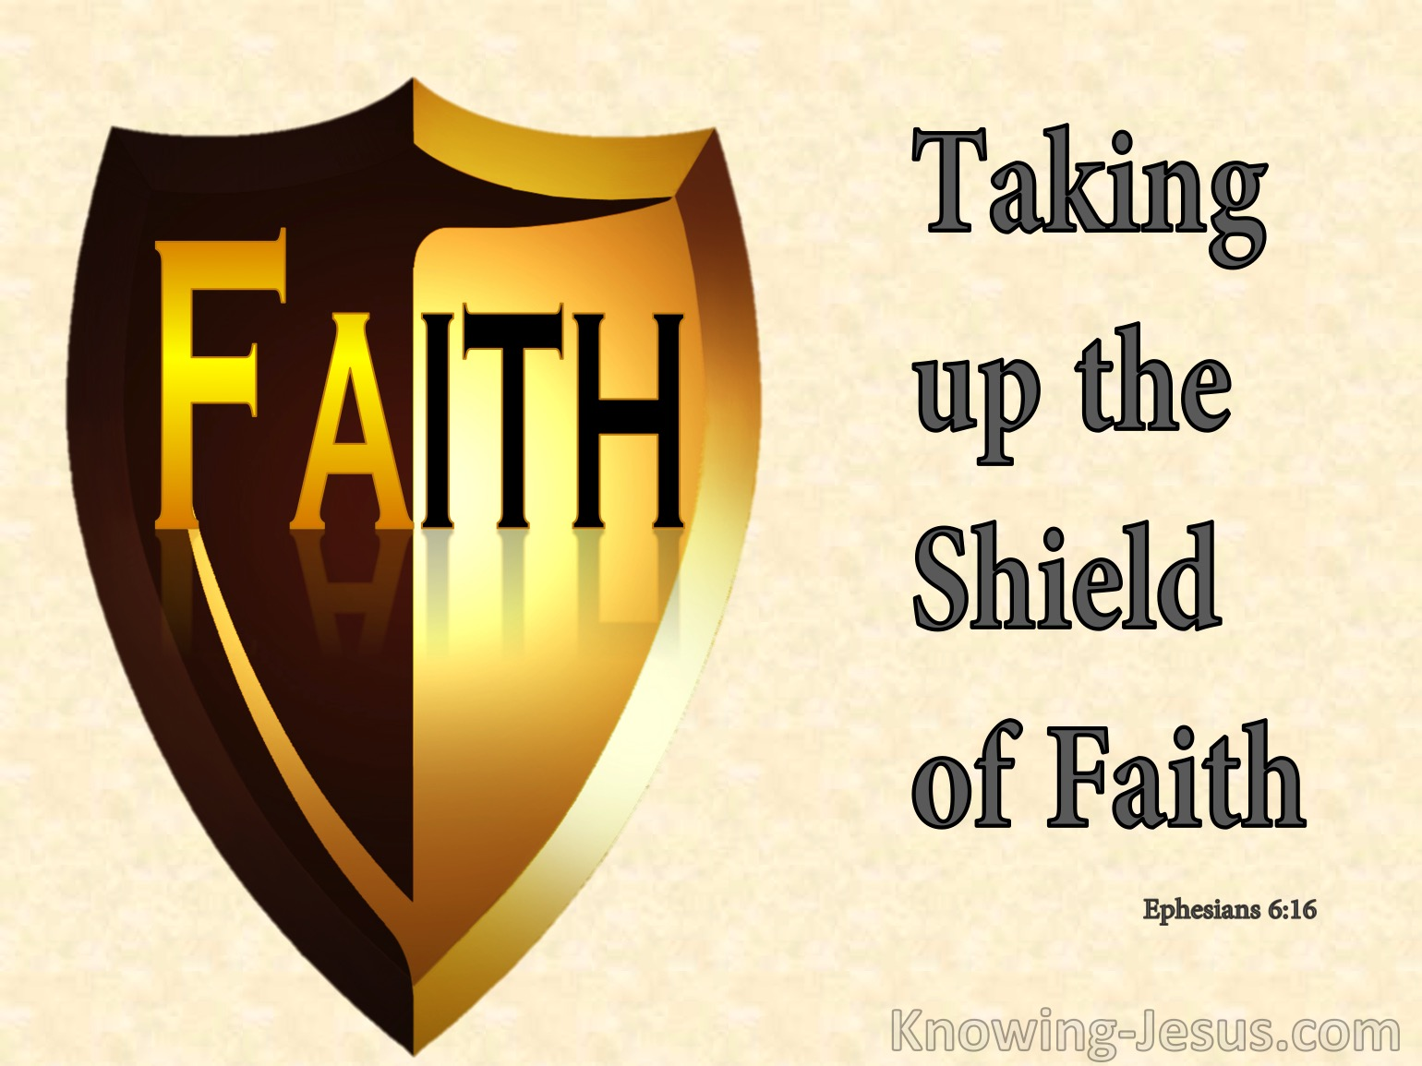

SONG OF GOING FORTH: Faith
MINISTRY OF ACOLYTES
BLESSING OUR GOING FORTH

Thank you to these Worship Servants:
Piano / Keyboard: Tesia Wagar
Greeter(s): (we need volunteers)
Scripture Reader(s): Jaime Grabski
Acolytes: Sammy Grabski / Piper Morrison
Communion / King’s Kids: Jaime Grabski
Ushers: Chris Wagar / Samuel Grabski / Zach Earnsberger
Tech Engineer: Chris Wagar

(September 7, 2025) PRAYER CONCERNS:
PRAYER REQUEST CARDS ARE PROVIDED IN A RACK AT THE WELCOME CENTER AREA AS YOU ENTER THE CHURCH. PLACE THE REQUEST CARD IN THE OFFERING PLATE WHEN IT IS PASSED.

PERSONS: Anyone dealing with any type cancer,
Anyone mourning the loss of a loved one, Joyce Nilles,
Jay Nilles, Crystal Cales, Beth Hatfield, Karen Greer,
Joyce Lacey, Sandy Dreurey, Alan Ash, Sherry Lacey,
Paula Maynard Lynn, Nickolas, Hunter, and Aiden Skiffey, Bonnie Cottrell, Gary Johnson, Laura Jacks, Haille Riddle.

You may request Prayer & Anointing with Oil any time.

PRAY for our MILITARY and FIRST RESPONDERS.
Pray for the Persecuted Church in the World,
Pray for the Peace of Jerusalem and ISRAEL (Psalm 122:6-9),
Pray for the Unborn, and for The Gideons International
Pray for the new and emerging GMC (Global Methodist Church)

SITUATIONS: Pray for God’s Favor for Victory Fellowship. Pray for our Nation’s and the World’s Leaders; For our City and State; For Victims of Hurricanes, Fires, Earthquakes, Storms, Mudslides, Floods; For Unemployed and/or the homeless; For Public school safety; For those affected by acts of violence.

VICTORY FELLOWSHIP CONTACT INFO:
Mailing Address: 273 23rd St. S.W., Barberton, OH 44203
Rev. Roderick D. Grabski, Founding Pastor
Pastor’s Cell phone: 330-858-0223 (leave a message) Watch our services and bible study live on our Webpage: victoryfellowshipministries.com
Follow on FACEBOOK: Roderick Grabski or Victory Fellowship

