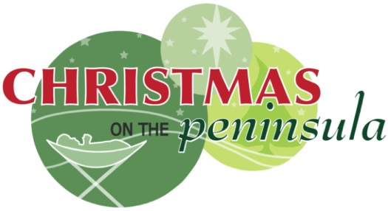**=[The Christmas on the Peninsula Society**

is seeking an

**Events Coordinator/ Festival Assistant**

on contract for **two months**, with possibility for ongoing contracts.

**Our mission** is to provide a first-class Christmas Festival on the Semiahmoo Peninsula for visitors and local communities, to gather together to hear and see the Christmas Story unfold.

**Scope of Services includes**

Manage festival equipment, recruit and manage event volunteers, sponsors and maybe entertainers keep documents up to date and promote the 2025 Christmas on the Peninsula Festival. In various media. For more information visit <http://www.Christmasonthepeninsula.com>

**Contractor experience and attributes**

* Experience in event planning/management or a related field
* Ability to multitask and prioritize while being flexible to deadlines and pressure
* Professional, personable, and comfortable interacting with event participants and attendees, donors, volunteers at all levels
* Experience recruiting and managing event volunteers including scheduling
* Proficient in MS Office Suite; adept social media user

**Fee for services**

The fee for this part time contract will be **$2000** paid in two instalments upon reports and invoices.

**Deadline for response**

Please send resume and letter demonstrating how your experience relates to our requirements ASP but no later than **September 17th** to Liv Butow, President Christmas on the Peninsula Society, via email to Liv@ butow.com

We thank all who apply and advise that only those selected for further consideration will be contacted.