**St. Paul**

**UNITED CHURCH OF CHRIST**

**August 31, 2025 10:30am**

***Welcome!*** Whether you are a guest, friend or member, we are delighted that you are here. Large print bulletins are available at either door. Ask a greeter for any directions you may need.

*“Please note that this service will be live-streamed on Facebook. If you do not wish to be visible on camera, please let an usher know so we can take appropriate measures to ensure*

*your privacy."*

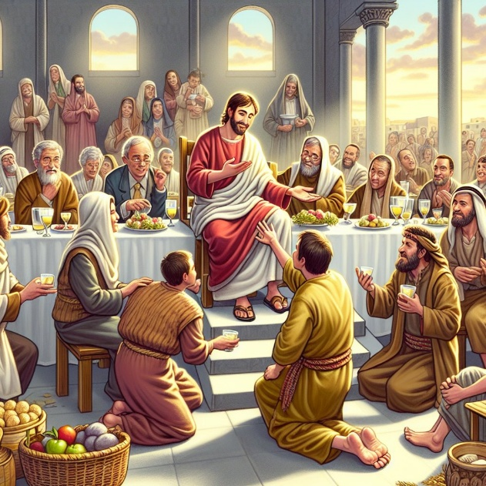

Rev. Jim Oleson, Pastor

Janet Morris, Musician

***Twelfth Sunday after Pentecost***

*\*Please rise in body or spirit*

**Ringing of the Bell**

**Welcome & Announcements**

*In the last days, says God, I will pour out my Spirit upon all people. Your sons and daughters shall prophesy. Your young people shall see visions, and your old people shall dream dreams. People of God, we have been baptized into one Spirit and one body through Jesus Christ. Let us worship today.*

**Prelude and Lighting of the Candles**

**\*** **Call to Worship** (Inspired by Psalm 81 and 112)

**One:** Sing aloud to God our strength; shout for joy to God.

**Many: Happy are those who revere the Holy One. Generation to generation delight in God’s blessings.**

**One:** Sing aloud to God our righteousness; shout for peace to God.

**Many: We rise from the depths in mercy, grace, and justice.**

**One:** Sing aloud to God our hope; shout for love to God.

**Many: Our hearts are steady and secure. Worship the Holy One!**

**\*Invocation**

**God of Glory, we acknowledge your presence among us as we gather. You have knit us together as a community. In your kindom, the first will be last and the last will be first. We only exalt you yet you come near to us. Dwell in the praises we voice, in the hope to which we cling, and the love that persists. Reveal yourself to us, Great One, and we will declare and spread your goodness in the land of the living. Amen.**

**\*Hymn of Praise** #237New Century I Come to the Garden Alone

**\*Prayer for Transformation** **and New Life**   
**Righteous God, forgive us for the positioning we do. We seek elevated places and too often fail to notice the absences at your table. Our tables are segregated by the ways we diminish the beautiful distinctiveness you celebrate among us. We live in complacency while the world around us weeps in pain, suffering, and despair. Break our hearts, O God, so that we will seek your kindom more than our own acquittal. As in the days of Jeremiah, we “have changed [our] glory for something that does not profit” and are appalled. Convict our spirits to propel us to reshape the world into your vision of beloved community—repaired, restored, and reconciled. Amen.**

<pause for silent reflection >

**Words of Grace**   
**Leader:** Beloved, the Holy One is righteous and just as well as compassionate and faithful to forgive the contrite heart. God will give you strength and courage to do justice, love mercy, and walk humbly.

**People: Thanks be to God. Amen.**

**\*Response of Praise**

**Glory be to the Father, and to the Son, and to the Holy Ghost; As it was in the beginning, is now, and ever shall be, World without end. Amen. Amen.**

**Mission Moment**  Janet Drown

**Written Word** Jeremiah 2:4-13

Hebrews 13:1-8, 15-16

Luke 14:1, 7-14

**Hymn** #433 New Century In the Bulb There is a Flower

**Message** Living Water or Broken Cistern? Rev. Jim Oleson

Jeremiah 2:4-13 & Luke 14:1,7-14

**Church in Prayer**

**Pastoral Prayer**

**Lord’s Prayer** (Debts, Debtors)

**Offertory**

**Invitation to Generosity**

**\*Doxology** (Tune: Old Hundredth)

**Praise God, from Whom all blessings flow; Praise Him, all creatures here below;**

**Praise Him above, ye heavenly host; Praise Father, Son, and Holy Ghost. Amen.**

**\*Prayer of Dedication**

**Holy, Holy, Holy God, be glorified in our giving. Receive and magnify these gifts so that needs will be met, communities transformed, and lives renewed. We dedicate them in your precious name. Amen.**

**\*Closing Hymn #**475New Century God's Eye is on the Sparrow

\***Commission and Benediction**

**\*Christ’s Light Leads Us into the World**

**\*Congregational Response** #76 New Century Sent Forth by God’s Blessing

(Verse 1)

**\*Ringing of the Bell and Postlude**

903 Meier Road, Old Monroe, Missouri 63369

[stpauluccom@gmail.com](mailto:stpauluccom@gmail.com)

Website: stpauluccom.com

636-665-5329

**OFFICE HOURS**

Wednesday: 9:00am – 3:00pm

Friday: 9:00am - Noon

It Happens

Here St. Paul UCC

Weekly Calendar

August 31st – September 7th

**August 31st**   ***Twelfth Sunday after***

***Pentecost***

10:30am Worship

11:30am Fellowship Hour

**September 7th**   ***Thirteenth Sunday after***

***Pentecost***

10:30am Worship

11:30am Fellowship Hour

***Looking Ahead***

September 9th

5:00pm Worship Committee

_______________________________________________________________________________

**OUR GIVING IN 2025**

**Needed weekly to meet our commitments** $**2317.02 $ 2317.02**

General Fund Offering August 24th $ 270.00 July Average $ 1237.25 Stewardship Offering August 24th $ 106.00 June Average $ 870.60

______ ____________________________________________________ ____________________ ________

**HAPPENING IN OUR COMMUNITY**

**Sunday, September 21:** St. Paul’s UCC in Marthasville, Annual Chicken Dinner & Country Store. Dine in or carry-out from 11:00am to 5:00pm.



**Thank you to all our volunteers!**

**Greeters/Ushers**

Darryl & Phyllis Freese

**Acolyte**

Bobby Roskowske

**Liturgist**

**Fellowship Hour**

Ground Committee

In our prayers …

We continue to keep in our prayers: Lauretta, Rich M., Steve, Mark H., Larry (Sharon’s grandson), Rick, Lynn and Ron D., Bill D., Cheryl V., Tosha D., Pat, Kenneth G., Christian, Laurie S., and Marlene. We also pray for the victims of the flooding in Elsberry.

We lift up in our prayers those who need prayers for their *long-term circumstances*: Carol Jean P.

The Food Pantry needs the following items:

Toilet Paper, Shampoo/Conditioner, Soap,

Soup, PB/Jelly, Cereal, Canned Fruit.

**PLEASE, NO:** Mac & Cheese, Diced Tomatoes,

Corn or Green Beans!

Emergency Planning is checking into a CPR/AED refresher course.  There are 2 options: refresher course without certification at no cost or a certification course at the cost of $40. Let Joyce Noble know if you are interested.