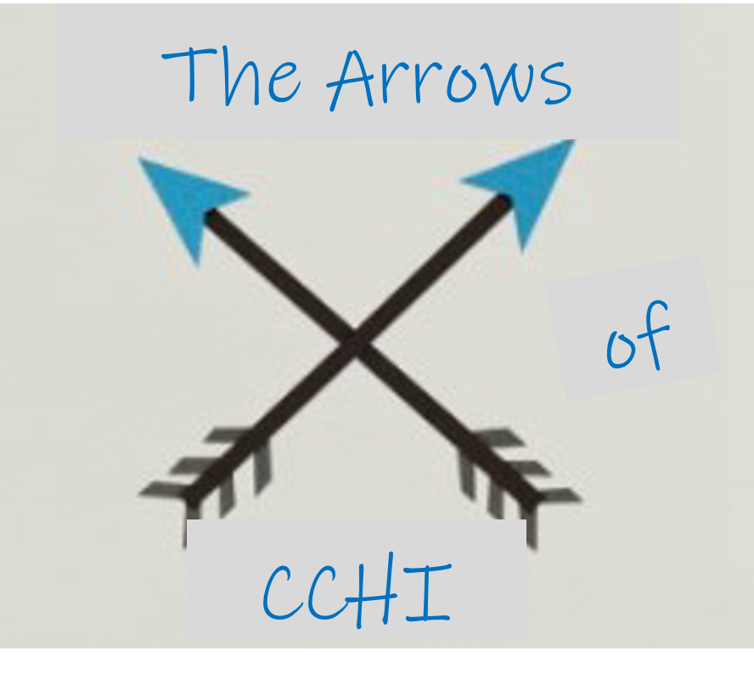  Like arrows in the hands of a warrior are children born in one’s youth.  Psalm 127:4 |  | 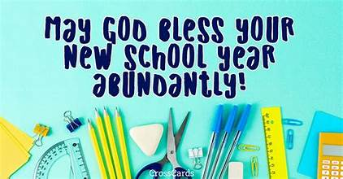  September News
September Teachers  Sunday  Juniors: Ms. Gloria  Seniors: Ms. Krystle  Wednesday  Juniors: Ms. Jamie  Seniors: Ms. Darlene |  | This month’s lesson topics are:  - Solomon Builds God’s Temple  - Wisdom from God  - Israel is Divided  - Unit 9 Review  Memory Verse: James 1:5  If any of you lacks wisdom, let him ask God, who gives generously to all without reproach, and it will be given him.
Upcoming Events  9/28 Sunday School Teachers Meeting 12  10/17 Glow Praise Party 6:30 @ Fountains  11/15 Fall Fellowship @ Fountains |  | Reminders:  - Pick your children up from their classrooms each Sunday.  - The take home sheet will help you review their lessons and memory verses with them. The Justin and Jesse story is read on Wednesday nights.  - We are taking this unit off from the memory verse bingo cards due to adjusting to the school year. Look for them again in the second half of unit 10

