**Saturday, August 30 & Sunday, August 31, 2025**

**Prayer of the Day**

Let us pray. **O God, you resist those who are proud and give grace to those who are humble. Give us the humility of your Son, that we may embody the generosity of Jesus Christ, our Savior and Lord. Amen.**

**First Reading: Proverbs 25:6-7a**

Do not put yourself forward in the king’s presence or stand in the place of the great, for it is better to be told, “Come up here,” than to be put lower in the presence of a noble.

Word of God, word of life.

**Thanks be to God.**

**Psalm 112** (read responsively)

**1**Praise the Lord! Happy are those who fear the Lord, who greatly delight in his commandments.

**2Their descendants will be mighty in the land; the generation of the upright will be blessed.**

**3**Wealth and riches are in their houses, and their righteousness endures forever.

**4They rise in the darkness as a light for the upright; they are gracious, merciful, and righteous.**

**5**It is well with those who deal generously and lend, who conduct their affairs with justice.

**6For the righteous will never be moved; they will be remembered forever.**

**7**They are not afraid of evil tidings; their hearts are firm, secure in the Lord.

**8Their hearts are steady; they will not be afraid; in the end they will look in triumph on their foes.**

**9**They have distributed freely; they have given to the poor; their righteousness endures forever; their horn is exalted in honor.

**10The wicked see it and are angry; they gnash their teeth and melt away; the desire of the wicked comes to nothing.**

**Second Reading: Hebrews 13:1-8, 15-16**

Let mutual affection continue. Do not neglect to show hospitality to strangers, for by doing that some have entertained angels without knowing it. Remember those who are in prison, as though you were in prison with them, those who are being tortured, as though you yourselves were being tortured. Let marriage be held in honor by all, and let the marriage bed be kept undefiled, for God will judge the sexually immoral and adulterers. Keep your lives free from the love of money, and be content with what you have, for he himself has said, “I will never leave you or forsake you.” So we can say with confidence, “The Lord is my helper; I will not be afraid. What can anyone do to me?” Remember your leaders, those who spoke the word of God to you; consider the outcome of their way of life and imitate their faith. Jesus Christ is the same yesterday and today and forever. Through him, then, let us continually offer a sacrifice of praise to God, that is, the fruit of lips that confess his name. Do not neglect to do good and to share what you have, for such sacrifices are pleasing to God.

Word of God, word of life.

**Thanks be to God.**

**Gospel: Luke 14:1, 7-14**

On one occasion when Jesus was going to the house of a leader of the Pharisees to eat a meal on the Sabbath, they were watching him closely. When he noticed how the guests chose the places of honor, he told them a parable. “When you are invited by someone to a wedding banquet, do not sit down at the place of honor, in case someone more distinguished than you has been invited by your host, and the host who invited both of you may come and say to you, ‘Give this person your place,’ and then in disgrace you would start to take the lowest place. But when you are invited, go and sit down at the lowest place, so that when your host comes, he may say to you, ‘Friend, move up higher’; then you will be honored in the presence of all who sit at the table with you. For all who exalt themselves will be humbled, and those who humble themselves will be exalted.” He said also to the one who had invited him, “When you give a luncheon or a dinner, do not invite your friends or your brothers and sisters or your relatives or rich neighbors, in case they may invite you in return, and you would be repaid. But when you give a banquet, invite the poor, the crippled, the lame, and the blind. And you will be blessed because they cannot repay you, for you will be repaid at the resurrection of the righteous.”

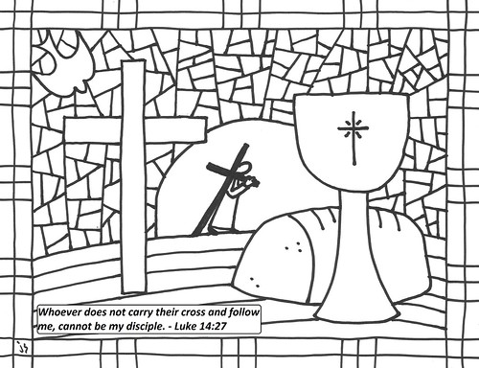

**Prayers of Intercession – 8/30 & 8/31/2025**

Let us pray for the church, the creation, and the whole people of God, for God is near.

*A brief silence.*

For the leaders of the church, we pray. Inspire deacons, pastors, Sunday school teachers, and Christian education directors with a passion for speaking the word of God. Equip all the baptized to share your word of grace.

Receive our prayers, O God.

**Your mercy is great.**

For the well-being of creation, we pray. Sustain farm workers and all who labor in fields and vineyards to grow the food we eat. Revive plains and pastures and provide for the cattle and creatures who rely on the land for their sustenance Receive our prayers, O God.

**Your mercy is great.**

For the leaders of towns, cities, provinces, states, and nations, we pray. Guide them to enact equitable laws and policies for all. On this Labor Day weekend, make us mindful of workers whose labor often goes unnoticed.

Receive our prayers, O God.

**Your mercy is great.**

For the lowly and those who are ignored, we pray. Provide for the needs of vulnerable communities, those who are unemployed, burdened by debt, or struggle to make ends meet. Accompany all who need reassurance of your loving presence (*especially*…*and all other people or concerns we now name aloud on our lips or in the silence of our hearts*).

Receive our prayers, O God.

**Your mercy is great.**

For the hospitality ministries of this congregation, we pray. Give ushers and greeters a spirit of welcome for visitors and bless the work of those who feed and nourish us. Receive our prayers, O God.

**Your mercy is great.**

For all the saints who from their labors rest, we give thanks. With them, we offer our sacrifice of praise to you, O God, the same yesterday and today and forever.

Receive our prayers, O God.

**Your mercy is great.**

Confident in God’s presence and promise, we entrust our prayers to the one who always receives them; through Jesus Christ, our wisdom and companion.

**Amen.**