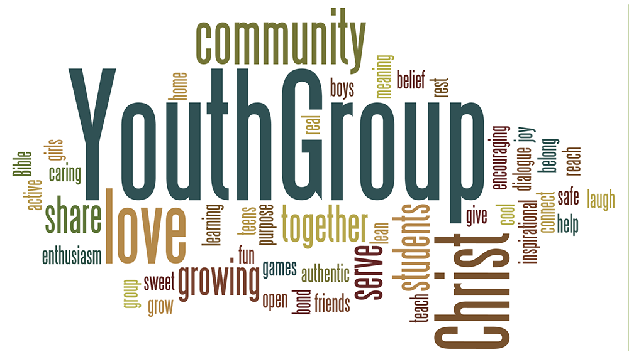
JUMMP Youth Group (6th through 12th graders)
Johnstown United Methodist and Milliken Presbyterian Youth Group
Calendar 2025-2026
AUGUST
24th – Sunday – Youth Group at JUMC – 4 to 6 pm
31st – Sunday – No Youth Group (Labor Day weekend)
SEPTEMBER
7th – Sunday – Youth Group at MPC – 1 to 3 pm
14th – Sunday – Youth Group at JUMC – 1 to 3 pm
21st – Sunday – Youth Group at MPC – 1 to 3 pm
28th – Sunday – Youth Group at JUMC
OCTOBER
5th – Sunday – Youth Group at MPC – 1 to 3 pm
12th – Sunday – Youth Group at JUMC – 1 to 3 pm
19th – Sunday – Youth Group at MPC – 1 to 3 pm
26th – Sunday – Youth Group at JUMC – 1 to 3 pm
NOVEMBER
2nd – Sunday – Youth Group at MPC – 1 to 3 pm
9th – Sunday – Youth Group at JUMC – 1 to 3 pm
16th – Sunday – Youth Group at MPC – 1 to 3 pm
23rd – Sunday – Youth Group at JUMC – 1 to 3 pm
30th – Sunday – Youth Group possible Angel Tree shopping
DECEMBER
7th – Sunday – Youth Group at MPC – 1 to 3 pm
14th – Sunday – Youth Group at JUMC – 1 to 3 pm – Christmas party!
21st – Sunday – No Youth Group
28th – Sunday – No Youth Group
2026
JANUARY
4th – Sunday – Youth Group at MPC – 1 to 3 pm
11th – Sunday – Youth Group at JUMC – 1 to 3 pm
18th – Sunday – Youth Group at MPC – 1 to 3 pm
25th – Sunday – Youth Group at JUMC – 1 to 3 pm
FEBRUARY
1st – Sunday – Youth Group at MPC – 1 to 3 pm
8th – Sunday – No Youth Group – Super Bowl
15th – Sunday – Youth Group at MPC – 1 to 3 pm
22nd – Sunday – Youth Group at JUMC – 1 to 3 pm

MARCH
1st – Sunday – Youth Group at MPC – 1 to 3 pm
8th – Sunday – Youth Group at JUMC – 1 to 3 pm
15th – Sunday – No Youth Group due to spring break
22nd – Sunday – Youth Group at JUMC – 1 to 3 pm
29th – Sunday – Youth Group offsite event – time and place to be determined
APRIL
5th – Sunday – No Youth Group due to Easter
12th – Youth Group at JUMC – 1 to 3 pm
19th – Sunday – Youth Group at MPC – 1 to 3 pm
26th – Sunday – Youth Group at JUMC – 1 to 3 pm
MAY
3rd – Sunday – Youth Group at MPC – 1 to 3 pm – last Youth Group of the spring
10th – Sunday – Mother’s Day – No Youth Group
17th – Sunday – No Youth Group
24th – Sunday – No Youth Group – Memorial Day weekend
31st – Sunday – No Youth Group
JUNE
22nd – Monday through Thursday the 25th – VBS at MPC – 9 am – 12 pm
(breakfast at 8 am)
25th – Thursday – VBS celebration 5:30 to 7:30 pm
JULY
6th – Monday through Friday the 10th – VBS at JUMC – 9 am – 12 pm
AUGUST
23rd – Sunday – Youth Group begins again

