God’s Work. Our Hands.

Happy Wednesday Everyone!

September 6th and 7th will be here before we know it! That weekend is celebrated throughout the ELCA as “God’s Work. Our Hands” weekend (GWOH for short). This week you are going to hear about GWOH in multiple publications, with this reflection being the first.

Today I want to reflect first on the meaning behind the theme “God’s Work. Our Hands.” And I want to explain more in depth the three service projects that will be taking place on Saturday, September 6th.

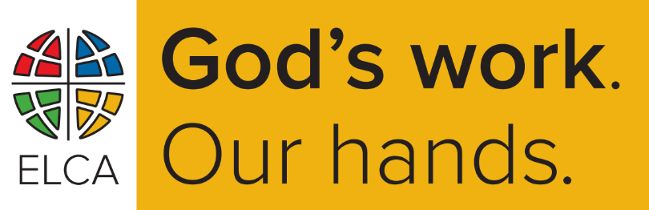 What do we mean when we say “God’s Work. Our Hands?” In short, I’d offer that phrase means several things. For starters, we believe that God is always active in the world; creating, reforming, guiding, changing, calling, accompanying, holding, moving…God is not static. God is involved and at work in the world. God is with us. In Advent we sing the song, “O Come, O Come, Emmanuel.” The name Emmanuel literally means “God is with us.”

Every day we experience God’s work in our midst. In the generosity of friends, in opportunities to stand in solidarity with the hurting and overlooked, in the compassion of family, in the excitement of new opportunity, in the mystery of the unknown; God is at work, doing something in our presence. We too are also instruments through which God works in the world. We are each uniquely gifted with opportunities to share God’s love and Grace. So, we affirm that life is filled (with) God’s Work. (Even through) Our Hands.

So, here is how we are going to participate in God’s Work with Our Hands on Saturday, September 6th. There will be three service opportunities, each scheduled to start at 9am at their respective location and to be concluded by noon. If your project concludes sooner, then enjoy the remainder of your Saturday! You will see a more detailed description of each below:

**First Responder Treat Bags (location: Bethlehem FLC)**

 Participants in this project will be putting together treat bags with cookies and a note to be delivered to area fire stations, EMS bases, and the police department as a “thank you” to those who serve as first responders in our community. Participants are invited to bake some cookies at home to bring with you (and some cookies will be baked on site at Bethlehem). Cookies will be bagged, and a thank you note will be attached. After treat bags are assembled, participants in this project can divide up delivery routes as you depart to drop off treat bags to area first responders.

**Safe Harbor’s Resource Warehouse**

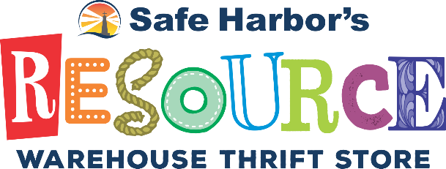Located off of NC Hwy 70, the Resource Warehouse receives donations and provides a space for the community to help folks in need. Participants in this project might help with organizing and sorting through donations, assisting with items available to the public, and with various staffing needs for a the time that the group is there to support the Resource Warehouse.

**Lenoir-Rhyne’s Lutheran Theological Southern Seminary**

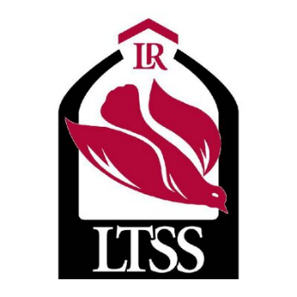LTSS has made it’s way to Hickory and is settling into their new home on LR’s campus. The building that they are utilizing could use some beautification in it’s front flower bed’s, some cleaning in the buildings kitchen area, and if time allows some pressure washing. Participants will help with planting plants, and giving the seminary’s new home a little TLC as students, faculty, and continue to settle into their new Hickory home.

A quick reminder, that everyone is invited and encouraged to wear their gold and black “God’s Work. Our Hands” t-shirts that Saturday. If you haven’t received your t-shirt yet, they are available in the narthex of the sanctuary. If you have questions, contact the church office. We will celebrate these service opportunities when we gather for worship on September 7th… but more to come on worship that Sunday later this week.

Until then look for God’s work around you. And open yourself to see how God is working through your hands to do good in the world.

The Peace of Christ be with y’all,

Pastor Vern