**PARISH HOUSE: August Items of the Month**

**Items Needed:** Canned fruit, toothpaste

**EVERY WEDNESDAY**

Choir Practice @ 6:15pm

Bible Study @ 7:00pm

**Upcoming Events:**

**Today –** 2:00-6:00pm Spaghetti Dinner @

The Outpost Event Center

Fund raising benefit for Patty Boone

**August 24th** – 4th Sunday Lunch

**August 30th** – 9:00am Women’s Meeting

**August 30th** – 2:00pm Gospel Sing

Mt. Hope UMC

Lunch afterwards

**Tithes and Offerings:** Give your gifts, tithes, and offerings through PayPal. It is quick, easy, and safe! Just use the camera on your phone to scan the QR Code. *All donations will be placed into our General Account unless otherwise stated.*

**TENNERTON**

*United Methodist Church*

August 17, 2025

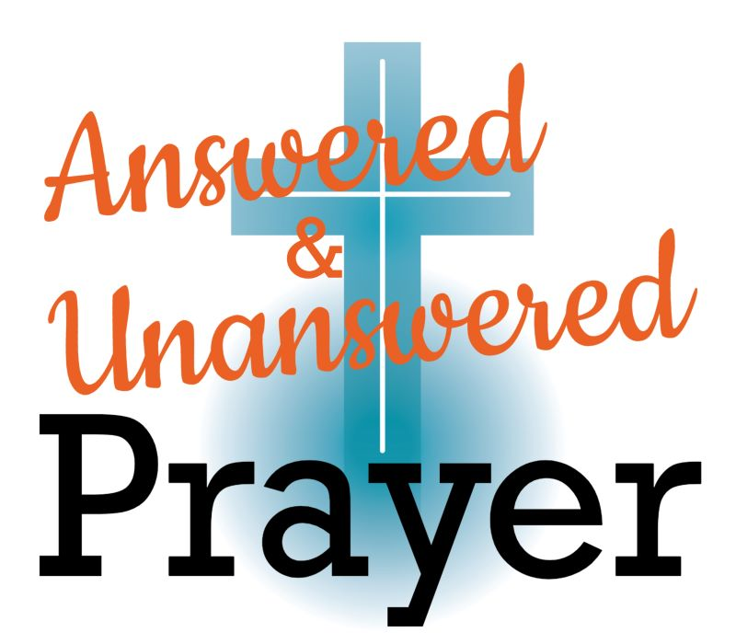

**Pastor Jim Minutelli**

**304-629-9398**

**Office**: 126 Tallmansville Rd.  
Buckhannon, WV 26201

**Office Phone:** 304-472-1064  
**Sermon by Phone:** 304-460-0029  
**Website:** <https://tennertonumc.org>  
**Email:** [umc.tennerton@gmail.com](mailto:umc.tennerton@gmail.com)   
**Facebook:** <https://www.facebook.com/thetennertonumc>  
**Prayer Concerns:** Call Candy George @ 304-613-6424

**JOYS & CONCERNS**

**WELCOME/OPENING PRAYER** Pastor

**OPENING** **HYMN:** “Thank You, Lord”

2/31 UMH 84

**CALL TO WORSHIP:** Psalm 80 UMH 801

**\*OFFERING/DOXOLOGY/PRAYER**

3/6 UMH 95

**CHOIR:** “O For a Thousand Tongues to Sing”

2/2 UMH 57

**CHILDREN MESSAGE** Vickie Snyder

**ANNOUNCEMENTS** *(ON BACK PAGE)*

**READING:**  Isaiah 5: 1 - 7

**\*HYMN:**  **“**How Great Thou Art”

2/20 UMH 77

**SCRIPTURE READING:**

**SERMON:**

**\*CLOSING HYMN:** “Amazing Grace”

13/11 UMH 378

**\*BENEDICTION**

**GREETERS & WORSHIP LEADERS** *If you would like to be a greeter or lead worship service,   
print your name on the clip board on the front pew.*

***This Week*   
GREETER(S):** Shane & Billi West

**WORSHIP LEADER:** Vickie Snyder

***Next Week*   
GREETER(S):** Susie Sheets

**WORSHIP LEADER:** Kathy Black

**AUGUST BIRTHDAYS**Corrine Wamsley – 8th, Jo McCartney – 20th,

Maac Carson- 25th

**AUGUST ANNIVERSARIES**

Shane & Billi West – 6th

Marden & Ina Jean Cutright – 31st

**Quote of the Week:**

“Our greatest weakness is giving up. The most

certain way to succeed is always to try

just one more time.”

Thomas A. Edison

***\*Please stand if you are able. Don’t Forget to Feed the Pig***