Pastor and Mrs. Courtney Lewis founded Cornerstone Baptist Church in Chicago in 2008, aiming to serve the community and address individual needs. Originally from Chesterton, Indiana, where they graduated from Fairhaven Baptist College, Pastor Lewis grew up in Chicago, while his wife is from Oceanside, California. They have four daughters: Lois, April, Justine, and Ruth.
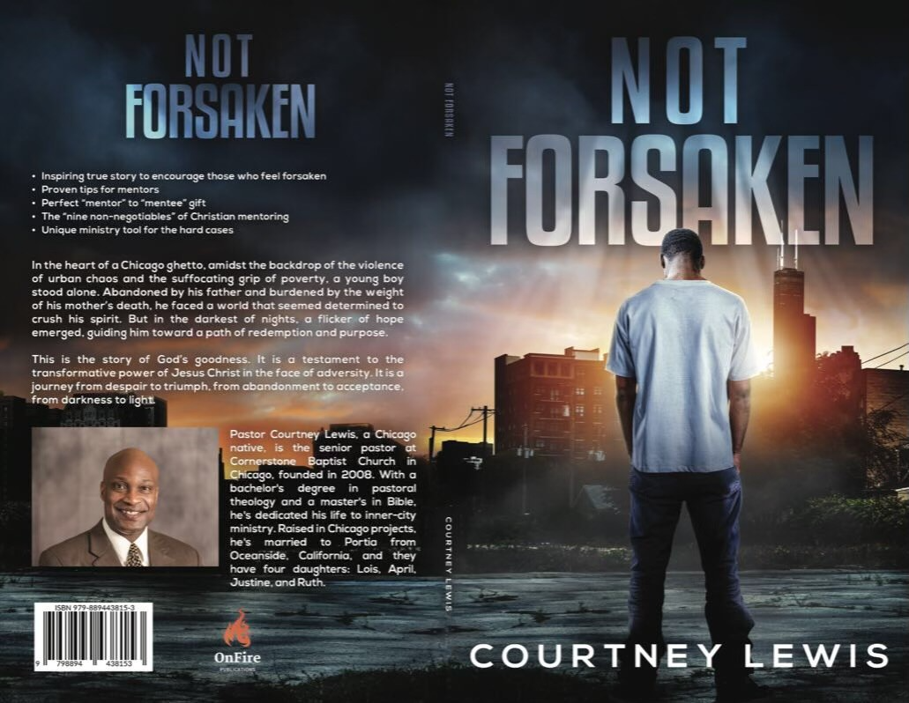
Friend,
"Not Forsaken” is about finding “Hope for the Hard Cases.” Our prayer is that the book will continue to be a beacon of light in the midst of darkness, offering Biblical solace to those who feel forsaken. In this powerful evangelistic and discipleship tool for church workers, the author draws from Biblical wisdom and personal experience to guide readers on a transformative journey. Through poignant stories and insightful teachings, readers will discover that no one is beyond redemption, and no situation is too hopeless for God's grace to reach.
With compassion and clarity, we have sought to tackle the tough questions and challenges commonly faced by those who minister to the forsaken. From addiction and homelessness to broken families and deep despair, "Not Forsaken" offers practical guidance and Biblical truths to bring healing and restoration. Each chapter is filled with encouragement and practical steps for both the weary worker and the lost soul seeking redemption.
As you turn the pages of "Not Forsaken," you will be inspired to embrace God's unyielding love and to extend that love to others, no matter how broken or lost they may seem. This book is a testament to the power of God's redemption and a call to action for all who seek to bring hope to the forsaken.
Sincerely,
Courtney Lewis

