***Holy Spirit Lutheran Church***

***10th Sunday after Pentecost***

***August 17, 2025***

***Vicar Tom Kaye (Smoot)***

A congregation of the Evangelical Lutheran Church in America

2205 Old Liberty Road, Eldersburg, MD 21784

Church Office 410-795-6333

HSLC Website--www.hslceldersburgmd.org



***We extend the warmest welcome*** *to all worshipping with us today. Whether this is your first time worshipping with us, you haven’t been in a while, or you are here regularly; we are so glad you are here! If this is your first time with us, we ask that you sign our Friendship Book, so that we might pray with/for you, get to know you better, and check-in with you from time to time.*

***Holy Communion is open to all.*** *In this church, we preach, teach, and confess that this is the table of Jesus, and it is Jesus who invites you to His table. You need not be a member of this church, or any other church; anyone who desires a deeper walk with Christ is invited. The ushers will direct you to proceed up the center aisle. You are invited to take an empty, individual cup from the silver tray near the baptismal font, and red wine, the blood of Christ, will be poured for you at the altar rail. You will also find red grape juice, the blood of Christ, in sealed individual cups in that same tray. As you come to the altar rail, you may stand or kneel as you are able, and the minister will place bread, the body of Christ, in your hand. If you are in need of a gluten free host, please let the minister know. If you prefer not to receive the Communion elements, Jesus still invites you into His Holy Communion; at the altar rail you may fold your arms and the minister will pray with and bless you.*

**PRELUDE**

**ANNOUNCEMENTS**

**LIGHTING OF THE CANDLES**

*Let us prepare our hearts and minds for worship.*

**CONFESSION AND FORGIVENESS**

*Please rise, in body or spirit.*

P: Blessed be the Holy Trinity, the Father, the ☩ Son, and the Holy Spirit.

**C: Amen.**

P: We live fractured lives, and God seeks not to punish us for those faults and fault lines, but to reconcile and restore us. Trusting in God’s grace and mercy, let us confess our sin in the presence of God and one another.

*(We pause for reflection)*

P: Loving God,

**C: Help us. When we have run away, when we have turned our backs on love, when we have sought immediate satisfaction and not long-term healing, help us.**

P: Merciful God,

**C: Forgive us. When we have been selfish, when we have been unkind, when we have closed our ears to the cries of others, forgive us.**

P: Powerful God,

**C: Heal us. When we are so broken we cannot move, when we don’t know how to stem the bleeding of our wounds, when we are too ashamed to seek community, heal us.**

**Give us the courage, the strength, and the hope to accept your grace and hear your call in Christ. Amen.**

P: Sisters and brothers in Christ, to open our hearts to God is to risk vulnerability, judgment, and condemnation. But throughout the scriptures, we learn that God is merciful and just, slow to anger, and abounding in steadfast love. In Jesus Christ, we are ☩ forgiven, and freed to live as New Creations.

**C: Amen.**

**Gathering Hymn: *How Firm a Foundation – LBW (Green) - 507***



**Greeting**

P:The grace of our Lord Jesus Christ, the love of God, and the communion of the Holy Spirit be with you all.

**C: And also with you.**

**HYMN OF PRAISE**

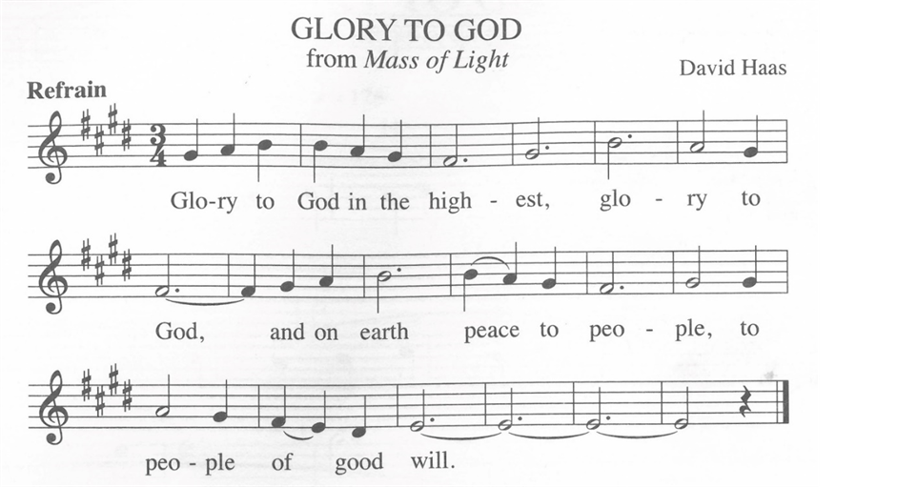

**PRAYER OF THE DAY**

P: O God, judge eternal, you love justice and hate oppression, and you call us to share your zeal for truth. Give us courage to take our stand with all victims of bloodshed and greed, and, following your servants and prophets, to look to the pioneer and perfecter of our faith, your Son, Jesus Christ, our Savior and Lord.

**C: Amen.**

***Please be seated.***

### FIRST READING: Jeremiah 23:23-29

23 Am I a God near by, says the Lord, and not a God far off? 24 Who can hide in secret places so that I cannot see them? says the Lord. Do I not fill heaven and earth? says the Lord. 25 I have heard what the prophets have said who prophesy lies in my name, saying, “I have dreamed! I have dreamed!” 26 How long? Will the hearts of the prophets ever turn back—those who prophesy lies and who prophesy the deceit of their own heart? 27 They plan to make my people forget my name by their dreams that they tell one another, just as their ancestors forgot my name for Baal. 28 Let the prophet who has a dream tell the dream, but let the one who has my word speak my word faithfully. What has straw in common with wheat? says the Lord. 29 Is not my word like fire, says the Lord, and like a hammer that breaks a rock in pieces?

L: The word of the Lord.

**C: Thanks be to God.**

### Psalm 82

1 God stands to charge the divine council assembled, giving judgment in the midst of the gods:  
2 **“How long will you judge unjustly, and show favor to the wicked?**  
3 Save the weak and the orphan; defend the humble and needy;  
4 **rescue the weak and the poor; deliver them from the power of the wicked.**    
5 They do not know, neither do they understand; they wander about in darkness; all the foundations of the earth are shaken.  
6 **Now I say to you, ‘You are gods, and all of you children of the Most High;**  
7 nevertheless, you shall die like mortals, and fall like any prince.’ ”  
8 **Arise, O God, and rule the earth, for you shall take all nations for your own.**

### Second Reading: Hebrews 11:29—12:2

29 By faith the people passed through the Red Sea as if it were dry land, but when the Egyptians attempted to do so they were drowned. 30 By faith the walls of Jericho fell after they had been encircled for seven days. 31 By faith Rahab the prostitute did not perish with those who were disobedient, because she had received the spies in peace.  
  32 And what more should I say? For time would fail me to tell of Gideon, Barak, Samson, Jephthah, of David and Samuel and the prophets, 33 who through faith conquered kingdoms, administered justice, obtained promises, shut the mouths of lions, 34 quenched the power of fire, escaped the edge of the sword, were made strong out of weakness, became mighty in war, put foreign armies to flight. 35 Women received their dead by resurrection. Others were tortured, refusing to accept release, in order to obtain a better resurrection. 36 Others suffered mocking and flogging and even chains and imprisonment. 37 They were stoned to death; they were sawn in two; they were killed by the sword; they went about in skins of sheep and goats, destitute, persecuted, tormented 38 of whom the world was not worthy. They wandered in deserts and mountains and in caves and holes in the ground.  
  39 Yet all these, though they were commended for their faith, did not receive what was promised, 40 since God had provided something better so that they would not, apart from us, be made perfect.  
  12:1 Therefore, since we are surrounded by so great a cloud of witnesses, let us also lay aside every weight and the sin that clings so closely, and let us run with perseverance the race that is set before us, 2 looking to Jesus, the pioneer and perfecter of faith, who for the sake of the joy that was set before him endured the cross, disregarding its shame, and has taken his seat at the right hand of the throne of God.

L: The word of the Lord.

**C: Thanks be to God.**

**Gospel Acclamation**- **WOV (Blue Book)- 612**

### Gospel: Luke 12:49-56

P: The Holy Gospel according to St. Luke, the twelfth chapter.

**C: Glory to you, O Lord.**

[Jesus said:] 49 “I have come to cast fire upon the earth, and how I wish it were already ablaze! 50 I have a baptism with which to be baptized, and what constraint I am under until it is completed! 51 Do you think that I have come to bring peace to the earth? No, I tell you, but rather division! 52 From now on five in one household will be divided, three against two and two against three; 53 they will be divided:   
 father against son and son against father, mother against daughter and daughter against mother, mother-in-law against her daughter-in-law and daughter-in-law against mother-in-law.”  
  54 He also said to the crowds, “When you see a cloud rising in the west, you immediately say, ‘It is going to rain,’ and so it happens. 55 And when you see the south wind blowing, you say, ‘There will be scorching heat,’ and it happens. 56 You hypocrites! You know how to interpret the appearance of earth and sky, but why do you not know how to interpret the present time?”

### P: The Gospel of the Lord

### C: Praise to you, O Christ

**CHILDREN’s MESSAGE**

**SERMON**

**Hymn of the Day****:*****Let the Whole Creation Cry - LBW (Green) – 242***

*Please rise, in body or spirit, as we lift our hearts and voices together in song.*



**Nicene Creed**

A: Lets us confess our faith in the words of the Nicene Creed,

**C: We believe in one God, the Father, the Almighty, maker of heaven and earth, of all that is, seen and unseen. We believe in one Lord, Jesus Christ, the only Son of God, eternally begotten of the Father, God from God, Light from Light, true God from true God, begotten, not made, of one Being with the Father; through him all things were made. For us and for our salvation he came down from heaven, was incarnate of the Holy Spirit and the virgin Mary and became truly human. For our sake he was crucified under Pontius Pilate; he suffered death and was buried. On the third day he rose again in accordance with the scriptures; he ascended into heaven and is seated at the right hand of the Father. He will come again in glory to judge the living and the dead, and his kingdom will have no end. We believe in the Holy Spirit, the Lord, the giver of life, who proceeds from the Father and the Son, who with the Father and the Son is worshiped and glorified, who has spoken through the prophets. We believe in one holy catholic and apostolic church. We acknowledge one baptism for the forgiveness of sins. We look for the resurrection of the dead, and the life of the world to come. Amen.**

**Prayers of Intercession**

A: Let us pray for the church, the creation, and the whole people of God, for God is near.

*A brief silence.*

A: Raise up faithful leaders for your church around the world. Inspire global missionaries (*missionaries sponsored by this congregation may be named*) with a spirit of accompaniment, as they walk alongside our partners in the gospel in solidarity, interdependence, and mutuality. Hear us, O God.

**C: Your mercy is great.**

A: Safeguard rivers and lakes (*local water sources may be named*) from pollution. Sustain the work of conservationists, policy makers, and advocacy groups seeking to protect fresh water sources. Hear us, O God.

**C: Your mercy is great.**

A: Bridge divisions across partisan lines. Strengthen cooperative efforts among lawmakers (*local elected officials may be named*) who enact policies that protect our neighbors who are most vulnerable. Hear us, O God.

**C: Your mercy is great.**

A: Embrace all who suffer in isolation: for those who are incarcerated or detained, those who are fleeing from unsafe environments, and those who are sick or homebound (*especially*). Reassure them of your care in all times and places. Hear us, O God.

**C: Your mercy is great.**

A: Guide the leaders of this congregation. In these late summer weeks, inspire their planning for a new program year ahead. Kindle in us a spirit of collaboration and support for their work. Hear us, O God.

**C: Your mercy is great.**

*Here other intercessions may be offered.*

A: : With thanksgiving, we remember the cloud of witnesses who surround us. By the example of their faith, enable us to run with perseverance the race set before us, until that day when we join their unending praise. Hear us, O God.

**C: Your mercy is great.**

A: Confident in God’s presence and promise, we entrust our prayers to the one who always receives them; through Jesus Christ, our wisdom and companion.

**C: Amen.**

**PaSSING THE PEACE**

**P:** The Peace of the Lord be with you always!

**C: And also, with you.**

**P:** Let us share a sign of peace with one another.

**Offering**

*Here at Holy Spirit Lutheran Church, there are many ways to give. The ushers will pass around an offering plate, in which you can place your weekly offering. If you are attending worship online or you simply wish to give online, you may do so by visiting our website,****hslceldersburgmd.org/give****. We give thanks to God for all offerings of time, talent, and treasure, all of which make it possible to serve God, by serving our neighbors, here in Eldersburg.*

**OFFERTORY HYMN**

**C: We lift our voices, we lift our hands, we lift our lives up to You: We are an offering.**

**Lord, use our voices, Lord, use our hands. Lord use our lives, they are Yours. We are an offering. All that we have, all that we are, all that we hope to be, we give to you, we give to you. We lift our voices, we lift our hands, we lift our lives up to you: we are an offering; we are an offering.**

**OFFERING PRAYER**

P: Let us pray.

P: Creator God, in your wisdom you bring forth all that is good and the harvest is plentiful.

Strengthen us at your table with these gifts of the earth and our labor, that we may work for the good of all; through Jesus Christ, our Savior.

**C: Amen.**

**THE GREAT THANKSGIVING**

**P:** The Lord be with you.

**C: And also with you.**

**P:** Lift up your hearts.

**C: We lift them to the Lord.**

**P:** Let us give thanks to the Lord our God.

**C: It is right to give our thanks and praise.**

**PREFACE**

**P****:**  It is indeed right, our duty and our joy, that we should at all times and in all places

give thanks and praise to you, almighty and merciful God, through our Savior Jesus Christ;

who on this day overcame death and the grave, and by his glorious resurrection opened to us the way of everlasting life.

And so, with all the choirs of angels, with the church on earth and the hosts of heaven, we praise your name and join their unending hymn:

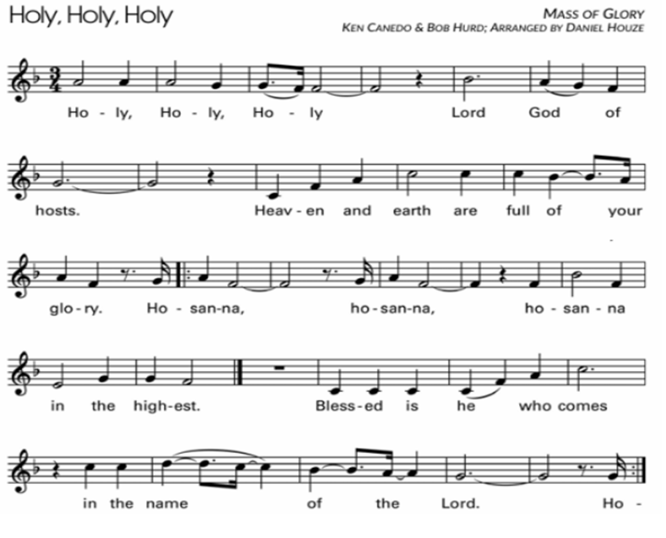

**EUCHARISTIC PRAYER & WORDS OF INSTITUTION**

P: Blessed are you, O God of the universe. Your mercy is everlasting and your faithfulness endures from age to age.

P: You formed the earth from chaos; you encircled the globe with air; you created fire for warmth and light; you nourish the lands with water. You molded us in your image, and with mercy higher than the mountains, with grace deeper than the seas, you blessed the Israelites and cherished them as your own.

P: That also we, estranged and dying, might be adopted to live in your Spirit, you called to us through the life and death of Jesus.

P: In the night in which he was betrayed, our Lord Jesus took bread, and gave thanks;

broke it, and gave it to his disciples, saying:

Take and eat; this is my body, given for you. Do this for the remembrance of me.

P: Again, after supper, he took the cup, gave thanks, and gave it for all to drink, saying:

This cup is the new covenant in my blood, shed for you and for all people for the forgiveness of sin. Do this for the remembrance of me.

P: Holy God, holy and merciful one, holy and compassionate, send upon us and this meal your Holy Spirit, whose breath revives us for life, whose fire rouses us to love.

Enfold in your arms all who share this holy food. Nurture in us the fruits of the Spirit,

that we may be a living tree, sharing your bounty with all the world.

**C: Amen. Come, Holy Spirit.**

P: Holy and benevolent God, receive our praise and petitions, as Jesus received the cry of the needy, and fill us with your blessing, until, needy no longer and bound to you in love, we feast forever in the triumph of the Lamb: through whom all glory and honor is yours, O God, O Living One, with the Holy Spirit, in your holy church, now and forever.

**C: Amen.**

**THE LORD'S PRAYER**

P: Gathered into one by the Holy Spirit, let us pray the prayer our Lord Jesus taught us, in the language of our hearts:

**C: Our Father, who art in heaven, hallowed be thy name, thy kingdom come, thy will be done, on earth as it is in heaven. Give us this day our daily bread; and forgive us our trespasses, as we forgive those who trespass against us; and lead us not into temptation but deliver us from evil. For thine is the kingdom, and the power, and the glory, forever and ever. Amen.**

**INVITATION TO COMMUNION**

P**:** Come to the table of grace. Receive the gift of new life.

**C: Amen.**

*Please be seated.*

**COMMUNION HYMN**

*Please come forward at the direction of the ushers.*

**SONG DURING COMMUNION**

*After all have communed, please rise, in body or spirit.*

**COMMUNION BLESSING**

P: May the body and blood of our Lord Jesus Christ bless us and keep us in God’s grace, from now and until life everlasting.

**C: Amen.**

**POST-COMMUNION PRAYER**

A: Let us pray, Mothering God, you gathered us to your table and we drank deeply of your grace. Send us out by your Spirit to love our neighbors as ourselves and proclaim your love in Jesus’ name.

**C: Amen.**

**BLESSING**

P: You are exactly who God created you to be. Created in Christ Jesus for good works. Created and called holy. Created and called beloved. Now go forth into the world in peace and be of good courage. Hold fast to that which is good. Render to no one an evil thing for an evil thing. Strengthen the fainthearted. Support the weak. Help the afflicted. Show Christ’s love to everyone and let the blessing of almighty God, the Father, the +Son, and the Holy Spirit, be among you and remain with you now and forever.

**C: Amen.**

**Sending Hymn:*Have Thine Own Way, Lord***

**DISMISSAL**

A: Alleluia, Christ is risen!

**C: He is risen indeed, Alleluia!**

A:Our purpose is to love God,

**C:** **And bring people into a growing relationship with Jesus and his church.**

***“We all serve as ministers in the mission of the Church.”***

From Sundays and Seasons.com. Copyright 2012 Augsburg Fortress. All rights reserved.

Reprinted by permission under Augsburg Fortress Liturgies Annual License #23995.

New Revised Standard Version Bible, copyright 1989, Division of Christian Education of the National Council of the Churches of Christ in the United States of America. Used by permission. All rights reserved.

**ACTIVITIES AT HOLY SPIRIT LUTHERAN CHURCH:**

Sunday (08/17) 9:30 am – Sunday Morning Worship w/Communion

Sunday (08/24) 9:30 am – Sunday Morning Worship w/Communion

**Please contact Vicar Tom** via email at HSLC.pastor@comcast.net if you would like to meet, have any questions, or for any pastoral emergencies.

**Volunteers**

|  |  |  |
| --- | --- | --- |
|  | ***THIS WEEK (08-17-2025)*** | ***NEXT WEEK (08-24-2025)*** |
| Greeters | Lily K. | TBD |
| Ushers | Bradley T.  Henry K. | Dave L.  Luke F. |
| Acolyte | Willow T. | Maryann F. |
| Assisting  Minister | Holly deB. | Megan F. |
| Communion Assistant | Holly deB. | John F. |
| Lector | Lisa H. | Krissy K. |
| Altar Care | Linda L. | Lorraine M. |