GOSHEN FIRST CHURCH

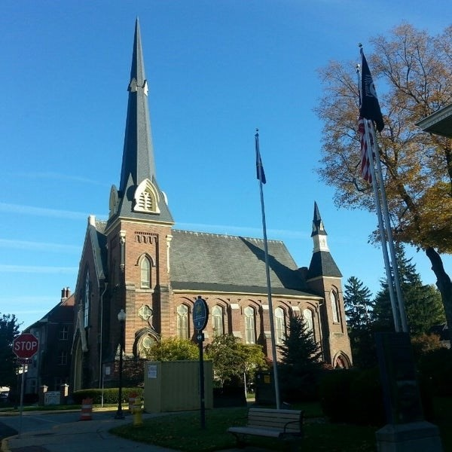 ***Auugust 6, 2025***

***A Global Methodist Church***

***214 S. 5th Street***

***Goshen, IN 46528***

***Phone: 574-533-9518***

***Office Hours: Monday-Friday,***

***8:00 a.m.-12:00 noon***

***Worship: 9:00 a.m.***

***Sunday School: 10:30 a.m.***

***Pastor: Diana Siegel***

***Associate Pastor: Rich Hull***

***OUR CHURCH VISION – “Growing in Faith, Gathering in Community, and Giving in Love”.***

On Sunday, we will have our Coffee Hour in the Garden Room to welcome

our new pastor and wife, Jeff & Lisa Bealmear.

The Primetimers will ride the Dixie Sternwheeler on Thursday, August 21,

in North Webster. Cost is $10 per person. Lunch will be at the American

Legion in North Webster. The bus will depart from the Life Center at 10:00 a.m.

For more information or to reserve a space, contact Sharon Hull or Bob Shirk.

It is almost time for students to head back to the classroom. We are able to help Waterford School by providing Kleenex boxes for 25-30 classrooms. Quaker Oat bars for students who miss the meal time, but are hungry are appreciated. You may drop off your contributions in the bins in front of the church office. The lunch for teachers and staff will be Tuesday, August 12. Let Marcia Parsons know if you would like to help.

VOLUNTEERS – Thank you for your service! Sunday morning, August 10

Greeters: Max Leatherman VIP: Kelley Leeper

Elevator Hosts: John Allyn, Kathy Robarge

Ushers: Chuck Rink,Jeff Showalter,George Buckingham,Kent Evans,Mary Ann Eash

Scripture Reader: Ann Stutsman

Junior Church: Elementary – Rachel Parsons Tenorio, Karen Andrews,

Marcia Parsons

Junior Church: Jr. High – Beth Pettit

Coffee Hour: Steve & Beth Pettit, Dave & Marcia Parsons, Dan & Kathy Seltenright,

Steve & Lori Warner

Bus Driver: Gary Miller

July Income: $25,045.27 Thank you for your

July Expenses: $25,801.35 faithful giving!

Year-to-Date Income: $259,209.90

Year-to-Date Expenses: $215,537.96