GOSHEN FIRST CHURCH

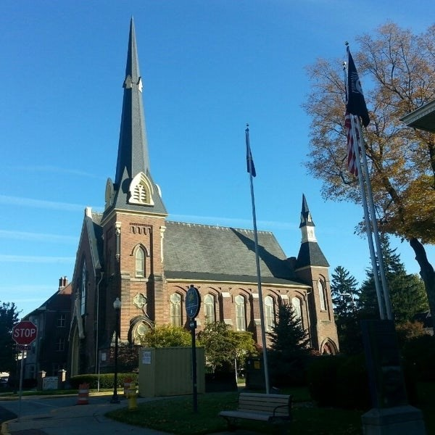 ***July 23, 2025***

***A Global Methodist Church***

***214 S. 5th Street***

***Goshen, IN 46528***

***Phone: 574-533-9518***

***Office Hours: Monday-Friday,***

***8:00 a.m.-12:00 noon***

***Worship: 9:00 a.m.***

***Sunday School: 10:30 a.m.***

***Pastor: Diana Siegel***

***Associate Pastor: Rich Hull***

***OUR CHURCH VISION – “Growing in Faith, Gathering in Community, and Giving in Love”.***

Next Sunday there will be no Coffee Hour or Sunday School. After the worship

service we will have a brunch in honor of Pastor Diana in the Garden Room. After the brunch there will be a short program upstairs in the sanctuary. Everyone is

welcome!

The next Men’s Brown Bag Lunch will be on Thursday, August 7, from

12:00-1:00 p.m. All men are welcome.

‘’Thank you for the beautiful birthday flower, and thanks to Sharon Hull for delivering it and for the nice visit.” -Janet Miller

VOLUNTEERS – Thank you for your service! Sunday morning, July 27

Greeters: Randy & Beth Cripe VIP: Cathy Smith

Elevator Hosts: Max Leatherman

Ushers: Erv Herschberger, Sharon Hull, Ken Smith, Dan Becker, Steve Warner

Scripture Reader: Pastor Rich Hull

Junior Church – Elementary – Rachel Parsons Tenorio, Kelley Leeper

No Coffee Hour on July 27th

Bus Driver: Al Eppert