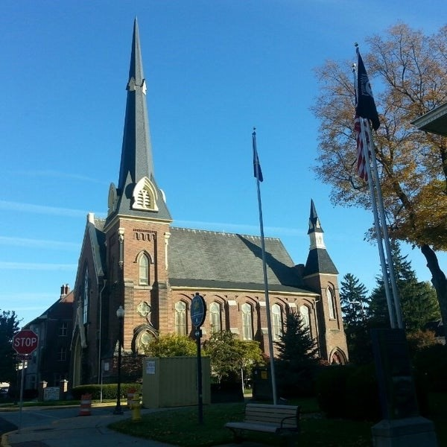 ***August 13, 2025***

***A Global Methodist Church***

***214 S. 5th Street***

***Goshen, IN 46528***

***Phone: 574-533-9518***

***Office Hours: Monday-Friday,***

***8:00 a.m.-12:00 noon***

***Worship: 9:00 a.m.***

***Sunday School: 10:30 a.m.***

***Pastor Jeff & Lisa***

***Associate Pastor Rich Hull***

***OUR CHURCH VISION – “Growing in Faith, Gathering in Community, and Giving in Love”.***

The Primetimers will ride the Dixie Sternwheeler on Thursday, August 21,

in North Webster. Cost is $10 per person. Lunch will be at the American Legion in North Webster. The bus will depart from the Life Center at 10:00 a.m. For more information or to reserve a space, contact Sharon Hull or

Bob Shirk.

Pastor Jeff & Lisa Bealmear’s address is: 1425 Pembrook Circle, Apt. 4, Goshen, IN, 46526. Pastor Jeff’s phone is: 618-889-2641, and his E-mail is:

pastorjeff@goshenfirstgmc.org

**“THE EDGE” is Coming!**

Beginning on **Sunday August 17th**a **6pm and 4pm** evening service will be in order to bring a new dimension to the Goshen First Church experience. **“The Edge”** will deal with hot topics and controversial subjects many face in their everyday life. There will be some worship along with Prayer, **The Topic**, and Holy Communion.  The **“The Edge”** topic will involve both large and small group discussion.  A Biblical response will be given about the topic along with a question and answer session.  “**The Edge"** will last about an hour.  Come out and experience **“The Edge”** and see where you are and where you stand on these issues from our changing world.

In August and September, we will be having cottage meetings in people’s homes or at the church for you to get acquainted with Pastor Jeff and Lisa. Please sign up on Sunday in the Gym during Coffee Hour. Host/Hostesses are: Rich & Sharon Hull, Bob & Donna Shirk, Ron & Loraine Troyer, Randy & Beth Cripe, Steve & Beth Pettit, Dave & Elaine McCann, Steve & Lori Warner, Dave & Marcia Parsons, George & Marty Buckingham, and Larry & Donna

Solyom. All are welcome!

**Hey Kids!** On Saturday, August 23, we will have a pool party at Dave & Elaine’s house. It will begin at 3:00 p.m. For children and youth, but all are invited!



In September, we are planning to have a “Block Party” event at the church. There will be activities and games and a light meal served. The purpose is to invite new families to the church and also to show the community that we do have an active children’s program at our church. Please see Rachel during coffee hour on Sunday to help on the planning committee.

VOLUNTEERS – Thank you for your service! Sunday morning, August 17

Greeters: Gary & Diane Miller VIP: Kelley Leeper

Elevator Hosts: Neil & Sue Graves

Ushers: Chuck Rink,Jeff Showalter,George Buckingham,Kent Evans,Mary Ann Eash

Scripture Reader: Gene Stutsman

Junior Church: Elementary – Pat Huber, Patty Krebs

Junior Church: Jr. High – Linda Russell

Coffee Hour: J.D. & Linda Russell, Steve & Beth Pettit

Bus Driver: Steve Warner